EYFS and Key Stage 1 Curriculum Progression


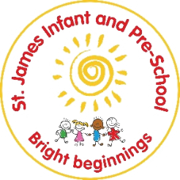
Communication and Language and Vocabulary Development
In EYFS, the development of children’s spoken language underpins all seven areas of learning and development. Children’s back-and-forth interactions from an early age form the foundations for language and cognitive development. The number and quality of the conversations they have with adults and peers throughout the day in a language-rich environment is crucial. By commenting on what children are interested in or doing, and echoing back what they say with new vocabulary added; practitioners will build children's language effectively. Reading frequently to children, and engaging them actively in stories, non-fiction, rhymes and poems, and then providing them with extensive opportunities to use and embed new words in a range of contexts, will give children the opportunity to thrive. Through conversation, storytelling and role-play, where children share their ideas with support and modelling from their teacher, and sensitive questioning that invites them to elaborate, children become comfortable using a rich range of vocabulary and language structures.

In school oracy is a powerful tool for learning, By teaching students to become more effective speakers we empower them to better understand themselves, each other and the world around them. It is also a route to social mobility enabling all students, not just some, to find their voice to succeed in school and life.

At St James infant and Pre-School we introduce new words to children that are useful and meaningful. Early language ability is one of the strongest predicators of later development through school and in life. Language is essential for thinking, expressing our feelings, making friends and finding solutions. The rate of language development in the first few years of life is, like many other aspects of young children's development, dramatic. If a young child does not develop the basic skills of speech, language and communication, they are likely to be disadvantaged for life. For this reason, it is a priority in our EYFS curriculum.

We plan a high quality oracy education where children learn through talk and to talk, Children develop and deepen their subject knowledge through talk in the classroom. Activities have been carefully planned to enable them to develop the oracy skills they need through modelling and scaffolding to enable then to learn the skills needed to talk effectively.

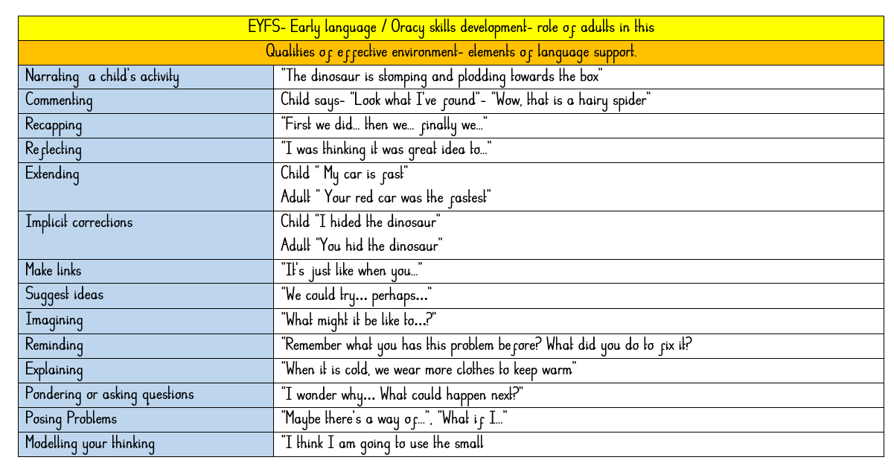

Selecting words
The three tiers framework

1
The first tier consists of the most basic words: warm, dog, tired, run, talk, party, swim, look, and so on. These are the words that typically appear in oral conversations, and so children are exposed to them at high frequency from a very early age.. This high exposure means that children become familiar with this set of words pretty readily, and so these Tier One words rarely require instructional attention to their meanings in school although to ensure communication gaps are narrowed our Oracy development strategies ensure constant coverage of Tier one words.

2
The second tier words are of high utility for literate language users and are found across a variety of domains. These words are characteristic of written text and are found only infrequently in conversation, which means that children are less likely to learn these words independently, compared with Tier One words. Because of the large role Tier Two words play in a language user’s repertoire, rich knowledge of words in the second tier can have a powerful impact on verbal functioning. Thus, planned vocabulary development is directed toward Tier Two words.

3
The third tier of words has a frequency of use that is quite low and often limited to specific topics and domains.. In general, a rich understanding of these words would not be of high utility for most learners. These words are probably best learned when a specific need arises.

An excellent source for words that will expand young children’s vocabularies are books that are desgined to be read aloud to children. Books are jampacked full of tier two words. A word is considered a good candidate for a tier two word if it is likely to be unfamilair to young children but is a concept they could indentify and use within normal converstaions. At the heart of a robust vocabulary approach is to select a set of words to be introduced and sustained, we do this throughout our focus texts and curriculum coverage.

St James criteria for choosing tier 2 words
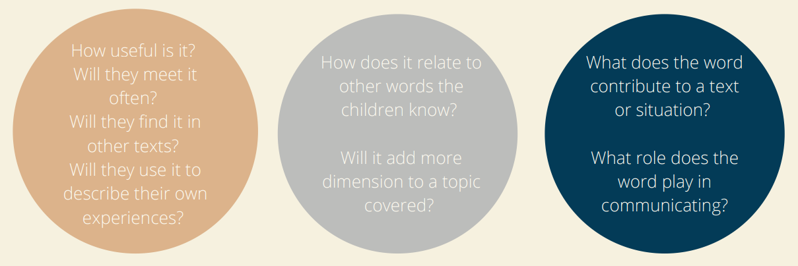
However we need to be aware of the fact that:
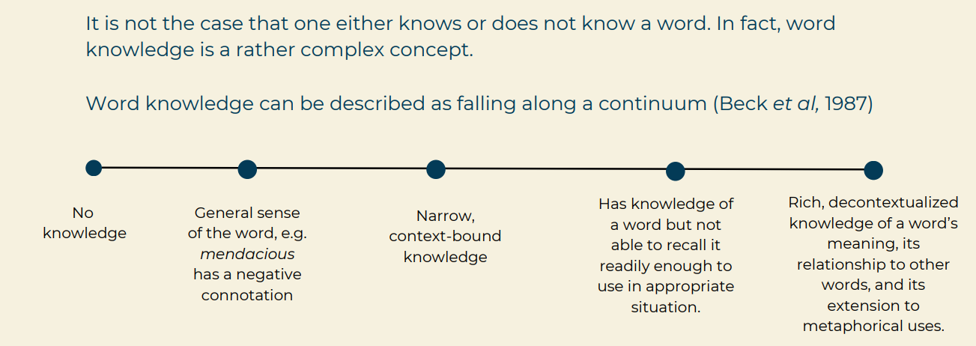
Process of new vocabulary introduction in the EYFS
1
The word is identified as part of a story context (using Grandma or Grandad Fantastic). This provides a situation that is already familiar to children and a rich example of the word’s use.


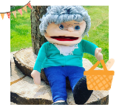
2
The meaning of the word is explained in a child-friendly way e.g. reluctant means you are not sure you want to do something.
3
The children are asked to repeat the word because pronouncing a word helps build a memory for the sound and meaning of the word (Say the word with me). – using WORD WIZARD STRATEGIES J



4
Examples given in contexts other than the one used in the story are provided (You might be reluctant to eat a food that you never had before, or you might be reluctant to ride a roller coaster because it looks scary).

5
Children interact with examples or provide their own examples (Tell about something you would be reluctant to do. Try to use reluctant when you tell about it. You could start by saying something like “I would be reluctant to __________”).

6
Children say the word again to reinforce its phonological representation and meaning (What is the word that means you do not want to do it?).

The planned for Tier Two words identified through texts chosen that develop our termly learning umbrellas (Big questions) as we believe linked learning give opportunities for frequent revisiting of newly taught vocabulary. Re-jig this sentence
We need to add in – easy, just right, challenging -

Preschool (To be completed with literacy plans –in process)
 | Autumn 1 | Autumn 2
Focus Texts
Tier 2 Vocabulary
Big Question | What if things change?

 | Spring 1 | Spring 2
Focus Texts
Tier 2 Vocabulary
Big Question | Is it moving?
 | Summer 1 | Summer 2
Focus Texts |  | 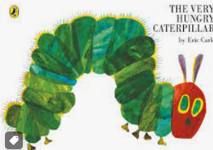
Tier 2 Vocabulary |  | Popped searching  Big, fat (Huge, large, ginormous)  Cocoon  Hungry (starving)
Big Question | Will it grow?

Wider curriclum vocabulary introductions

 | Autumn | Spring | Summer
UW (Past and Present) vocabulary
UW (People, cultures and communities) vocabulary
UW (The natural word) vocabulary
EAD vocabulary | 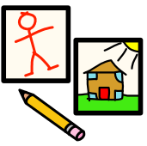 Marks Lines Circles   Colour Wet Dry Flaky Paintbrush  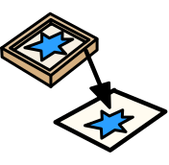Card Sponge Press Stamp     Playdough Press Roll  Smooth Shiny Rough Prickly Patterned Bumpy Jagged    Cut Glue Stick | Shapes  Finger prints Foot prints Spray Roll  Junk Attach Glue  Tissue paper | Squirt Splatter
Maths vocabulary
PSED vocabulary
PD vocabulary

Reception(To be completed with literacy plans –in process)
 | Autumn 1 | Autumn 2
Focus Texts
Tier 2 Vocabulary
Big Question | What if Paddington got lost in Daventry?
 | Spring 1 | Spring 2
Focus Texts
Tier 2 Vocabulary
Big Question | What’s Behind the door?
 | Summer 1 | Summer 2
Focus Texts
Tier 2 Vocabulary
Big Question | What if the world had no colour?

 | Autumn | Spring | Summer
UW (Past and Present) vocabulary
UW (People, cultures and communities) vocabulary
UW (The natural word) vocabulary
EAD vocabulary | Thin Thick Light Dark Strong Soft Hard Circle Cross Rectangle  Red Yellow Blue Mixing  Print Repeat Patterns  Fold Bend Clay  Cutting Weave Texture Fold Decoration  Cutting Shapes Sticking Texture | Pastels Chalk Felt tips  Primary Black White Shade  Shapes Smudge Roll  Sculpture Balance | Self-portrait  Light Dark Bright Dull Colourful
Maths vocabulary
PSED vocabulary
PD vocabulary
Wider curriclum vocabulary introductions
In addition and complementary to robust vocabulary instruction, at St James we create an “energised verbal environment” , a classroom where words are in play almost all of the time - noticed, investigated and savoured - and where every opportunity is taken to add words to children's surroundings
Energising the verbal environment
The adults are the most important element in this environment – alert to opportunities to use sophisticated, interesting and precise language.
Adults are sensitive to words and show their own curiosity about words.
Poetry is used to expose children to fascinating and innovative ways of celebrating language, whether this be through poems that lend themselves to performance or poems encouraging children to think about the images that words evoke.
Adults take spontaneous opportunities to introduce new words as they naturally arise, using their professional judgment as to what best to do with words as they enter the verbal environment.
Once words have been introduced and discussed, they can be ‘kept around’ in the classroom, for example on a word wall or display board, with adults alert for ways to “sprinkle them in”.
Further daily opportunities for a language rich day
Picture Power/
Review of learning wheels
Songs, rhymes, poems
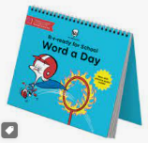
Rich, meaningful activities and experiences (Cross-curricular)
Small group opportunities to chatter
Informal conversations
Reading for pleasure texts
On-going Oracy development strategies- across all learning

Preschool
Autumn  During the Autumn term, children will… |  |  | Spring  During the Spring term, children will… |  | Summer  During the Summer term, children will…
 | Speaking
Children will use the names for a range of familiar objects, people and actions.  Children will use a range of words for time, space, function and description.  Children will use talk in my play to help organise e.g. “You sit there…. I will be the mummy”  Children will link words together in the start of a sentence e.g. more milk. |  |  | Children will use some new vocabulary e.g. scientific and story vocabulary.  Children will develop my sentences e.g. I have more milk.  Children will express my opinion using short sentences. |  | Children will explain, describe, recount and retell.  Children will join in with conversation (linked to listening)  Children will use a sentence of 4-6 words e.g.  Can I have more milk please?  Children will use connectives to link words in sentences e.g. I want the car and the crayon/ I like milk because it tastes nice.
How will this be achieved?
Reception
Autumn  During the Autumn term, children will… |  |  | Spring  During the Spring term, children will… |  | Summer  During the Summer term, children will…
Speaking
Children will express a point of view (in response to stories, interest, pictures, videos)  Children share my ideas using talk as a tool  Children will use talk to share what they think and will use speech as a way of starting to express myself to both adults and children.  Children will use a sentence of 4-6 words.  Children talk to organise my thoughts.  Children listen to and talk about stories, rhymes and non-fiction  Children say how I feel using talk as a tool (PSED LINK) |  | Children develop the confidence to share my ideas in small groups and with familiar adults.  Children will explain events that have already happened in detail  Children will engage in stories, rhymes and non-fiction sharing my ideas about them.  Children will start to use full sentences.  Children are starting to use past, present and future tenses. |  | Children will take part in whole class and group discussions.  Children can explain why things happen/ might happen  Children will use vocabulary from stories, non-fiction, rhyme and poems.  I can express ideas and feelings  I can use full sentences using past, present and future tenses.  I can use conjunctions (with support and modelling) to connect my ideas.
How will this be achieved?
Oracy devlopemnt  Reflect sessions- pirates |  | Reading spine  JC  Review wheel |  | Tiers of language  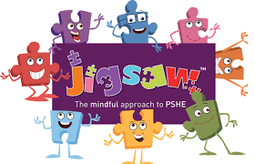  Class assemblies
Assessment
Half termly assessment trackers completed
Weekly evaluations.
 | Interventions
Prime interventions tool kit – implement to support specific areas of needs with childrens daily learning and play.
Time to talk Chatterway
Oracy development framework Communication Cookbook

