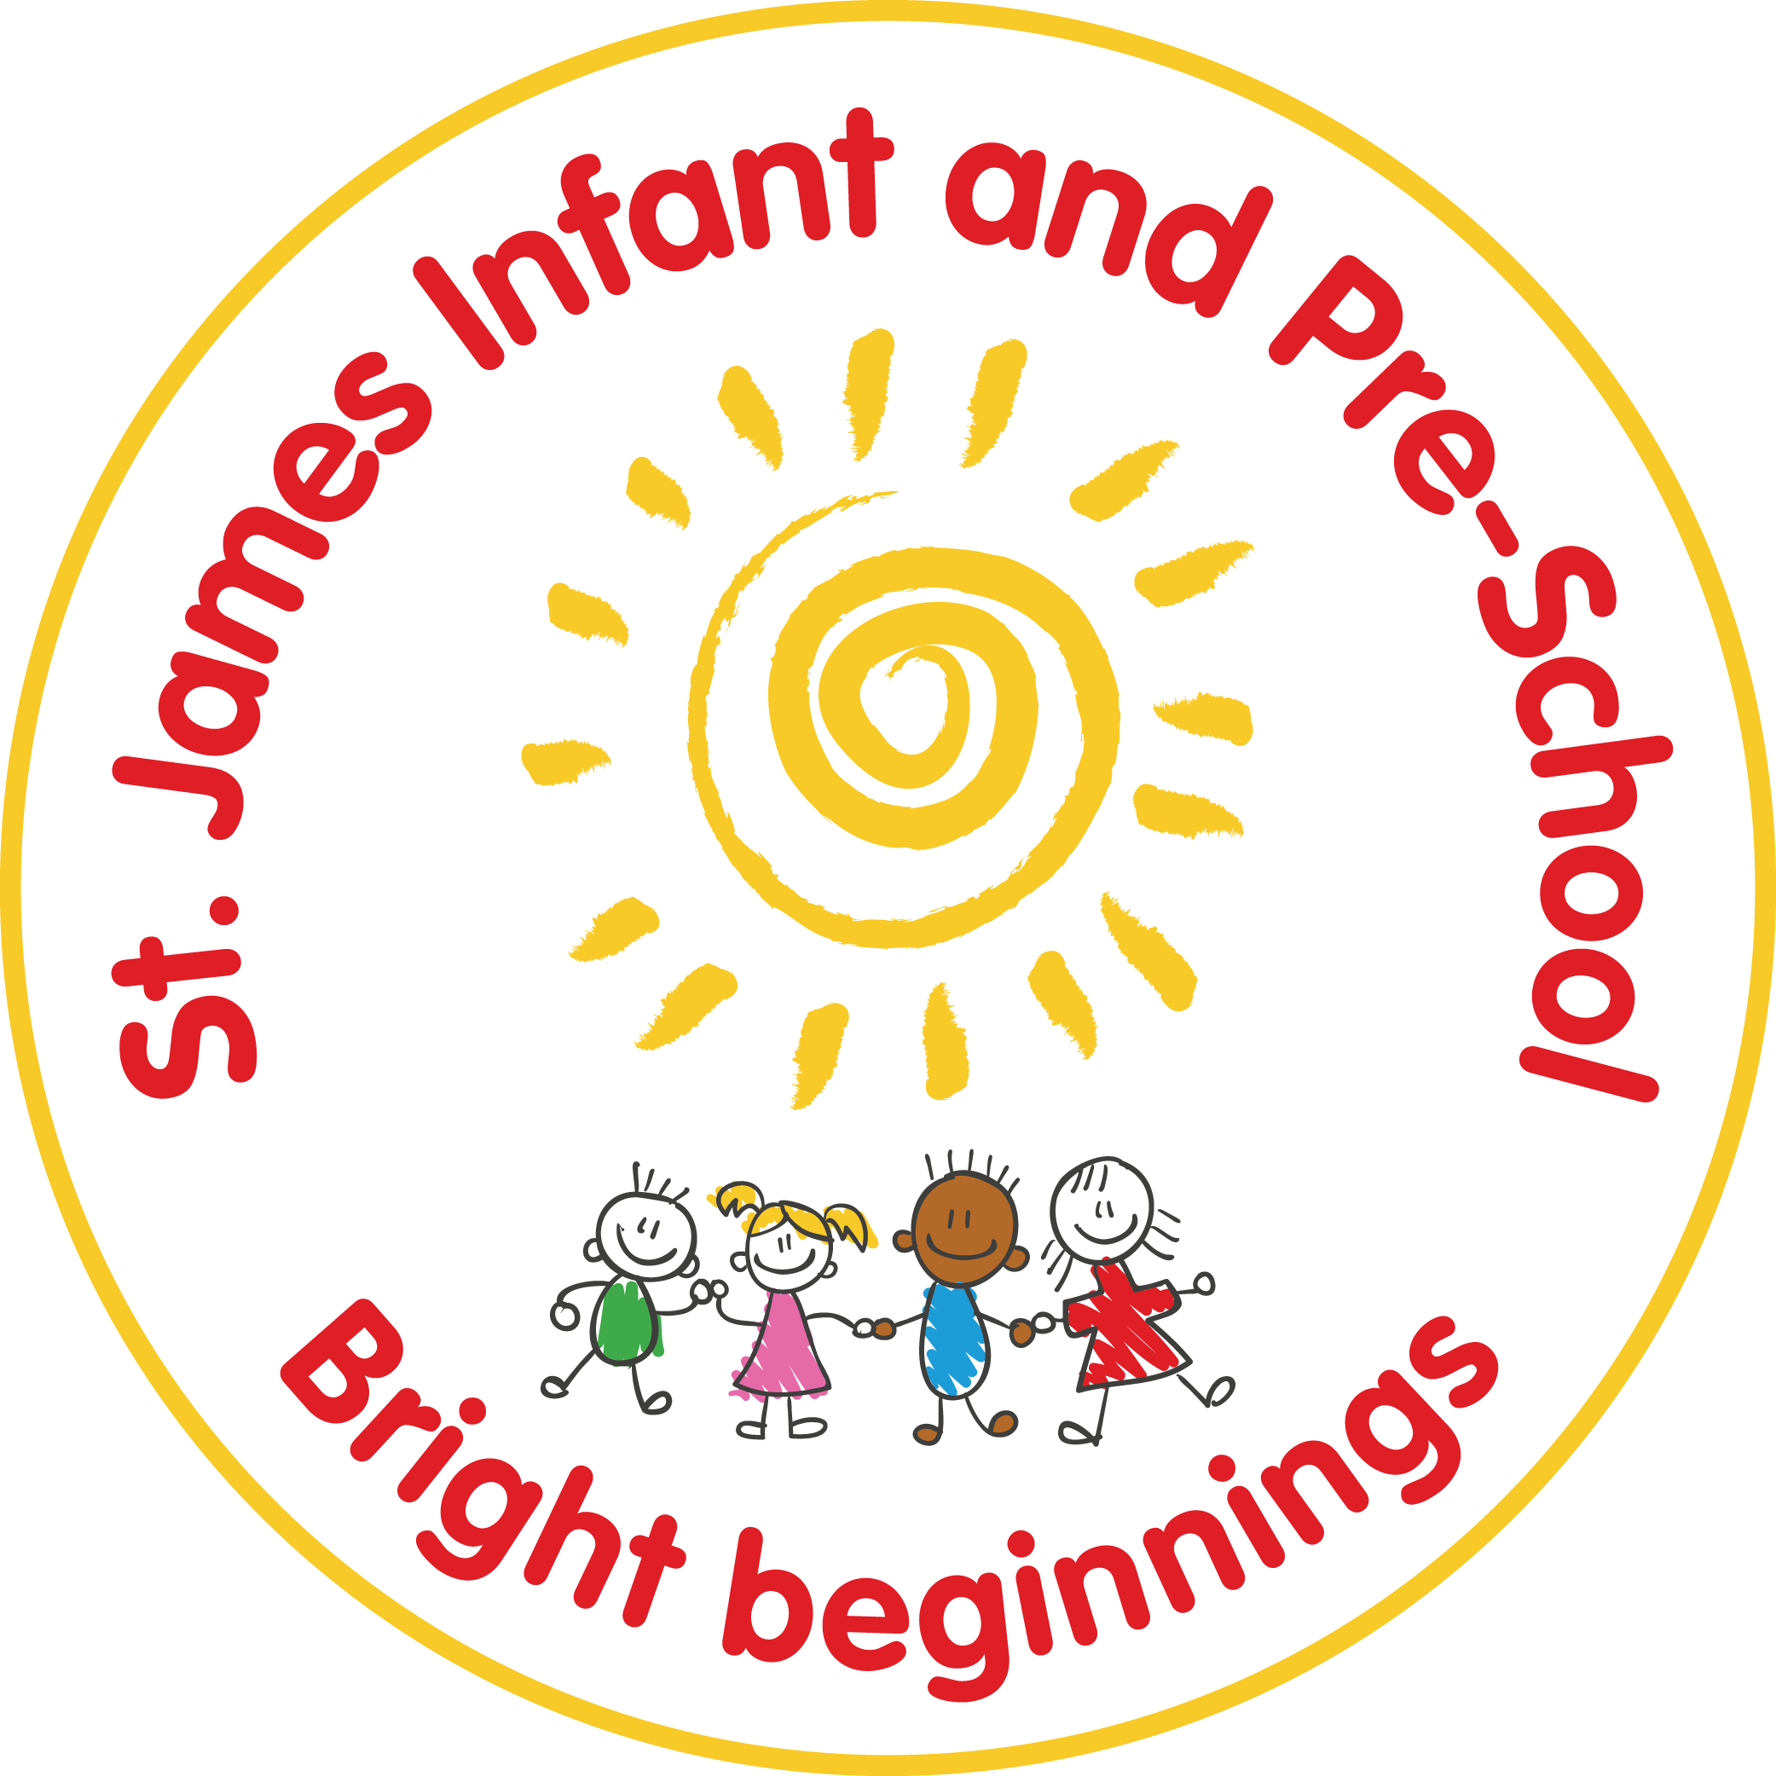

St James Infant & Pre-School
English Policy inc. Library
Statutory / Non-statutory
Date policy adopted | Sept ‘15
Review date | Sept 2019 | Sept ‘20 | September 2021 |  | May 2024
Reviewer’s name | BF and LS | BF and LS | BF and MK |  | BF and SH
Date minuted by committee meeting | 3.12.19
Next review due by | Sept 2020 |  | September 2022 |  | May 2025
Annual review / 2 yearly review

This policy is intended to ensure that whilst children are at St. James we help them develop the skills and knowledge that will enable them to communicate effectively and creatively with the world at large, through spoken and written language. We also intend to help children to enjoy and be inspired by literature and its rich variety.
English should enhance learning through:
- A rich and stimulating language environment, where speaking and listening, reading and writing are integrated.
- An inclusive environment where children are encouraged to construct and convey meaning, both in speech and writing, of factual, imaginary and personal experiences.
- Opportunities for children to become confident, competent and expressive users of language with a developing knowledge of how it works.
- Opportunities for children to be reflective users of language, able to analyse and evaluate its main features
- An enthusiasm for, and love of reading for life
- Opportunities to develop a fluent and legible handwriting script
- Opportunities to write independently and at length using own initiative
- Opportunities for children to communicate ideas through a wide variety of mediums, including technology
- Opportunities for role-play and drama
- Providing opportunities for vocabulary to be enriched and developed so that each child can flourish and reach their potential
Phonics:
Children are taught phonetic awareness from Pre-school, in dedicated, daily phonics time. Throughout the main school we follow the ‘Read Write Inc’ phonics programme, where children are grouped according to termly assessment data and any child needing additional tuition receives this also. The programme is very structured so the look and sound of each lesson is the same, thus ensuring that the children cognitive load is not overwhelmed. In Reception children are taught in their whole class for the first term before being assessed and grouped accordingly. Systmatic checks are made of both progress and understanding and staff are constantly coached and trained. Every in class adult in the school is a phonics teacher. The Read Write Inc language and approach threads through all curriculum lessons in terms of the silent signals and the cues for how to hear sound and spell words.
Mock phonics assessments take place regularly during Year 1 to ensure progress is being made and children are on track in preparation for the annual phonics screening check in June. The results are immediately analysed allowing all staff to see gaps and therefore plan strategic and systematic interventions. Any Year 2 children who may need to retake the screen also complete the mock assessments.

Reading:
Children are encouraged to become confident, enthusiastic, critical and independent readers. They are given the opportunities to experience print that has been produced in a variety of forms and for a variety of purposes. They will have opportunities to read for information, interest and enjoyment. Children read daily as part of their phonics lesson and have further opportunties to read throughout the school day in reading lessons, across all subjects, class reader time and also DEAR (drop everything and read) sessions as well as termly book and biscuit sessions where families are invited in to enjoy stories.
The above structure is enhanced through:
- Opportunities to investigate and understand the features of books and how they work, appreciate the work of individual authors, illustrators and publishers.
- Encouraging an interest in words and their meanings, reflecting on their reading, and offer a personal response to a wide range of texts
- Having opportunities to read for and with other children and adults, in a variety of situations
- Having a ’20 minutes reading pledge’ where teachers and parents agree to read to their child for 10 minutes a day each, providing the opportunity for the adult to model reading styles and further encourage a love of books. This reading partnership is promoted and celebrated.
- Use of Dojo videos and Book and Biscuit sessions to model reading with children for families and enabling parents to become more involved and have an active part in their child’s reading journey.
- Termly reading newsletters sent home to pass on information and ideas to the school community.
- Having access to ‘Oxford Owl’ (an e-book account) to encourage further reading at home; enabling phonics books to be available online too
- Weekly reading raffle where a child from each cohort wins a book, nominated by any of the adults in school
- Weekly visits to the library to choose books and enjoy reading for pleasure.

Reading Lessons

In Key Stage One children have a dedicated reading lesson at least three times a week. The Reading Ninjas programme is the main tool for this, with staff creating lessons based on the text and skills taught through the programme. Children who have completed the phonics programme have an additonal reading lesson in phonics time which is based on a blended approach of Reading Ninjas, Vipers and Literacy Shed. By taking a hybrid approach it ensures that children meet different types of text, different questions and learn reading skills in a variety of ways. This well-rounded approach means that children are able to dig deep into texts for meaning and understanding.

In Reception reading lessons are taught alongsid writing lessons and oracy development, digging deep into our spine texts, using a mix of drama, oracy techniques, talk for writing and Jane Considine’s fanastics and brave writing to fully understand books and their meanings.

All year groups have a set reading spine which encompasses fiction, non-fiction and poetry. There is also a reading for pleasure spine which complements cross-curricular learning. Reading takes the form of calm, echolaic and responsive reads.

Assessment of reading is ongoing using PiXL, Itrack and teacher assessment. data of each year group is analysed closely in termly pupil progress meetings. The subject lead tracks the data of children who are reading below the expected level as well as tracking progress in phonics through the mock assessments. PiXL gap analysis is also used as an assessment tool. Children are given individual reading targets in each big term.

Writing:
We believe it is important for children to develop as independent, enthusiastic and expressive writers, who are able to write in a meaningful way. They should be able to use a range of forms, for a variety of purposes and audiences. They should be confident in their choice of style for a specific purpose. Children are encouraged to regard themselves as writers and value their own work and that of others.
This is enhanced through:
- Having a variety of opportunities to use writing as a means to communicate ideas and information to a reader
- Using talk and drama to help generate ideas creatively and to inspire children
- Having opportunities to collaborate with others during the writing process
- Explore and use technology as a tool for writing
- Having the opportunity to write at length across the curriculum and to promote engagement
- Classrooms are set up to help provide opportunities for children to write at length if they choose to. This is through opportunities in role play areas and also flexible seating options in EYFS.

We aim to provide hooks for children, based on a first hand ‘WOW’ experiences. Specific elements of grammar, punctuation and spelling are taught overtly and discreetly through this approach. English planning is integrated into unit plans to ensure that cross-curricular links are being developed. All planning is monitored regularly by the English Leader. The subject leader works closely with staff using a coaching model. Staff also moderate standards within school and across the academy.
In addition, the library is set up by teaching staff at the beginning of each term, as an exciting space to reflect the time of year and cohorts learning focuses.

Assessment of writing is ongoing, attainment is recorded on I-Track and Pixl (Ks1 only) for data analysis at least termly during pupil progress meetings. Subject leads track the data of children who are reading below the expected level. In KS1 children complete independent writes at the end of the teaching sequence, the Jane Considine Assessment Framework is used to assess each piece of writing and to build up a moderation portfolio. This would show an ‘at’ and a ‘below’ for every year group.

Children are given planned opportunities to use a range of dramatic forms for example role-play, hot seating, tableaux, mime and freeze frame techniques, to express feelings and ideas both verbally and non-verbally in English sessions, which children can then develop further in the setting, through independent learning opportunities. Children are also encouraged to appreciate drama, both as participants and observers, through themed planning, theatre visits/visitors, and Christmas Concerts.

Spelling, Punctuation and Grammar:
Children are taught to have the understanding of how to apply grammar rules and punctuation in their writing. We believe that punctuation and grammar should be taught within English lessons, to enable it to be put into context.
This is enhanced through:
- Teaching punctuation and grammar within English teaching
- Using support materials from a grammar scheme to enhance their understanding
- Expanding their knowledge into other areas of the curriculum

Children are encouraged to develop as confident and independent spellers, who use an adventurous vocabulary in their writing. We encourage the children to use a range of spelling strategies, alongside their phonic knowledge, so they can attempt unknown words.
This is enhanced through:
- Providing fun and engaging opportunities to develop an increasingly wide range of words from memory, especially high frequency words.
- Children apply the taught sound within phonics lessons to spell words.
- Using high-quality resources such as RWI spelling programmes to support the teaching of spelling rules and patterns (KS1)
- Having a variety of resources and strategies to help them with spelling, for example word banks, dictionaries, spelling rules and mnemonics.
Within RWI, children begin to learn Red Words and begin to practice spelling these words within lesson time.

Handwriting:
This is taught in separate daily sessions throughout the week, but forms an important part of the children’s English work. This begins in Pre-school and Reception, where the focus begins with building core strength and pencil grip/control. We have adopted the ‘Kinetic Letters’ handwriting programme. It is important for children to be able to write clearly and develop a fluent and legible handwriting style. We reward children with a pen licence when all their letters are formed correctly, and then encourage them to join their letters together, following the handwriting scheme. We also reward children who are trying very hard with their handwriting with a weekly handwriting award which is given out in our celebration assembly.
We aim for the children:
- To form letters correctly and use upper and lower case letters appropriately
- To use the correct and comfortable pencil grip
- To sit properly and comfortably in their writing positions – lying, kneeling and sitting.

Special Educational Needs:
Children who require extra support with their English skills are given this either in the classroom alongside the other children, or groups/individuals are withdrawn for a particular focus. The level of support given is outlined in the year group provision map or children’s Individual Education Plan. These children are reviewed regularly during Pupil Progress Meetings. In writing we use tools such as sound buttons, word mats and Widgits to support learners. Children may also use Colourful Semantic strategies to support writing. Learning adaptions are detailed on planning.
English as an additional language:
We also recognise the possible need to provide extra support for these children, where necessary, to maximise their access to English skills and the curriculum. We aim to provide learning activities which involve practical activity and discussion and dual coding strategies.
More Able and Equal opportunities:
Any child demonstrating a particular skill or talent in any aspect of English should be encouraged and given opportunities to make accelerated progress. The English Subject Leader will give advice on suitably challenging activities and differentiation.
All children have access to the English Curriculum regardless of gender, faith, culture, ethnicity, home language, sexuality or background. (Refer to the school’s Equal Opportunities policy for further details).
Resources:
Resources are carefully selected to engage and inspire children. Key texts are stored in classrooms, these include reading for pleasure texts and those required to support writing. Audits take place at least once annually to ensure the resources meet the needs of the English curriculum.
MONITORING AND EVALUATION
The English subject leaders monitor the English Curriculum on a regular basis through a coaching model of planning with year group teachers, observing lessons and discussing afterwards including some work scrutiny, data analysis, year group and cross year group moderation sessions, and reviewing planning documents. Staff/pupil/parent voice is also sought. The Subject Leader tracks the provision of the Early Years Foundation Stage and National Curriculum through the planning to ensure coverage of all of the objectives. The subject area is evaluated formally on an annual basis and an action plan with priorities for the following year is drawn up from this. The subject leader is responsible for the annual review of this policy and writing an action plan, where necessary, for the subject and is also available for support and advice on resources, teaching, learning and intervention. The curriculum group World of Words meets termly to monitor the teaching of reading and writing across the school.

Wider Curriculum Offer
We have a team of volunteer readers who come in weekly to read with children who are below track or who do not have the opportunity to read regularly out of school. The reading lead works closely with the volunteers, delivering training sessions and discussing engagement of children. The school runs reading workshops for parents in the form of read write inc sessions where parents can join their child in their phonics lesson and in book and biscuit sessions where staff model enjoyment and sharing of books. The school endeavours to have visitors in school to promote reading such as the local library promoting reading challenges and the Word Guerilla who is a performance poet.

Reviewed and Updated May 2024
S.Harris and B.Finch
English Leaders

