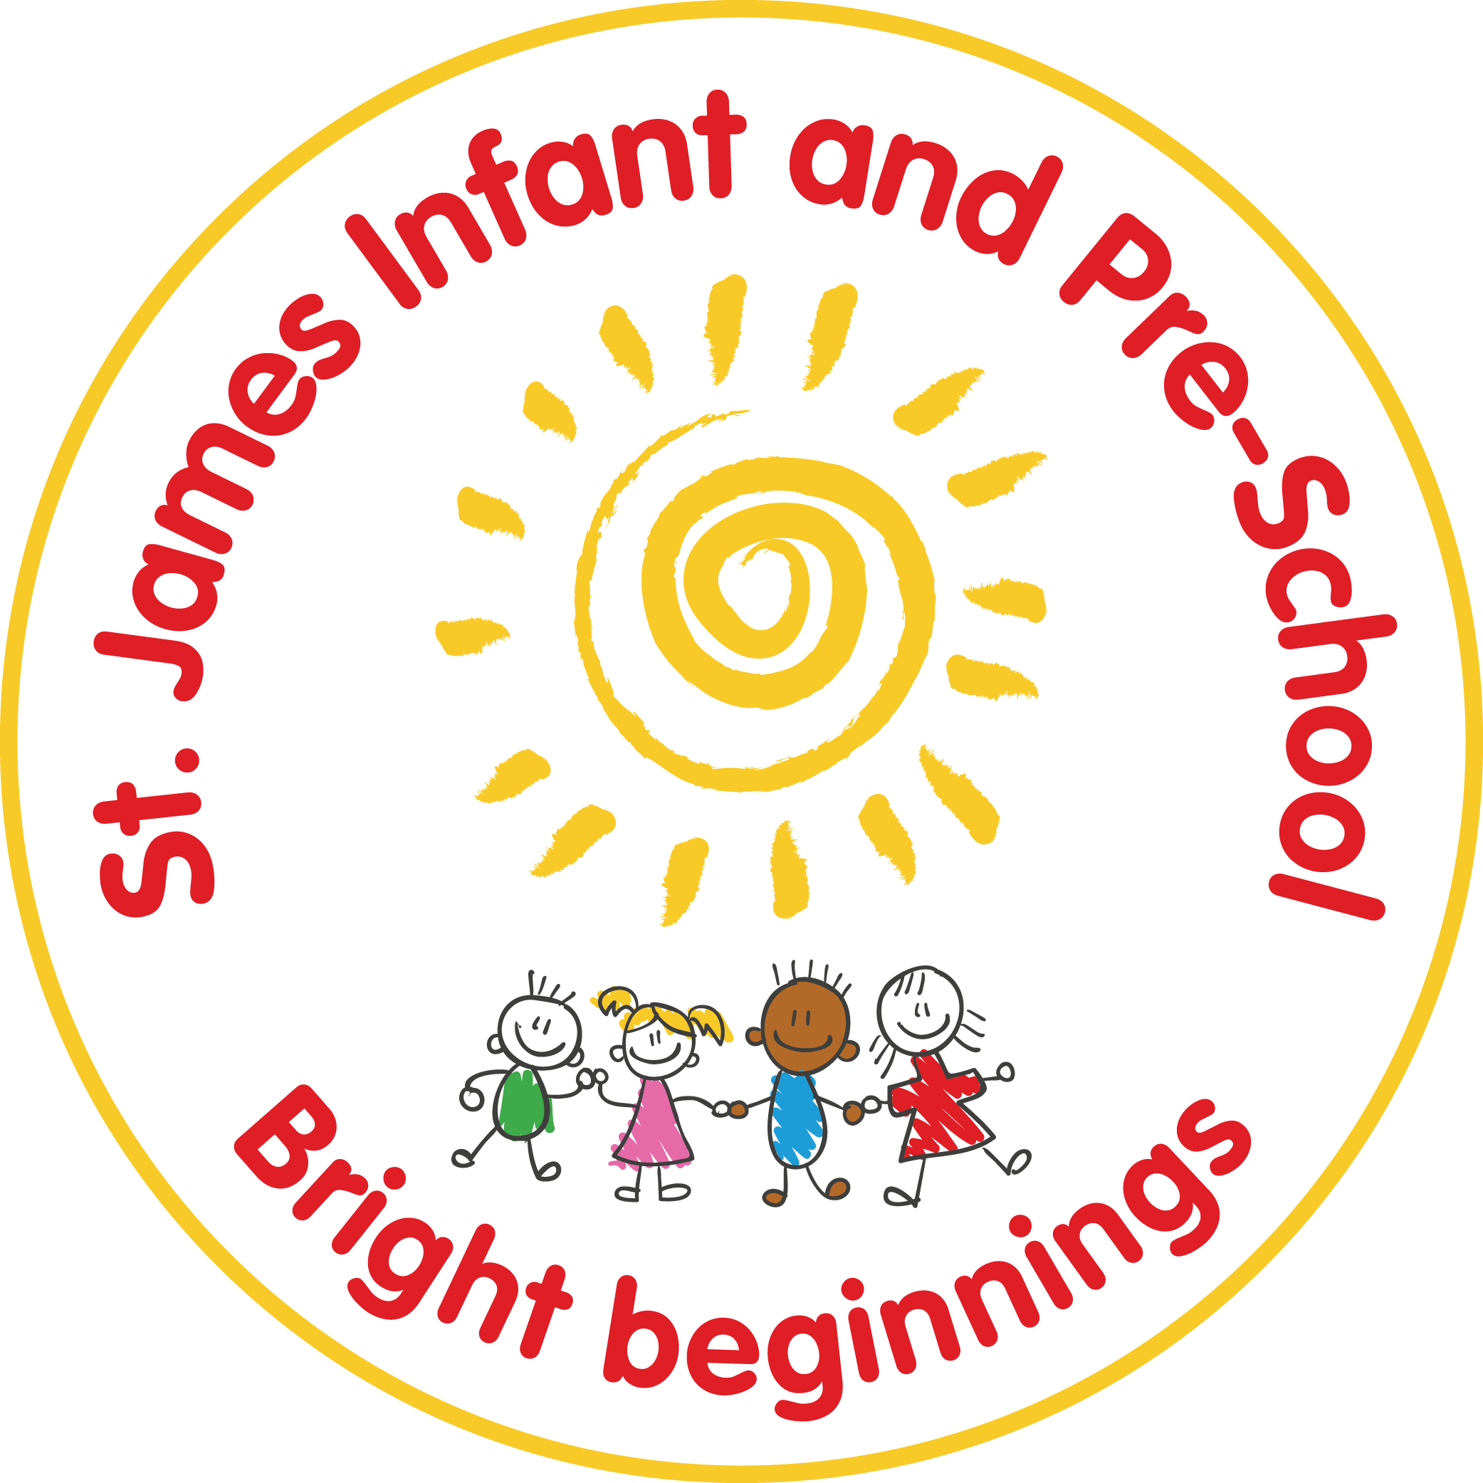

St James Infant & Pre-School
Calculation Policy
Statutory / Non-statutory
Annual review / 2 yearly review

Review date | 22.10.21 | 31.10.22 | 18.10.23
Reviewer’s name | S Harris | S Harris | SHarris
Date minuted by committee meeting
Next review due by |  | 31.10.23 | 31.20.24

St James Infant and Pre-School
Calculation Policy

THIS POLICY IS INTENDED TO PROVIDE calculation guidance, so that staff have a list of recommendations and teaching ideas that ensure that children during their time at St James receive effective teaching.
OUR PRIORITIES:
- Children will develop their fluency when working with basic numbers, solving calculations mentally and using written methods.
- Children will develop their understanding of the = symbol.
- Children will be able to calculate rather than count and work systematically.
- Children will be allowed to move between the concrete, pictorial, and abstract to enable them to problem solve.
- Children will be encouraged to contextualize mathematics and explain their answers using the correct mathematical terminology.

Power Maths calculation policy EYFS1 / Reception
Children develop the core ideas that underpin all calculation. They begin by connecting calculation with counting on and counting back, but they should learn that understanding wholes and parts will enable them to calculate efficiently and accurately, and with greater flexibility. Children record their calculations in their own ways, there is no expectation of number equations at this stage however children may choose this way to record their thinking.
Key language: whole, part, ones, ten, tens, number bond, add, addition, plus, total, altogether, subtract, subtraction, find the difference, take away, minus, less, more, group, share, equal, equals, is equal to, groups, equal groups, divide, share, shared equally
Addition:  Children start to explore addition by sorting groups. They then use sorting to develop their understanding of parts and wholes.  Children combine groups to find the whole, using a part-whole model to support their thinking. They also use the part-whole model to find number bonds within and to 10.  Using a five frame and ten frame, children add by counting on. They start by finding one more before adding larger numbers using counters or cubes on the frames.  Children use a number track to add by counting on. Linking this learning to playing board games is an effective way to support children’s addition. | Subtraction:  Children start to explore subtraction by sorting groups. They use sorting to develop their understanding of parts and wholes.  When comparing groups, children use the language more than and fewer than. This will lead to finding the difference when they move into KS1.  Children then connect subtraction with the idea of counting back and finding one less using a five frame to support their thinking.  They explore subtraction by partitioning numbers, developing their understanding of parts and wholes. This links to their developing recall of number bonds.  Children count back within 20 using number tracks and ten frames to see the effect of taking away. | Multiplication and Division:  Children first start to look at the idea of equal groups through their exploration of doubles. They use five frames and objects to check that groups are equal.  Children then explore halving numbers by making 2 equal groups. They highlight patterns between doubling and halving seeing that double 2 is 4 and half of 4 is 2.  As well as halving, children also explore sharing into more than 2 equal groups. They share objects 1 by 1, ensuring that each group has an equal share.

Reception
 | Real-life representation | Other representations
Addition | Sorting groups  Children sort everyday objects into groups.  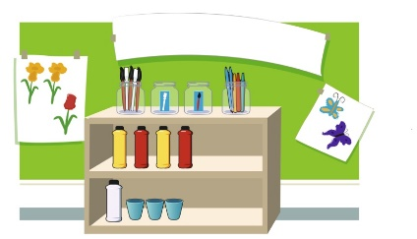
 | Counting and adding more (within 5)  Children add one more person or object to a group to find one more.  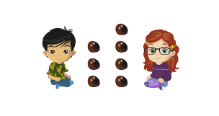  One more than 3 is 4 | Counting and adding more (within 5)  Children represent first, then, now stories on a five frame. They make the first number and then add one more.  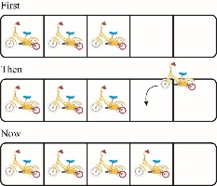  First, there are 3 bikes.  Then, 1 more bike came.  Now, there are 4 bikes.
 | Combining groups to find the whole  Children sort people and objects into parts and combine them to find the whole.  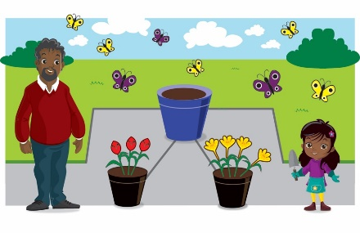  The parts are 3 and 4. The whole is 7. | Combining groups to find the whole  Children use counters or cubes in a part-whole model to find the whole.  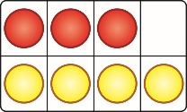  The parts are 3 and 4. The whole is 7.
 | Finding number bonds to 10  Children combine 2 groups to find a number bond to 10  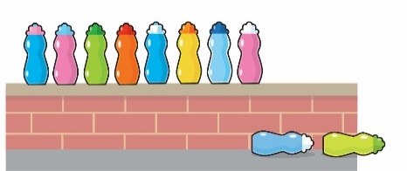  There are 8 bottles on the wall.  There are 2 bottles on the floor.  There are 10 bottles altogether. | Finding number bonds to 10  Use ten frames and part-whole models to represent key number bonds.  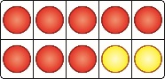  8 and 2 is 10  There are 10 altogether.  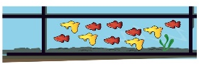  6 and 4 is 10  There are 10 altogether.
 | Adding by counting on (number track)  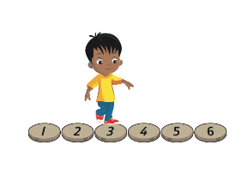  Children jump along a physical number track. They start at the larger number and count on the smaller number to find the total. | Adding by counting on (number track)  Children use a number track and a counter. They start at the larger number and count on the smaller number to find the total.  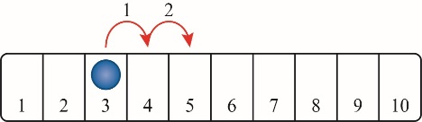
 | Adding by counting on (ten frames)  Children find the total number by counting on from the larger number. | Adding by counting on (ten frames)  Children make the larger number on the ten frames and then make the smaller number, counting on to find the total. They can use counters, cubes or other objects on the ten frames.  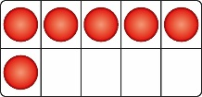  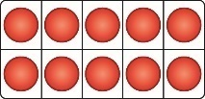
Subtraction | Sorting groups  Children sort everyday objects into groups.  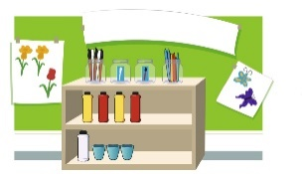
 | Comparing groups  Children line up objects to compare the amount. They line the objects up either horizontally or vertically.  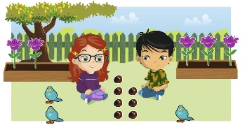  Ella has more conkers.  Tom has fewer conkers. | Comparing groups  Children line up cubes or counters to compare the amount in each group. Lines can either be horizontal or vertical. A starting line helps to line the objects accurately.  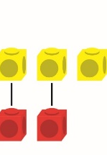  There are more yellow cubes.  There are fewer red cubes.
 | Counting back and taking away (within 5)  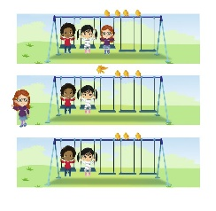  Children remove one more person or object from a group to find one less.  First, there were 3 children.  Then, 1 child left.  Now, there are 2 children. | Counting back and taking away (within 5)  Children use five frames and objects to make a number. They then remove or cross out one object to find one less.  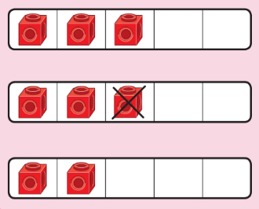  One less than 3 is 2
 | Introducing the part-whole model  Children sort everyday objects into parts.  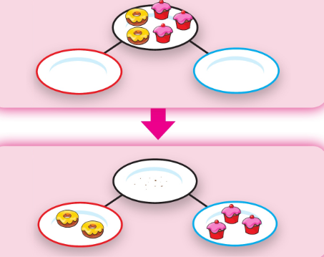    One part is the    The other part is the | Introducing the part-whole model  Children use counters or cubes to represent objects in a part-whole model.  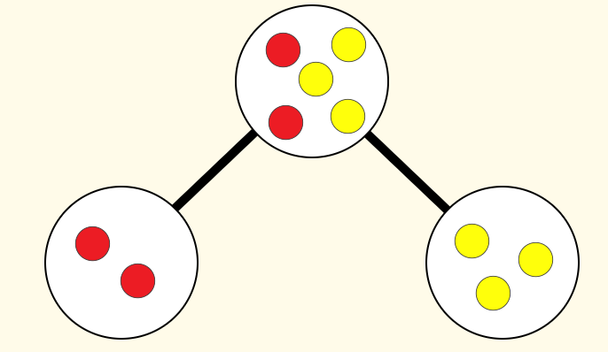  The whole is 5.  2 is a part.  3 is a part.
 | Finding number bonds to 10  Children partition 10 into different groups to find the number bonds to 10  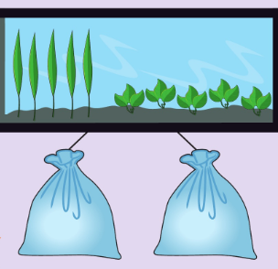 | Finding number bonds to 10  Children use part-whole models, ten frames and counters to find the number bonds to 10  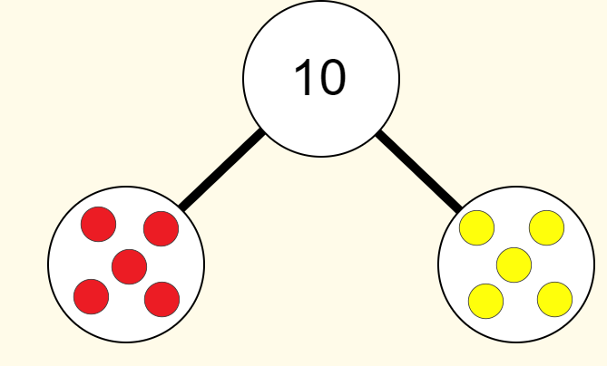  10 is the whole.  5 is a part and 5 is a part.  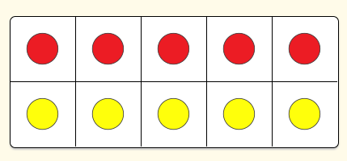  10 is the whole.  5 is a part and 5 is a part.
 | Counting back and taking away (number track)  Children use game boards and human number tracks to subtract by counting back.  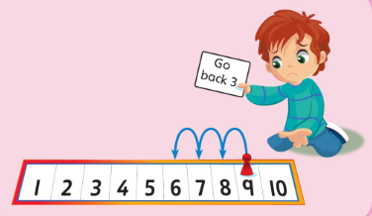  9 take away 3 equals 6  9…8…7…6 | Counting back and taking away (number track)  Children use a number track and a counter. They start at the larger number and count back the smaller number to find the answer.  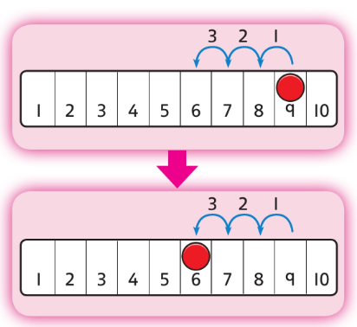  9 take away 3 equals 6  9…8…7…6
 | Counting back and taking away (ten frames)  Children count backwards to find one less with numbers up to 20  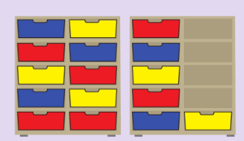  One less than 16 is 15 | Counting back and taking away (ten frames)  Children remove counters from ten frames to support in counting back with numbers up to 20.  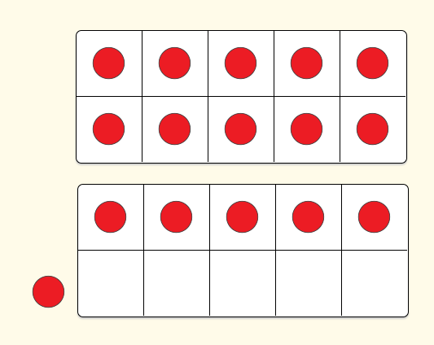  One less than 16 is 15
Multiplication | Making doubles  Children explore doubles in their environment including in games such as on dominoes or dice. They focus on the understanding of doubles being 2 equal groups.  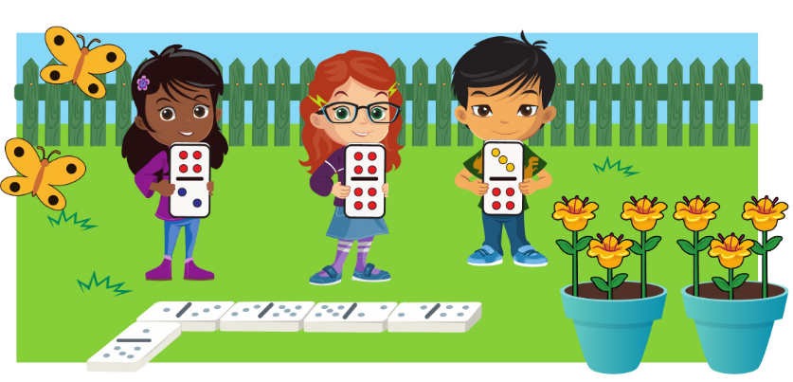  Double 4 is 8  Double 2 is 4  Double 3 is 6 | Making doubles  Children use five frames to find doubles by lining up counters or cubes.  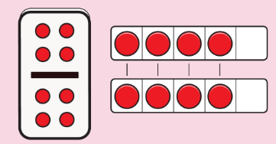  Double 4 is 8
Division | Halving and sharing  Children explore halving and sharing through practical sharing using real life scenarios including sharing fruit or classroom equipment.  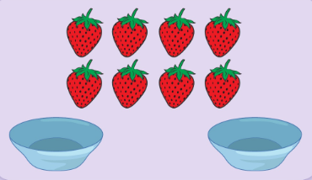  Half of 8 is 4 | Halving and sharing  Children use five frames to share amounts fairly and to check that the groups are equal. They share the counters/cubes one by one.  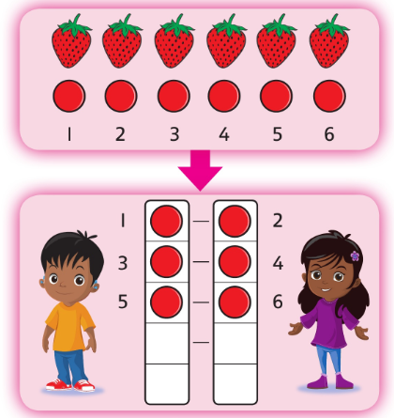  Half of 6 is 3

KEY STAGE 1
Children develop the core ideas that underpin all calculation. They begin by connecting calculation with counting on and counting back, but they should learn that understanding wholes and parts will enable them to calculate efficiently and accurately, and with greater flexibility. They learn how to use an understanding of 10s and 1s to develop their calculation strategies, especially in addition and subtraction.
Key language: whole, part, ones, ten, tens, number bond, add, addition, plus, total, altogether, subtract, subtraction, find the difference, take away, minus, less, more, group, share, equal, equals, is equal to, groups, equal groups, times, multiply, multiplied by, divide, share, shared equally, times-table
Addition and subtraction: Children first learn to connect addition and subtraction with counting, but they soon develop two very important skills: an understanding of parts and wholes, and an understanding of unitising 10s, to develop efficient and effective calculation strategies based on known number bonds and an increasing awareness of place value. Addition and subtraction are taught in a way that is interlinked to highlight the link between the two operations.  A key idea is that children will select methods and approaches based on their number sense. For example, in Year 1, when faced with 15 − 3 and 15 − 13, they will adapt their ways of approaching the calculation appropriately. The teaching should always emphasise the importance of mathematical thinking to ensure accuracy and flexibility of approach, and the importance of using known number facts to harness their recall of bonds within 20 to support both addition and subtraction methods. |  | Multiplication and division: Children develop an awareness of equal groups and link this with counting in equal steps, starting with 2s, 5s and 10s. In Year 2, they learn to connect the language of equal groups with the mathematical symbols for multiplication and division.  They learn how multiplication and division can be related to repeated addition and repeated subtraction to find the answer to the calculation.  In this key stage, it is vital that children explore and experience a variety of strong images and manipulative representations of equal groups, including concrete experiences as well as abstract calculations.  Children begin to recall some key multiplication facts, including doubles, and an understanding of the 2, 5 and 10 times-tables and how they are related to counting. |  | Fractions: In Year 1, children encounter halves and quarters, and link this with their understanding of sharing. They experience key spatial representations of these fractions, and learn to recognise examples and non-examples, based on their awareness of equal parts of a whole.  In Year 2, they develop an awareness of unit fractions and experience non-unit fractions, and they learn to write them and read them in the common format of numerator and denominator.
Year 1
 | Concrete |  | Pictorial |  | Abstract
Year 1
Addition
Counting and adding more | Children add one more person or object to a group to find one more. |  | Children add one more cube or counter to a group to represent one more.  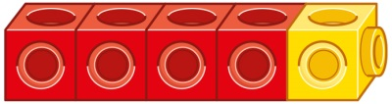  One more than 4 is 5. |  | Use a number line to understand how to link counting on with finding one more.  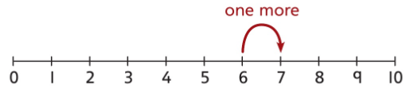  One more than 6 is 7.  7 is one more than 6.  Learn to link counting on with adding more than one.  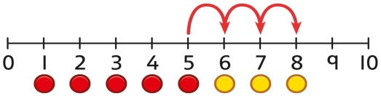  5 + 3 = 8
Understanding part-part-whole relationship | Sort people and objects into parts and understand the relationship with the whole.  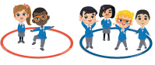  The parts are 2 and 4. The whole is 6. |  | Children draw to represent the parts and understand the relationship with the whole.  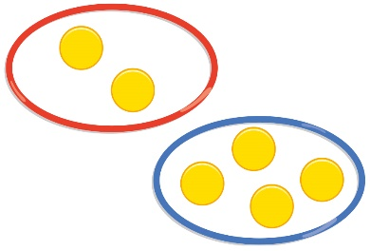  The parts are 2 and 4. The whole is 6. |  | Use a part-whole model to represent the numbers.  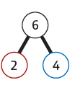  2 + 4 = 6
Knowing and finding number bonds within 10 | Break apart a group and put back together to find and form number bonds.  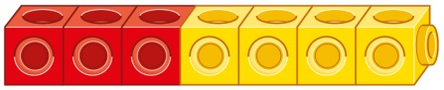  3 + 4 = 7    6 = 2 + 4 |  | Use five and ten frames to represent key number bonds.  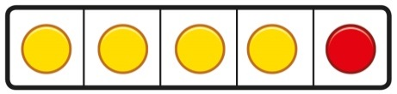  5 = 4 + 1  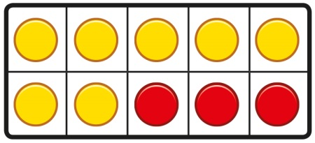  10 = 7 + 3 |  | Use a part-whole model alongside other representations to find number bonds.  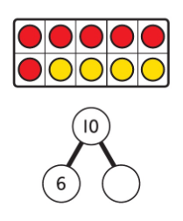  Make sure to include examples where one of the parts is zero.
Understanding teen numbers as a complete 10 and some more | Complete a group of 10 objects and count more.  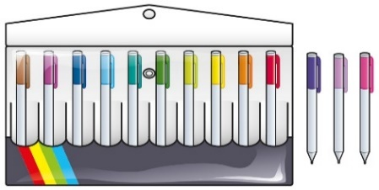  13 is 10 and 3 more. |  | Use a ten frame to support understanding of a complete 10 for teen numbers.  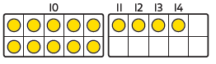  14 is 10 and 4 more. |  | 1 ten and 5 ones equal 15.  10 + 5 = 15
Adding by counting on | Children use knowledge of counting to 20 to find a total by counting on using people or objects.  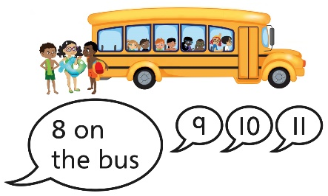 |  | Children use counters to support and represent their counting on strategy.  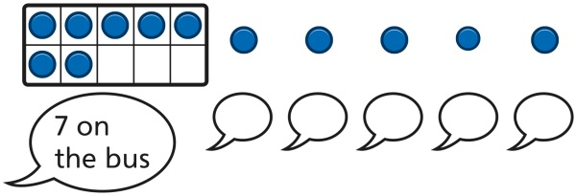 |  | Children use number lines or number tracks to support their counting on strategy.  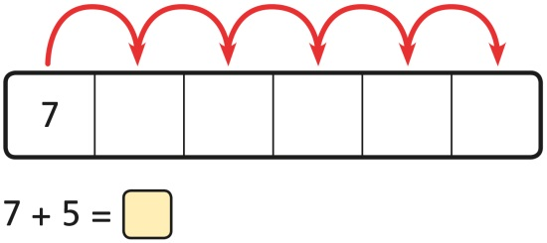
Year 1
Subtraction
Counting back and taking away | Children arrange objects and remove to find how many are left.  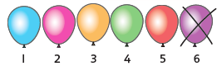  1 less than 6 is 5.  6 subtract 1 is 5. |  | Children draw and cross out or use counters to represent objects from a problem.  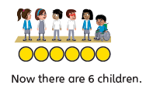 |  | Children count back to take away and use a number line or number track to support the method.  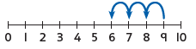  9 − 3 = 6
Finding a missing part, given a whole and a part | Children separate a whole into parts and understand how one part can be found by subtraction.  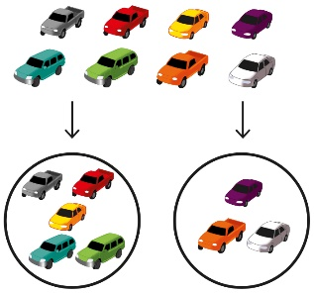  8 − 5 = ? |  | Children represent a whole and a part and understand how to find the missing part by subtraction.  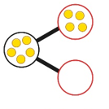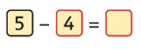 |  | Children use a part-whole model to support the subtraction to find a missing part.  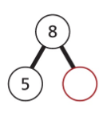  8 − 5 = ?  Children develop an understanding of the relationship between addition and subtraction facts in a part-whole model.  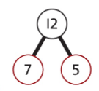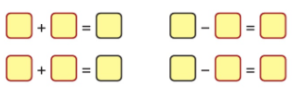
Finding the difference | Arrange two groups so that the difference between the groups can be worked out.  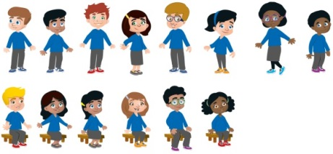  8 is 2 more than 6.  6 is 2 less than 8.  The difference between 8 and 6 is 2. |  | Represent objects using sketches or counters to support finding the difference.  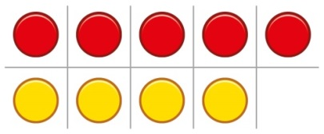  5 − 4 = 1  The difference between 5 and 4 is 1. |  | Children understand ‘find the difference’ as subtraction.  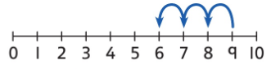  10 − 4 = 6  The difference between 10 and 6 is 4.
Year 1
Multiplication
Recognising and making equal groups | Children arrange objects in equal and unequal groups and understand how to recognise whether they are equal.  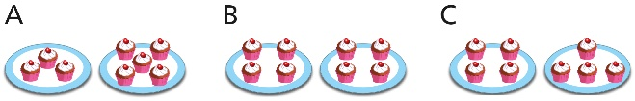 |  | Children draw and represent equal and unequal groups.  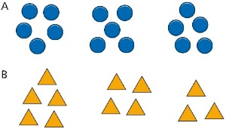 |  | Three equal groups of 4.  Four equal groups of 3.
Finding the total of equal groups by counting in 2s, 5s and 10s | 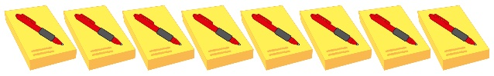  There are 5 pens in each pack …  5…10…15…20…25…30…35…40… |  | 100 squares and ten frames support counting in 2s, 5s and 10s.  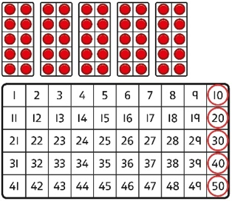 |  | Use a number line to support repeated addition through counting in 2s, 5s and 10s.  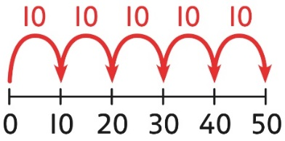
Year 1
Division
Grouping | Learn to make equal groups from a whole and find how many equal groups of a certain size can be made.  Sort a whole set people and objects into equal groups.  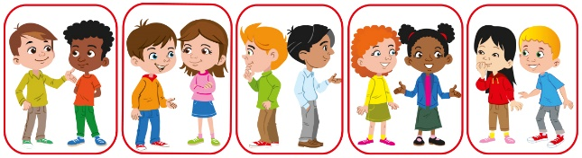  There are 10 children altogether.  There are 2 in each group.  There are 5 groups. |  | Represent a whole and work out how many equal groups.    There are 10 in total.  There are 5 in each group.  There are 2 groups. |  | Children may relate this to counting back in steps of 2, 5 or 10.  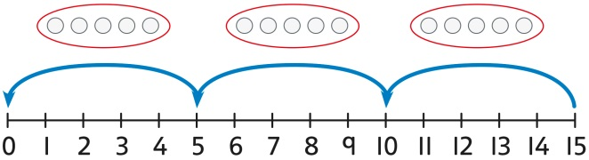
Sharing | Share a set of objects into equal parts and work out how many are in each part.  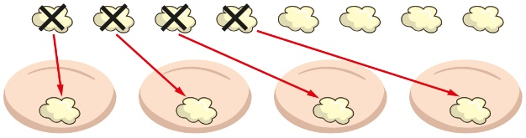 |  | Sketch or draw to represent sharing into equal parts. This may be related to fractions.  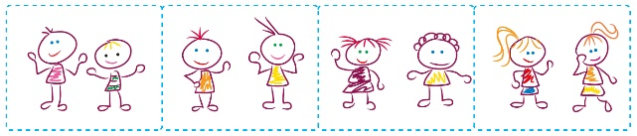 |  | 10 shared into 2 equal groups gives 5 in each group.

Year 2
 | Concrete | Pictorial | Abstract
Year 2
Addition
Understanding 10s and 1s | Group objects into 10s and 1s.  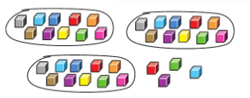  Bundle straws, pencils or pens to understand unitising of 10s.  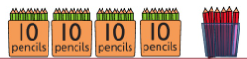 | Understand 10s and 1s equipment, and link with visual representations on ten frames.  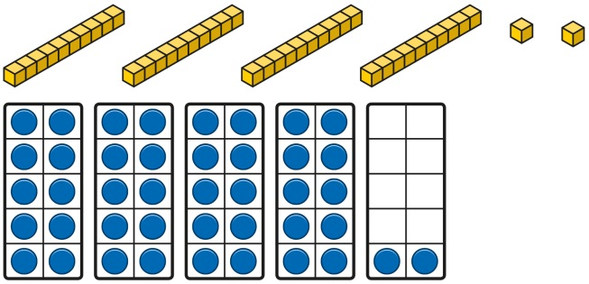  Represent numbers on a place value grid, using equipment or numerals.  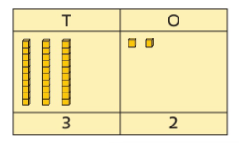 | Partition 2-digit numbers into 10s and 1s  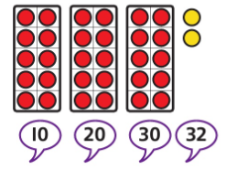  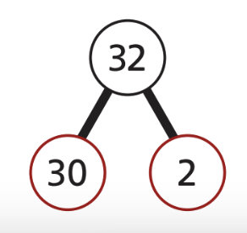  32 = 30 + 2
Learn bonds within 10 | Systematically build confidence and fluency in recall of number bonds within 10  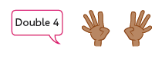  4 + 4 = 8. This is a double | Systematically build confidence and fluency in recall of number bonds within 10  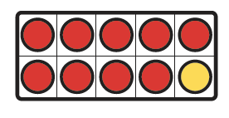  This is a bond to 10. 9 + 1 = 10 | Systematically build confidence and fluency in recall of number bonds within 10  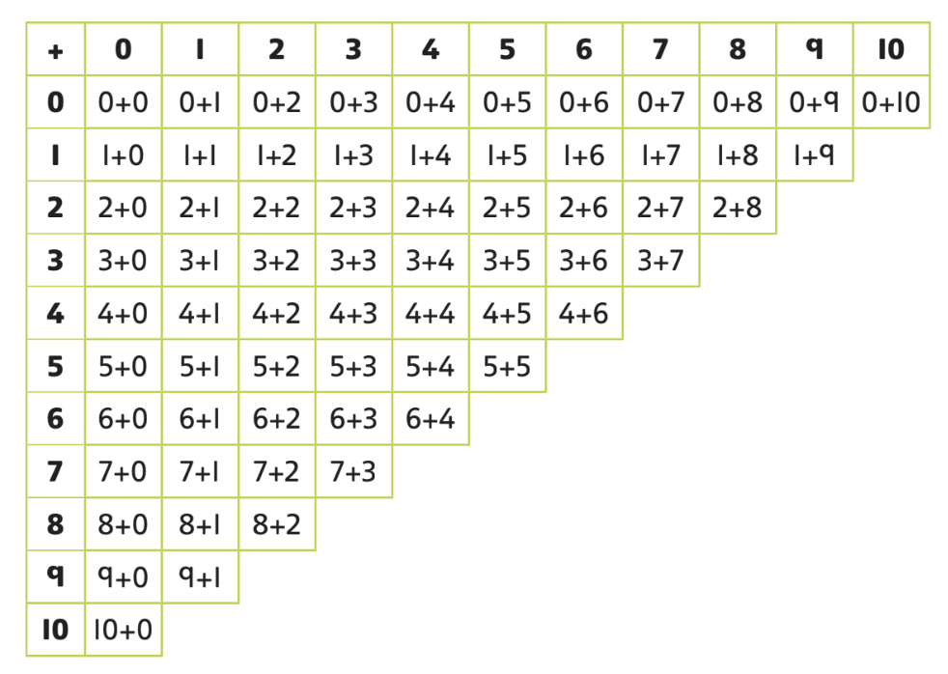
Adding the 1s | Children represent 10s and 1s with everyday items.  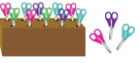 | Children represent calculations using ten frames to add a teen and 1s.  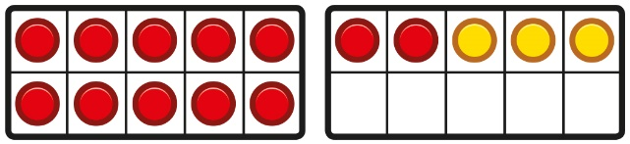  2 + 3 = 5  12 + 3 = 15 | Children recognise that a teen is made from a 10 and some 1s and use their knowledge of addition within 10 to work efficiently.  3 + 5 = 8  So, 13 + 5 = 18
Bridging 10 using number bonds | Children use counters to complete a ten frame and understand how they can add using knowledge of number bonds to 10.  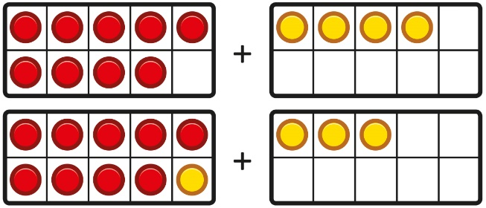  . | Use a part-whole model and a number line to support the calculation.  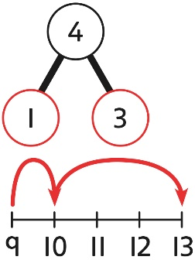  9 + 4 = 13 | Children use a bead string to complete a 10 and understand how this relates to the addition.  7 add 3 makes 10.  So, 7 add 5 is 10 and 2 more.
Add two multiples of 10 | Use known bonds and unitising to add 10s.  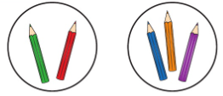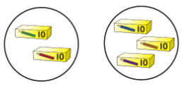  I know that 2 + 3 = 5.  So, I know that 2 tens add 3 tens is 5 tens. | Use known bonds and unitising to add 10s.  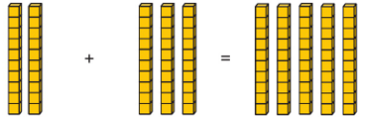  I know that 2 + 3 = 5  So, I know that 2 tens add 3 tens is 5 tens. | Use known bonds and unitising to add 10s.  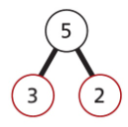  3 + 2 = 5  3 tens + 2 tens = 5 tens  30 + 20 = 50
Add a 2-digit number and 1s | Add the 1s to find the total. Use known bonds within 10.  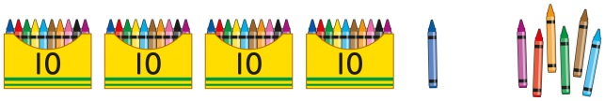  41 is 4 tens and 1 one.  41 add 6 ones is 4 tens and 7 ones. | Add the ones using known bonds  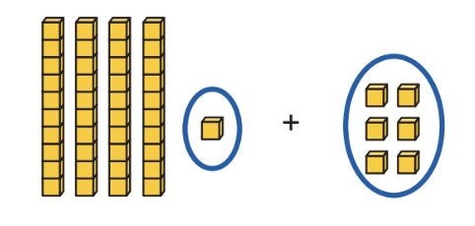  1 + 6 = 7  So  41 + 6 = 47 | Add the 1s.  Understand the link between counting on and using known number facts. Children should be encouraged to use known number bonds to improve efficiency and accuracy.  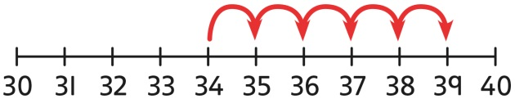  4 + 5 = 9  So  34 + 5 = 39
Add to the next 10 | Use known bonds to 10 to add to the next multiple of 10  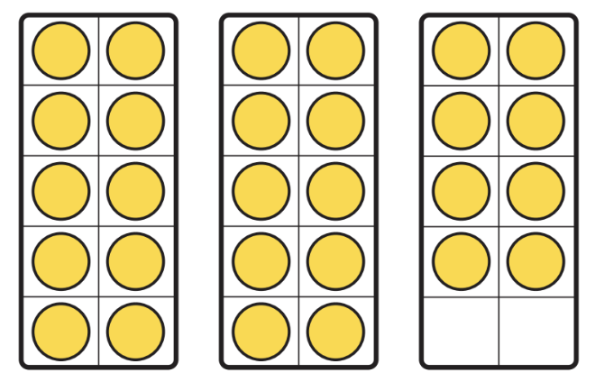  8 + 2 = 10  So  28 + 2 = 30 | Use known bonds to 10 to add to the next multiple of 10  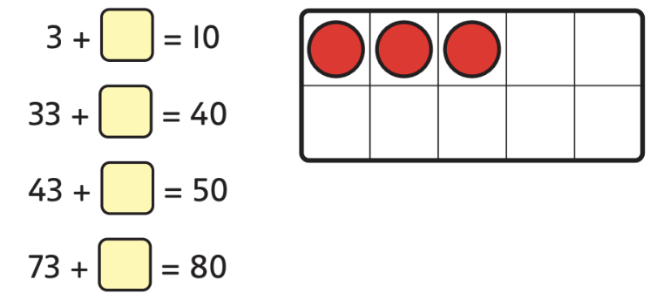 | Use known bonds to 10 to add to the next multiple of 10  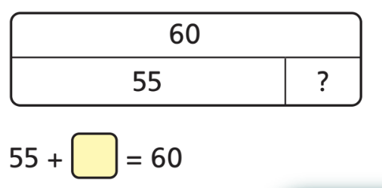  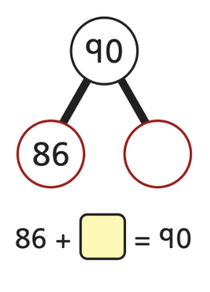
Add across a 10 | Use place value equipment to support adding across any multiple of 10  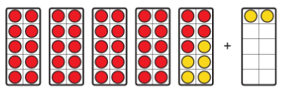  45 + 5 + 2 = 52  45 + 7 = 52 | Add across any multiple of 10 using two jumps  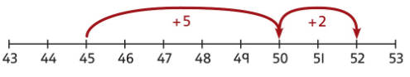  45 + 5 + 2 = 52  45 + 7 = 52 | Add across any multiple of 10 using two steps  45 + 5 + 2 = 52  45 + 7 = 52
Add 10s to a 2-digit number | Add the 10s using a place value grid to support, using classroom items to represent the numbers.  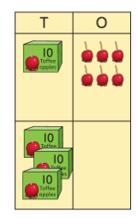  16 is 1 ten and 6 ones.  30 is 3 tens.  There are 4 tens and 6 ones in total. | Add the 10s using a place value grid to support.  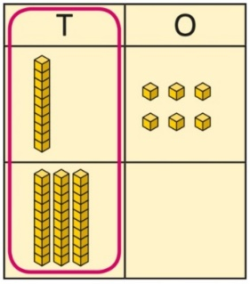  16 is 1 ten and 6 ones.  30 is 3 tens.  There are 4 tens and 6 ones in total. | Use known bonds and knowledge of place value to add multiples of 10  16 + 30 = ?  1 ten + 3 tens is 4 tens  There are 4 tens and 6 ones in total.  16 + 30 = 46  Count on in tens from a given number  ‘Start on 16’, ‘26’, ‘36’, ‘46’  16 + 30 = 46
Add more 10s then more 1s | Add on from a 2-digit number by adding tens then ones.  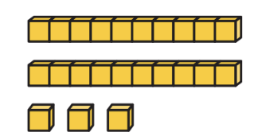+ +   Start on “23”, “33”, “35” | Add on from a 2-digit number by adding 10s then 1s.  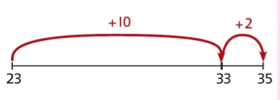  23 + 12 = 23 + 10 + 2 | Add on from a 2-digit number by adding tens then ones.  23 + 12 = 23 + 10 + 2
Add the 1s and 10s separately | Add the 10s and 1s separately.  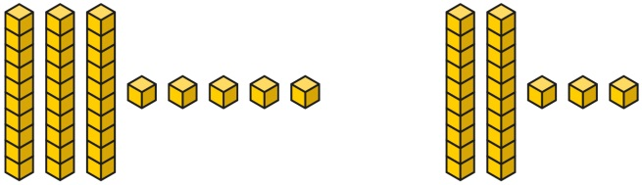  5 + 3 = 8  There are 8 ones in total.  3 + 2 = 5  There are 5 tens in total.  35 + 23 = 58 | Add the 1s and the 10s then recombine  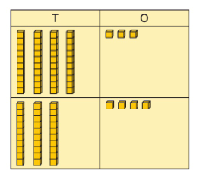  3 ones and 4 ones is 7 ones  4 tens and 3 tens is 7 tens  43 + 34 = 77 | Add the 10s and 1s separately.  32 + 11  30 + 10 = 40 2 + 1 = 3  32 + 11 = 43
Year 2
Subtraction
Subtract two multiples of 10 | Use known number bonds and unitising to subtract multiples of 10.  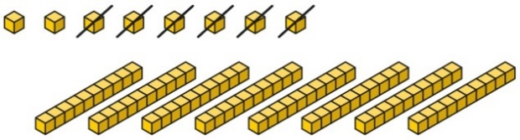  8 subtract 6 is 2.  So, 8 tens subtract 6 tens is 2 tens. | Use known number bonds and unitising to subtract multiples of 10.  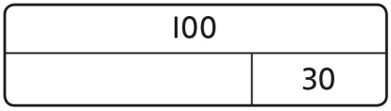  10 − 3 = 7  So, 10 tens subtract 3 tens is 7 tens. | Use known number bonds and unitising to subtract multiples of 10.  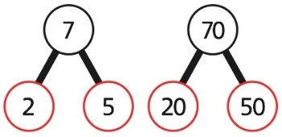  7 tens subtract 5 tens is 2 tens.  70 − 50 = 20
Subtraction within 20 | Subtraction within 20  Understand when and how to subtract 1s efficiently.  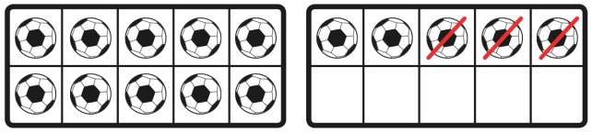  5 − 3 = 2  15 − 3 = 12 | Subtraction within 20  Understand how to use knowledge of bonds within 10 to subtract efficiently.  5 − 3 = 2  15 − 3 = 12 | Subtraction within 20  Understand when and how to subtract 1s efficiently.  Use a bead string to subtract 1s efficiently.  5 − 3 = 2  15 − 3 = 12
Subtracting 10s and 1s | Subtracting 10s and 1s  For example: 18 − 12  Use ten frames to represent the efficient method of subtracting 12.  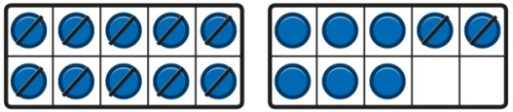  First subtract the 10, then subtract 2. | Subtracting 10s and 1s  Use a part-whole model to support the calculation.  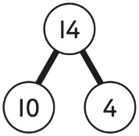  19 − 14  19 − 10 = 9  9 − 4 = 5  So, 19 − 14 = 5 | Subtracting 10s and 1s  For example: 18 − 12  First subtract the 10, then take away 2.
Subtraction bridging 10 using number bonds  . | Subtraction bridging 10 using number bonds  Represent the use of bonds using ten frames.  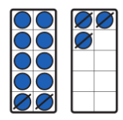  For 13 – 5, I take away 3 to make 10, then take away 2 to make 8. | Subtraction bridging 10 using number bonds  Use a number line and a part-whole model to support the method.  13 − 5  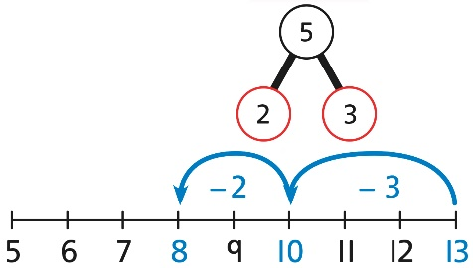 | Subtraction bridging 10 using number bonds  For example: 12 − 7  Arrange objects into a 10 and some 1s, then decide on how to split the 7 into parts.  7 is 2 and 5, so I take away the 2 and  then the 5.
Subtracting a single-digit number | Subtract the 1s. This may be done in or out of a place value grid using classroom items to represent the numbers.  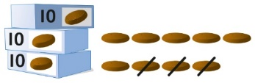  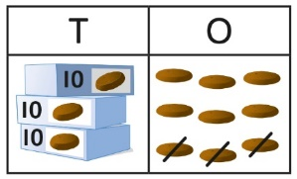  “9 ones subtract 3 ones is 6 ones”  39 – 3 = 36 | Subtract the 1s. This may be done in or out of a place value grid.  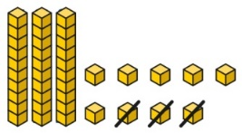  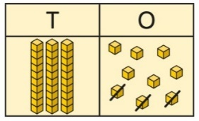  “9 ones subtract 3 ones is 6 ones”  39 – 3 = 36 | Subtract the 1s. Understand the link between counting back and subtracting the 1s using known bonds.  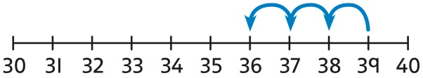  9 − 3 = 6  39 − 3 = 36
Subtracting a single-digit number bridging 10 | Bridge 10 by using known bonds.  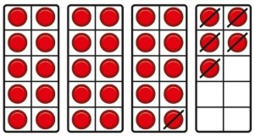  35 − 6  I took away 5 counters, then 1 more. | Bridge 10 by using known bonds.  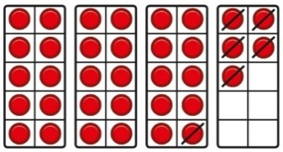  35 − 6  First, I will subtract 5, then 1. | Bridge 10 by using known bonds.  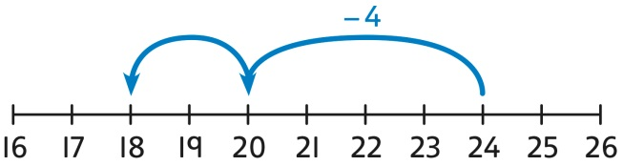  24 − 6 = ?  24 − 4 − 2 = ?
Subtract tens from a 2-digit number |  | Subtract tens using known bonds  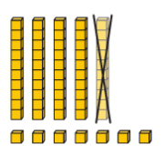  57 – 10 = 47 | Subtract tens using known bonds  43 – 10 = 33
Subtract ones from a 2-digit number | Subtract the 1s. This may be done in or out of a place value grid.  9 ones subtract 3 ones is 6 ones.  39 – 3 = 36 | Subtract the 1s. This may be done in or out of a place value grid.  9 ones subtract 3 ones is 6 ones.  39 – 3 = 36 | Subtract the 1s. Understand the link between counting back and subtracting the 1s using known bonds.  9 − 3 = 6  39 − 3 = 36
Subtract tens and ones from a 2-digit number | Subtract 10s then 1s using place value equipment.  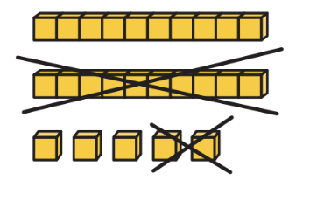  25 – 10 – 2 = 13  25 – 12 = 13 | Subtract 10s then 1s with a number line for visual support.  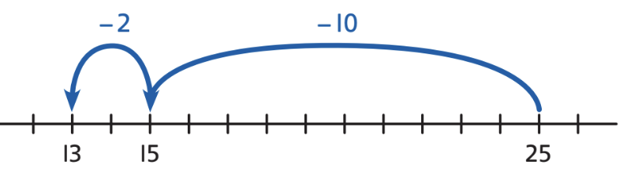  25 – 10 – 2 = 13  25 – 12 = 13 | Subtract 10s then 1s.  25 – 10 – 2 = 13  25 – 12 = 13
Subtract ones from a multiple of 10 (preparation for bridging) | Subtract from a 10 using known bonds to 10 using place value equipment.  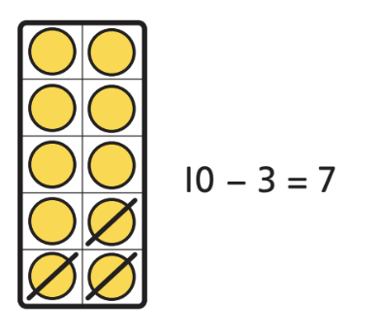  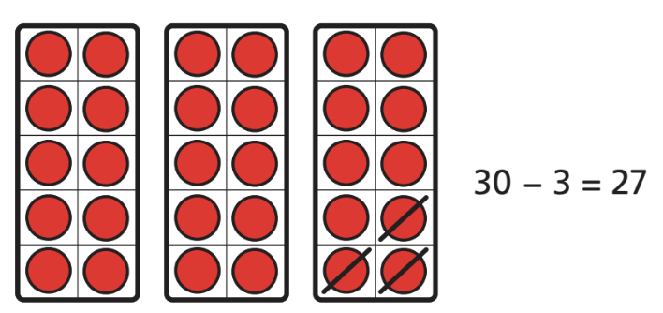  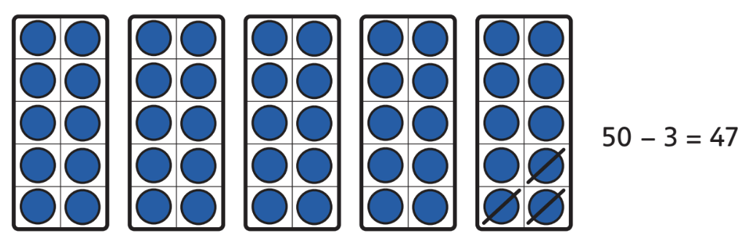 | Subtract from a 10 using known bonds to 10.  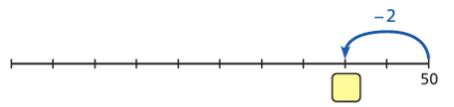  50 – 2 = 48 | Subtract from a 10 using known bonds to 10.  10 – 3 = 7  30 – 3 = 27  60 – 3 = 57  90 – 3 = 87
Subtract bridging a ten | Subtract in two steps, across a 10 with place value equipment.  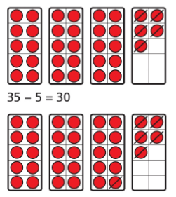 | Subtract in two steps, across a 10 with a number line for visual support.  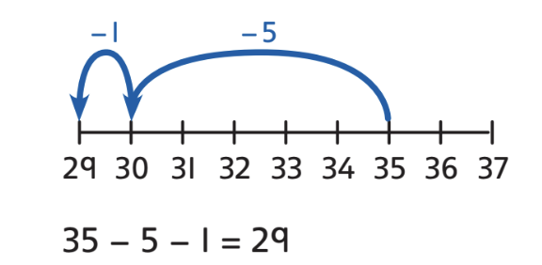 | Subtract in two steps, across a 10.  41 – 6 = 41 – 1 – 5  41 – 6 = 35
Year 2
Multiplication
Equal groups and repeated addition | Recognise equal groups and write as repeated addition and as multiplication.  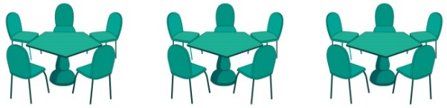  3 groups of 5 chairs  15 chairs altogether | Recognise equal groups using standard objects such as counters and write as repeated addition and multiplication.    3 groups of 5  15 in total | Use a number line and write as repeated addition and as multiplication.  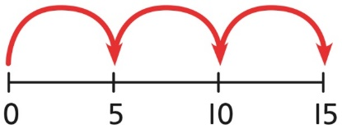  5 + 5 + 5 = 15  3 × 5 = 15
Using arrays to represent multiplication and support understanding | Understand the relationship between arrays, multiplication and repeated addition.  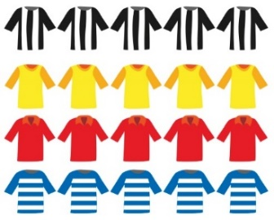  4 groups of 5 | Understand the relationship between arrays, multiplication and repeated addition.  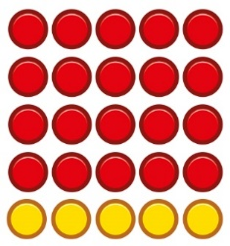  4 groups of 5 … 5 groups of 5 | Understand the relationship between arrays, multiplication and repeated addition.  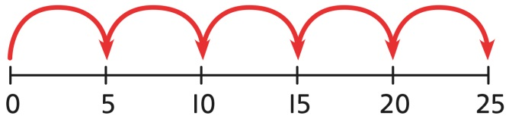  5 × 5 = 25
Understanding commutativity | Use arrays to visualise commutativity.  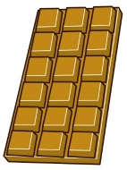  I can see 6 groups of 3.  I can see 3 groups of 6. | Form arrays using counters to visualise commutativity. Rotate the array to show that orientation does not change the multiplication.  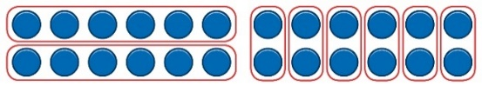  This is 2 groups of 6 and also 6 groups of 2. | Use arrays to visualise commutativity.  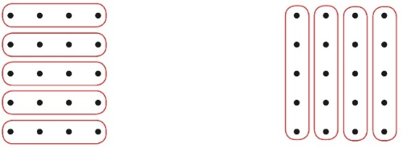  4 + 4 + 4 + 4 + 4 = 20  5 + 5 + 5 + 5 = 20  4 × 5 = 20 and 5 × 4 = 20
Learning ×2, ×5 and ×10 table facts | Develop an understanding of how to unitise groups of 2, 5 and 10 and learn corresponding times-table facts.  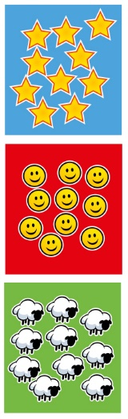  3 groups of 10 … 10, 20, 30  3 × 10 = 30 | Understand how to relate counting in unitised groups and repeated addition with knowing key times-table facts.  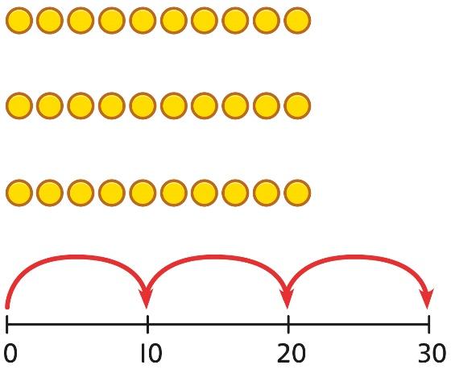  10 + 10 + 10 = 30  3 × 10 = 30 | Understand how the times-tables increase and contain patterns.  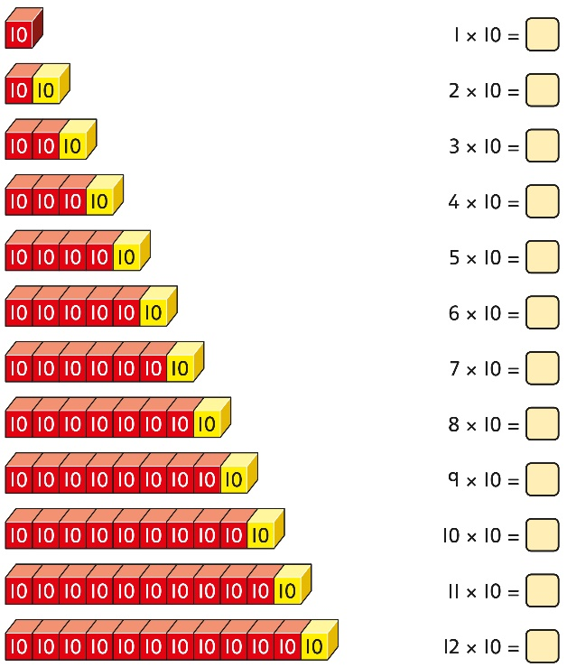  5 × 10 = 50  6 × 10 = 60
Year 2
Division
Sharing equally | Start with a whole and share into equal parts, one at a time.  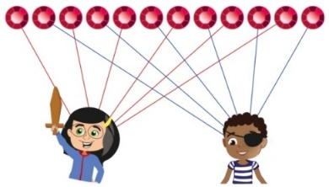  12 shared equally between 2.  They get 6 each.  Start to understand how this also relates to grouping. To share equally between 3 people, take a group of 3 and give 1 to each person. Keep going until all the objects have been shared  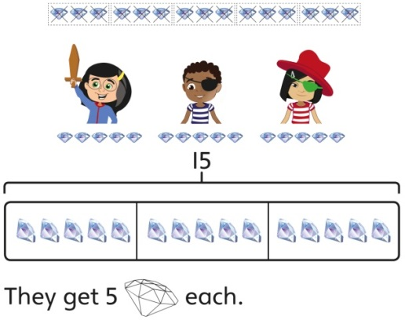  15 shared equally between 3.  They get 5 each. | Represent the objects shared into equal parts using a bar model.  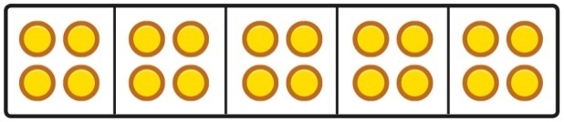  20 shared into 5 equal parts.  There are 4 in each part. | Use a bar model to support understanding of the division.  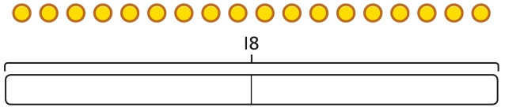  18 ÷ 2 = 9
Grouping equally | Understand how to make equal groups from a whole.  8 divided into 4 equal groups.  There are 2 in each group. | Understand the relationship between grouping and the division statements.  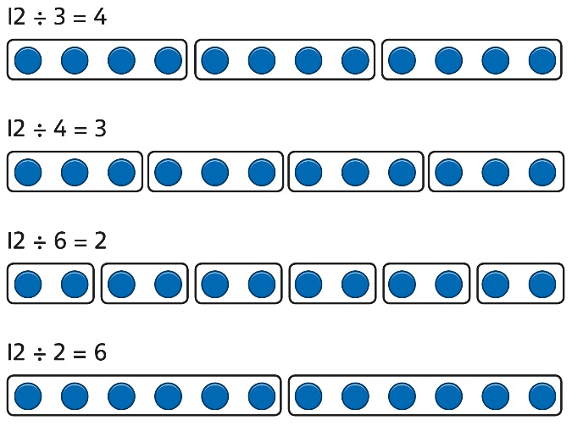 | Understand how to relate division by grouping to repeated subtraction.  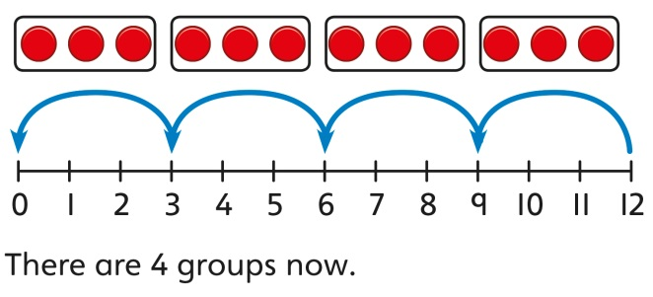  12 divided into groups of 3.  12 ÷ 3 = 4  There are 4 groups.
Using known times-tables to solve divisions | Understand the relationship between multiplication facts and division.  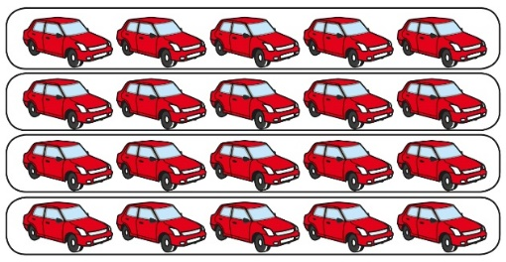  4 groups of 5 cars is 20 cars in total.  20 divided by 4 is 5. | Link equal grouping with repeated subtraction and known times-table facts to support division.  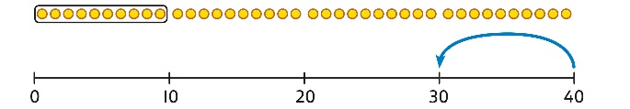  40 divided by 4 is 10.  Use a bar model to support understanding of the link between times-table knowledge and division.  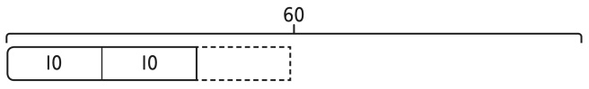 | Relate times-table knowledge directly to division.  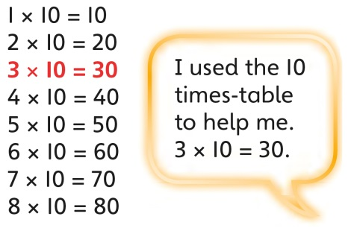  I know that 3 groups of 10 makes 30, so I know that 30 divided by 10 is 3.  3 × 10 = 30 so 30 ÷ 10 = 3

