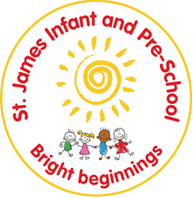
St James Infant and Pre-School
Oracy Policy

‘Be the best we can be’
Non statutory
2 yearly review
Date policy adopted | September 2023
Review date
Reviewer’s name
Date minuted
Next review due by | 2025

Mission Statement:
Children always come first, so that they can be the best that they can be.

1. Aim of Policy:
At St James Infant School, Oracy plays a key role in teaching and learning. We aim for all children to develop the confidence and skills to talk and listen effectively and we support this by valuing different views and engaging in meaningful conversations.
This policy aims to:
- Promote all forms of communication.
- Use all available opportunities to encourage children to interact and learn through talk.
- Embed oracy across the curriculum and use it to unlock new learning and challenge thinking.

2. Teaching and Learning:

The National Curriculum for English reflects the importance of spoken language in pupils’ development. Oracy is embedded throughout our curriculum. Questions are carefully planned to ensure that all children can participate and there is a shared understanding that everyone’s opinion should be valued.

Some of the activities we use to develop spoken language are:
- Adults clearly and correctly pronouncing words to model accurate language
- Getting down to the child’s level to model active talking and listening
- Echoing correct language back
- Allowing thinking time for children to formulate answers
- Talk partners
- Using Fantastics, Boomtastics and Grammaristics
- Engaging in discussions
- Stem sentences
- Asking children to explain – eg prove it, how do you know?
- Story times – discussing stories together
- Common words and signs used across the school
- Use of talking tins and sound buttons

3. The Oracy Framework:

At St James Infant School we take into account the oracy framework which was developed by the University of Cambridge and Voice 21. This framework breaks oracy into four strands and allows everyone to understand what makes good spoken communication.
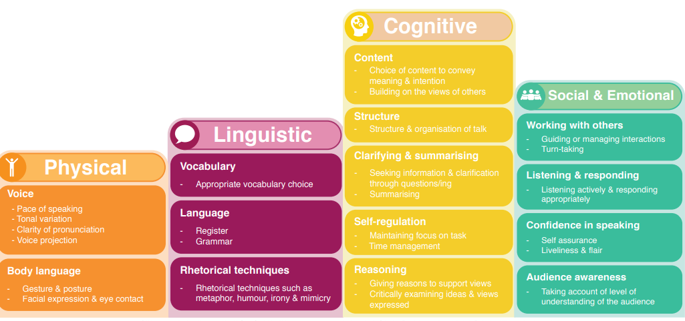

4. Oracy across the curriculum
Oracy is incorporated across our broad and balanced curriculum to develop understanding and higher order thinking. Oracy supports pupils to make their thinking clear to themselves as well as others. Oracy is carefully planned into lessons. Questions are differentiated to ensure full participation and pupil discussions are scaffolded to ensure inclusive practice. We also use the following strategies to support oracy across the curriculum:
- Vocabulary progression documents across the foundation subjects.
- Focus on key vocabulary in each lesson
- Widgits are used to support vocabulary acquisition
- Talk partners
- Adult modelling – my turn, your turn
- Vocabulary displayed in class
- Retrieval at the beginning of lessons

5. Oracy in English
As a school, we are committed to raising and maintaining high standards of Literacy. In addition to the points in Oracy across the curriculum, we use the following strategies to support our pupils to enable them to develop their skills.
- Word of the day
- Vocabmeter – easy, just right, challenging
- Grandma and Grandad Fantastic
- Fantastics lenses
- Phonics – the same language is used across all groups
- Weekly plans detail the key vocabulary
- Stem sentences
- Widgits
- Colourful semantics

6. Oracy in Maths
Oracy is incorporated in Maths lessons to increase mathematical vocabulary, support children in proving or justifying their answer and to address misconceptions. Oracy has a particularly important role in reasoning sessions which have a focus on children verbally communicating their thinking.
We use the following strategies to support oracy in maths:
- Stem sentences
- Adult modelling – I say, we say, you say
- Widgits
- Introduce vocabulary in the first lesson
- How do you know?
- Prove it

7. Oracy in Science
Oracy is incorporated into Science lessons to increase understanding of the concepts being introduced. The following strategies are used:
- 3 key vocabulary words per lesson
- Widgits to support vocabulary acquisition
- Making predictions
- Evaluations
- Testing and discussing their findings
- Asking and answering questions
- Retrieval

8. Learning environment:
Each classroom has working walls which contribute to promoting subject specific vocabulary development, these working walls are referred to by adults during teaching sessions. Widgits are used to support children’s understanding and language development.
In the Early Years classrooms, suggested sentences stems, to promote oracy, are placed in each area of the classroom and outside area.

9. Inclusion
All children are encouraged to take a full and active part in spoken language activities. Children with additional needs will work at a level appropriate to their needs. Some pupils will work with a speech and language therapist, and we welcome the expertise they bring in to school.
When initial concerns are raised, Talking Success is used to assess children across all areas of Speech and Langauge. Interventions are planned following this assessment.

