Pre-School Yearly Overview
(see curriculum progression documents for more detail)
Big Questions
Autumn term: | Spring Term: | Summer Term:
What if things Change? | Is it moving? | Will it grow?
Key Learning
Prime areas
Personal Social and emotional development:  Explore emotions  Share and take turns  Hygiene needs | Personal Social and emotional development:  Express feelings using words- happy, sad, angry  Independently manage basic hygiene needs  Awareness of rules and expectations | Personal Social and emotional development:  Talk about own feelings and those of others.  Follow rules and expectations  Resolve conflicts with others.
Communication and Language:  Naming objects  Linking words to form simple sentences  Using talk to help organise in play  Begin to develop listening skills- listen to stories, rhymes- sometimes joining in.  Respond and give attention when addressed.  Know how to answer questions | Communication and Language:  Know and use new vocabulary e.g. story language.  Develop sentences.  Use own opinions  Listen and join in with repeated parts of stories  Follow two-part instructions | Communication and Language:  Explain, describe, recount, retell.  Using sentences of six or more words.  Asking questions  Linking sentences with e.g. ‘but’  Know how to start and continue a conversation- listening attentively. Take turns to speak.  Understanding and respond to why questions.  Understand and respond to instructions with:  *2 key words- Put on your hat  *3 key words- Can you wash dolly’s face?
Physical Development:  Running, jumping hopping  Pouring and exploring tools  Show dominant hand | Physical Development:  Matching movements to activities e.g. crawl through a tunnel  Use of one-handed tools and equipment.  Manage coats- zips and buttons. | Physical Development:  Develop balance  Use a comfortable grip with good control when using pencils
Specific Areas
Literacy - Writing
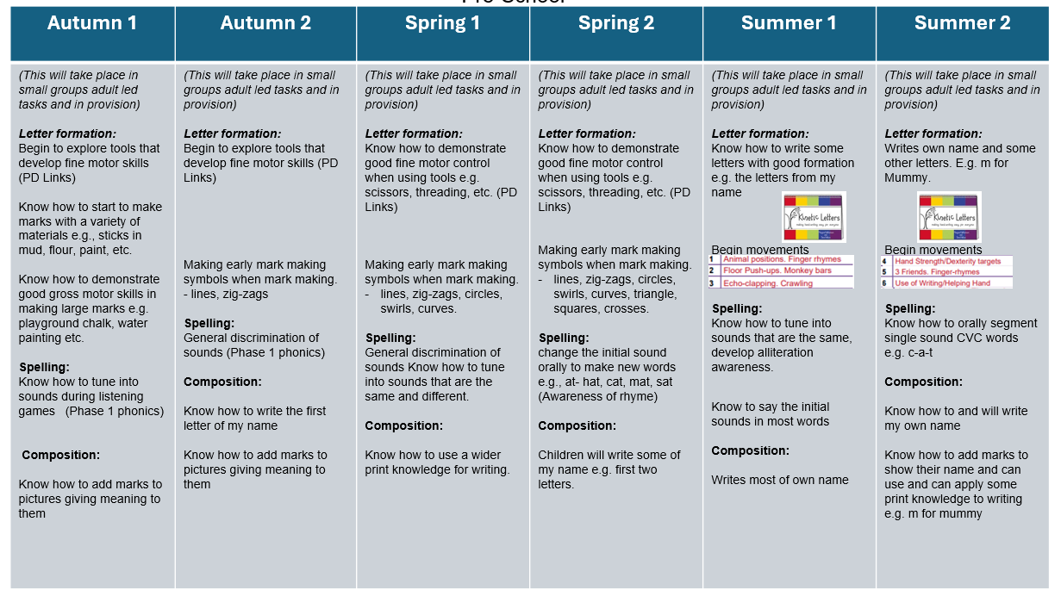
Literacy- Reading
Develop an understanding of letters and print e.g. page sequencing, book parts, etc.  Learn how to and is starting to notice rhyme and can clap syllables  Start to develop play around my favourite stories and props repeating words and phrases a familiar book  Begin to join in with familiar stories, rhymes and songs.  General sound discrimination environmental sounds | How to spot words with the same initial sound  Sequence events from stories that have been heard.  Use key vocabulary and start to use different vocabulary from books in my play.  General sound discrimination – body percussion  Rhythm and rhyme | Use good phonological awareness including oral blending skills, rhyme, alliteration and syllables.  Talk about stories that have been heard  Retell some familiar stories  Join in with familiar rhymes and songs (and some patterned stories).  Uses some story language or new vocabulary in my play.  Alliteration  Oral blending and segmenting  Beginning Read write Inc programme
Maths:  Changes in amounts 1-2  Subitising 1 and 2  Count to 5  Beginning to explore:  Size  Length  Weight  capacity | Maths:  ABAB Patterns  1:1 correspondence to 5  Finger numbers to 5  Subitising to 3  Exploring more and less comparisons of number.  Spotting errors in ABAB Patterns  2D shapes naming, exploring properties.  Using Shape in ABAB Patterns  Exploring Time (link to our day- e.g lunchtime, bedtime etc)  Recognising 1-3 | Maths:  2D shape  Naming and describing 2D shape.  3D shape – naming  Creating own ABAB Pattern  Ordering times of day.  Using First, then, next.  Number 4  Number 5  Comparing amounts and recognising when amounts are the same.  Subitising with numicon to 5.  Recognising number 1-5.  Exploring size, weight, length, capacity- developing language
Understanding the World:  Talking about own self and immediate family.  Exploring occupations.  Noticing difference between people  Exploring materials.  Developing language using our senses. | Understanding the World:  Talk about changes in own self – timeline of own lives.  Exploring how things work.  Name other countries in work  Develop awareness with positivity of the difference between people.  Show care and concern for plants and living things. | Understanding the World:  Talk about own family history (parents, grandparents).  Talk about the differences I have seen in people, countries and communities.  Talk about the key features of life cycles using key vocabulary. (ducks/ chicks experience)  Talk about the world around us observing animals and plants.
Expressive Arts and Design:  Exploring tools for large- and small-scale drawing and painting.  Explore colour shape and line.  Explore using different materials for creating art.  Music  Enjoy joining in with songs and rhymes and remember and sing some songs.  Begin to make rhythmic sounds.  Explore the sounds instruments make. | Expressive Arts and Design:  Know how to self-select to create using own ideas.  Explore colour shape and line.  Music  Play some musical instruments with greater control (percussion).  Follow some pitch, melody and tone. | Expressive Arts and Design:  Use a range of art materials and explore joining.  Explore colour mixing purposefully and freely  Draw with increasing complexity and details.  Show different emotions in their drawings and paintings.  Music  Know how to sing, respond and create music showing an understanding of pitch, melody and tone. (withers music scheme).

