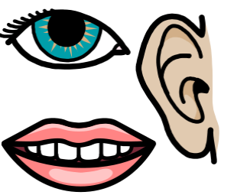 PERSONAL, SOCIAL AND EMOTIONAL DEVELOPMENT

Current learning;
Exploring emotions
Sharing and taking turns
Beginning to develop an awareness of our hygiene needs

Key vocabulary;
Happy, sad, share, turn, hand washing, toilet, clean, germs, feelings and friends.
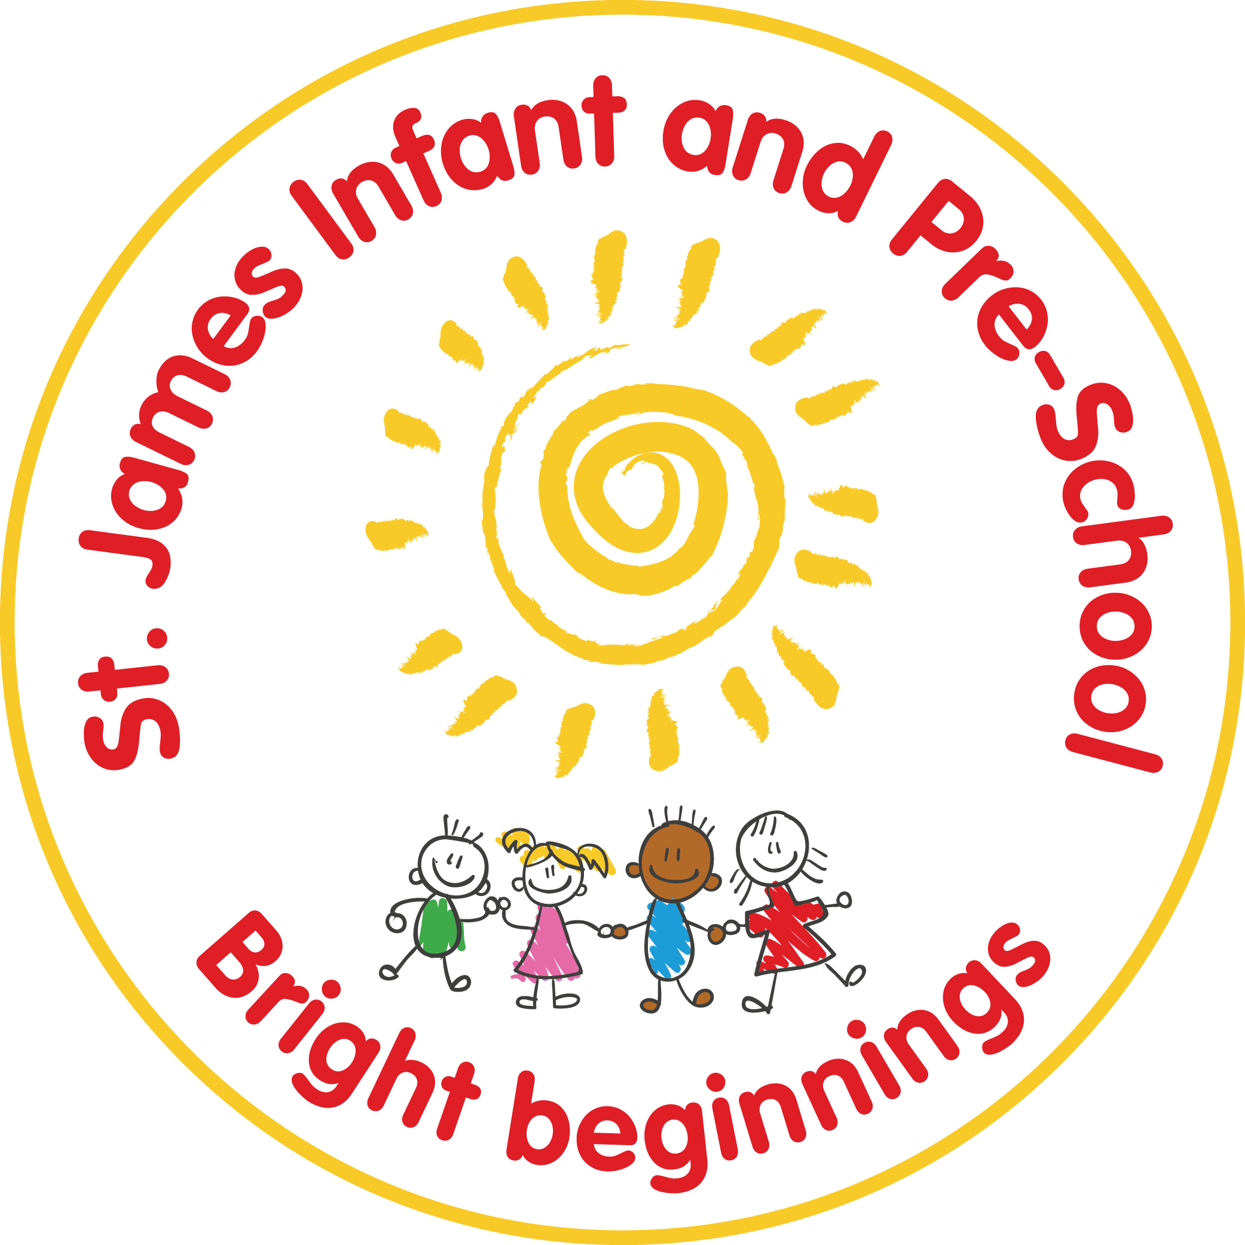
Knowledge Organiser – Pre-School – Autumn term
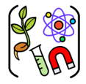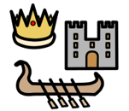
UNDERSTANDING THE WORLD
Current learning; Talking about own self and immediate family.
Exploring occupations.
Noticing difference between people
Exploring materials.
Developing language using our senses.
Begin to explore celebrations: Harvest
Bonfire Night / Diwali
Christmas Hanukkah
Key vocabulary;
Family, jobs, Material- plastic, wool, sand, stick, stone, metal, paper, card, feathers.
Changing, Bending, stretching, twisting, squishing. See, touch, smell, taste, hear (FANTASTICS)Autumn and Winter.
Celebrations.

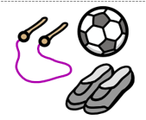PHYSICAL DEVELOPMENT

Current learning;
Exploring ways of moving
Pouring and exploring tools
Show dominant hand
Key vocabulary;
Pouring, filling, emptying, running, walking, jumping, hopping
Holding, Crawling, running, bending, dancing, pushing
Pressing, pinching, mixing, pouring, drawing, painting

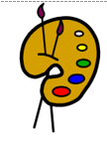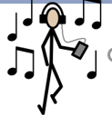
EXPRESSIVE ARTS AND DESIGN
Current learning;
Exploring tools for large- and small-scale drawing and painting.
Explore colour shape and line.
Explore using different materials for creating art.
Music
Enjoy joining in with songs and rhymes and remember and sing some songs.
Begin to make rhythmic sounds.
Explore the sounds instruments make
Key vocabulary; Marks, lines, circle, press, roll, print, colour, wet, dry, paint, brush, stamp, cut, glue, stick, song, sing, beat, instrument.
.

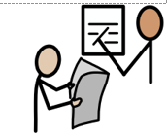LITERACY - WRITING

Current learning;
Letter formation:
Begin to explore tools that develop fine motor skills (PD Links)
Know how to start to make marks with a variety of materials e.g., sticks in mud, flour, paint, etc.
Know how to demonstrate good gross motor skills in making large marks e.g. playground chalk, water painting etc.
Spelling:
Know how to tune into sounds during listening games (Phase 1 phonics)
Composition:
Know how to add marks to pictures giving meaning to them

COMMUNICATION AND LANGUAGE

Current learning;
Linking words to form simple sentences.
Using talk to help organise in play
Begin to develop listening skills- listen to stories, rhymes- sometimes joining in.
Respond and give attention when addressed.
Know how to answer questions.

LITERACY –READING

Current learning;
Develop an understanding of letters and print e.g. page sequencing, book parts, etc.
Learn how to and is starting to notice rhyme and can clap syllables
Start to develop play around my favourite stories and props repeating words and phrases a familiar book
Begin to join in with familiar stories, rhymes and songs.
General sound discrimination environmental sounds

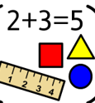MATHS

Current learning;
Changes in amounts 1-2
Subitising 1 and 2
Count to 5
Beginning to explore:
Size
Length
Weight
capacity
Key vocabulary; Count, Amount, Bigger, longer, shorter, taller, Small, big- size, Length, Height,

