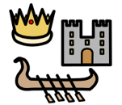HISTORY
Current learning: We will be making timelines of our own lives, looking at the history of television black and white to colour and the invention of braille, knowing why Louis Braille is important.
Key vocabulary: past, before now, long ago, today, invention, Louis Braille.
Knowledge Organiser – Reception – Summer term
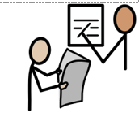ENGLISH- WRITING
Current learning: Key texts this term are: The greedy rainbow, Christina Rosetti – colour poem, Into the forest, planting a rainbow and journey. We will be digging deep into these texts and creating pieces of writing which will include labels, captions and sentences. We will also be remembering all the features of a successful sentence.

Key vocabulary:
Character, setting, finger space, capital letter, full stop, kinetic letters, Fred fingers, words in order
COMPUTING
Current learning: During internet safety sessions this term we will be looking at how people can be unkind online and how this makes us feel, how to find information online and identifying devices we can use to access information online.
We will also be working together to solve problems, sequencing instructions and some logical reasoning activities.
Key vocabulary: device, online, internet, sequence, instruction, positional language.
DESIGN TECHNOLOGY
Current learning: In Design technology we will be planning, making, eating and evaluating a fruit salad and a vegetable kebab. We will also be investigating if colourful food is better.
Key vocabulary: recipe, ingredients, evaluate, appearance, aroma, colour, taste, texture.

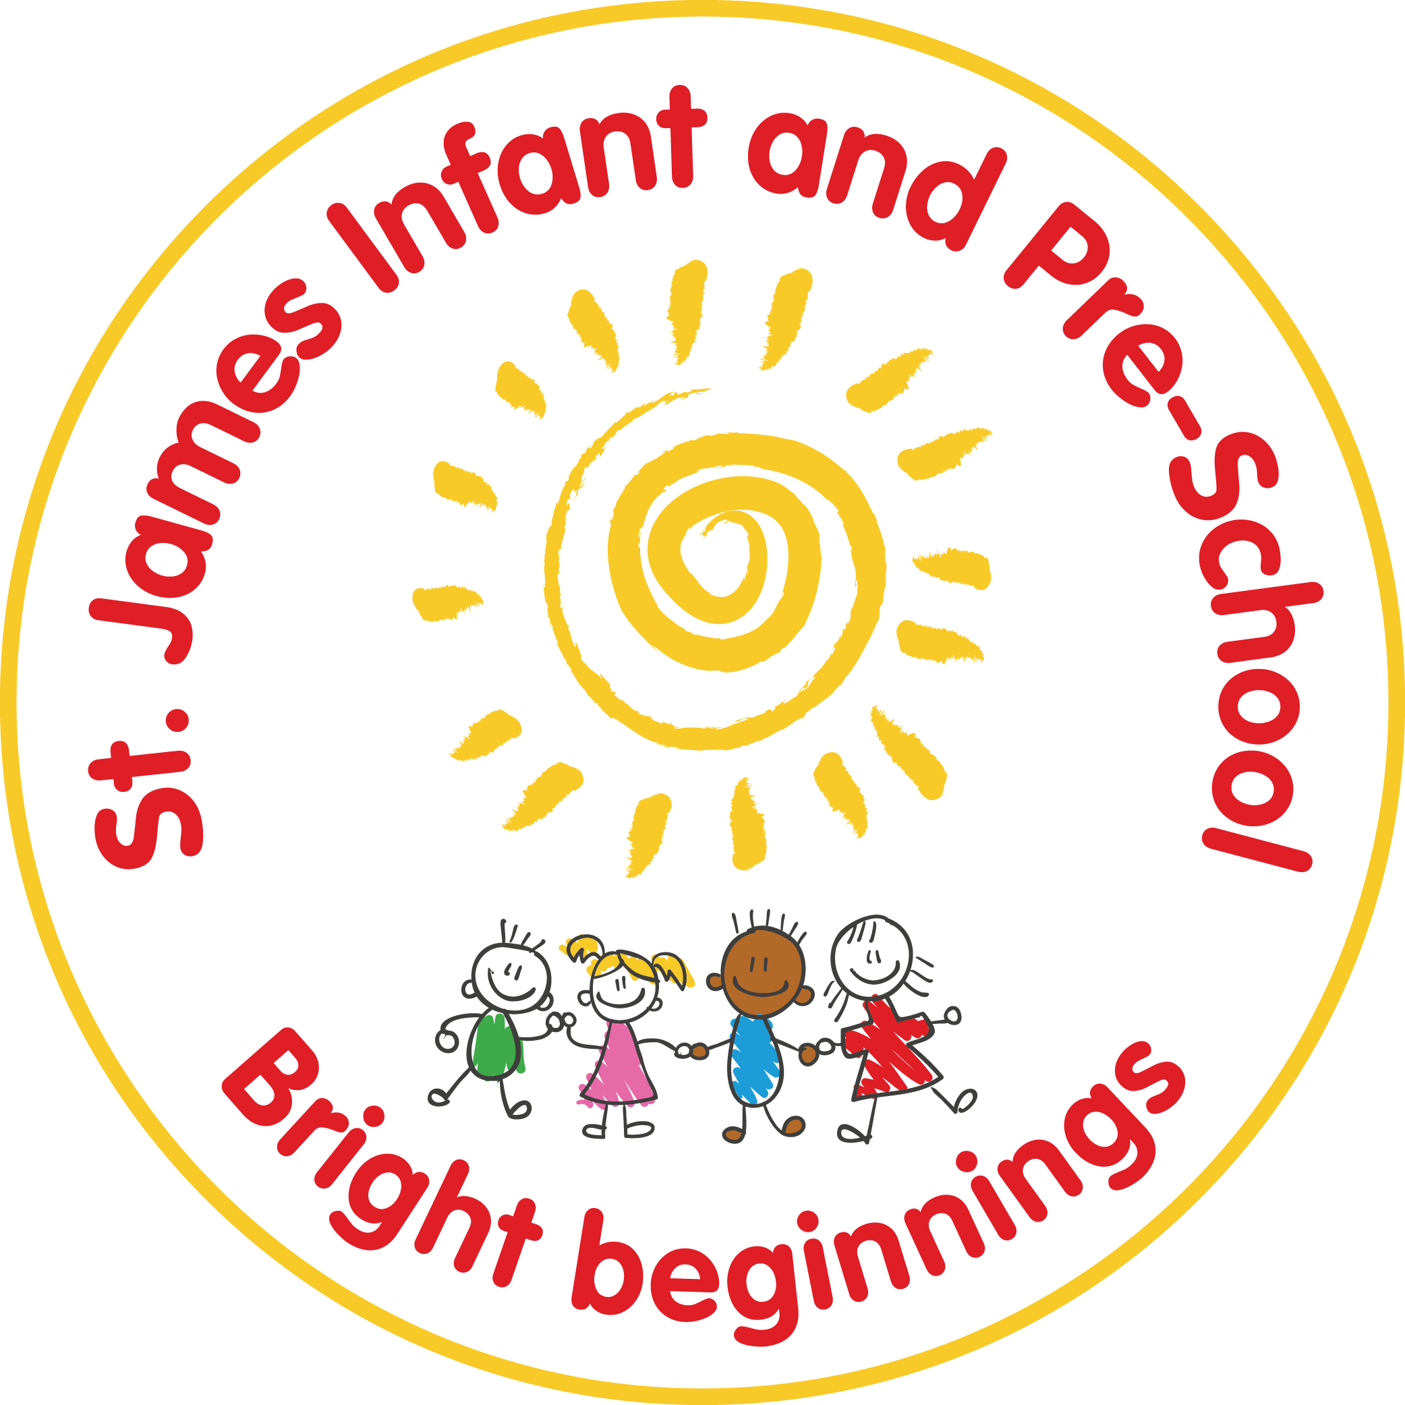

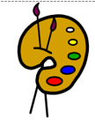ART
Current learning: We will be looking at colours of Spring and colour mixing, collages and creating work in the style of Matisse and Picasso.
Key vocabulary: light, dark, collage, material, artist, spiral, bold, self portrait.

GEOGRAPHY
Current learning: We will be learning about life in different countries, what is the same and what is different.
Key vocabulary: countries, similarities, differences, earth, desert, snow, mountain, beach.

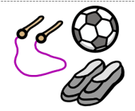PE
Current learning: This term Mr Nixon will be teaching the children athletics and games.
Key vocabulary: balance, climb, pass, rolling, teamwork, safety, speed.

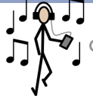MUSIC
Current learning: We will continue our use of our music scheme Withers music exploring animals and rhythm, superheroes and cartoons.
vocabulary: beat, rhythm, melody, pitch, improvise, pulse

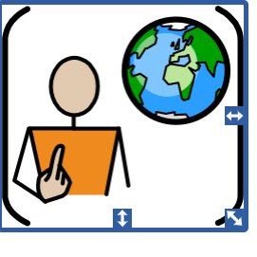PSHE
Current learning: Throughout this topic we will be exploring our No Outsiders books and relationships. We will begin our protective behaviour curriculum, details will follow.
Key vocabulary: family, relationships, inclusion, kindness.
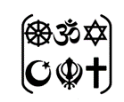RE
Current learning: This term our main focus will be stories from the Bible including, The Lost Coin, David and Goliath, Bilal and the beautiful butterfly and Noah’s Ark and looking at people who help us in the community
Key vocabulary: Bible, Jesus, God

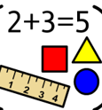MATHS
Current learning: The children will be counting large numbers, exploring the composition numbers and knowing doubles, odds and even and number bond facts.
Key vocabulary: number, counting, ordinality, cardinality, subitising, comparison, composition, doubles, odd and even.

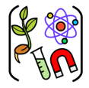SCIENCE
Current learning: We will be learning about plants, where they grow, how they grow and what they need, exploring the life cycles of a butterfly and learning about Summer.
Key vocabulary: flower, plant, tree, sunlight, water, leaves, vegetable, fruit, life cycle, change, grow.

ENGLISH –READING
Current learning: In reading we will continue to explore a variety of different texts, including poems and non-fiction texts. The children will be learning new special friends and reading them in words.
Key vocabulary: fiction, non – fiction, poems, phonics, special friends, Fred talk.

