

St James Infant & Pre-School
Attendance Policy
Statutory / Non-statutory
Date policy adopted | November ‘18
Review date | Nov ‘18 | Nov ‘19 | Nov ‘20 | Oct’23 | Oct ‘24 | Oct ‘25
Reviewer’s name | CC | CC | CC | CC | CC | CC
Date minuted by committee meeting | 01.19
Next review due by | Nov ‘19 | Autumn 2 | Oct 22 | Oct 24 | Autumn 1 ‘25
Annual review / 2 yearly review

St James Infant School
Attendance Policy

Aims of Policy
- To emphasise the importance of high levels of attendance at school
- To make clear to everyone the school’s expectations about attendance
- To clarify the legal position and expectations relating to attendance
- To stress the need for home and school to work in close partnership to achieve high attendance
.
For children to achieve their potential they need to have excellent attendance. Therefore, this is a very important issue to all stakeholders at St James Infant and Preschool. Children must be in education between the school term after their 5th birthday and the last Friday in June in the school year they turn 16. (Gov.uk 2021)
“School expectation is 96% attendance.”
It is the statutory duty of every parent / carer to ensure that their child attends school regularly and on time. (Section 444(1) Education Act 1996).
Procedures for recording attendance
The office staff (Administration Assistant and Administration Officer) are responsible for an accurate record of attendance being taken in the class register. The registers open at 8.55am and close at 9.10am. Any children entering school after the registers have closed, are entered in the late register with a reason recorded by the office staff. The children are then escorted to their classrooms. Any absences are recorded by the office staff after receiving confirmation of the reason for the absence.
If children are absent but there is no confirmation by the parent / carer, the Wellbeing Team or office staff will contact the parent / carer to ensure the safety of the child. Codes are entered in the class registers to explain the absence (see attached list). The Department for Education has issued guidelines to all schools detailing valid reasons for authorised or justified absences and activities that would classify as unauthorised.

Procedures for promoting regular attendance
A range of rewards are used to promote good attendance, both at individual and class level. All staff are clear about their role in promoting attendance. Parent / carer and children are encouraged to understand the importance of attendance and punctuality for successful learning. Attendance is regularly addressed through newsletters, messages on Class Dojo, parent’ evenings, assemblies and work in class. Attendances and absences are also included in a pupil’s annual school report. The office staff, Attendance Officer, Pupil Support Worker and the Headteacher will regularly monitor and challenge reasons for non-attendance, including patterns of absence. Monitoring of attendance has to be reported to the LAC each half term.

Dealing with absence
The office staff will investigate any unconfirmed absence, in the first instance. If absence continues or is not authorised, the Attendance Officer / Headteacher will become involved. Where the parent / carer cannot be contacted by telephone, a letter will be written or a message will be sent on Dojo. Any absence considered not to be a justified reason will remain unauthorised. In extreme circumstances, the Attendance Officer / Headteacher may require medical evidence to validate a reason provided by the parent. If a child’s attendance is consistently below 90% their parents may be invited to attend an attendance meeting, with the aim of putting in place an ‘Attendance Contract’.
A series of unauthorised absences will trigger a meeting with the Attendance Officer and the Headteacher and may lead to a penalty notice being issued.

Staggered Approach:
- Day 1- Ring (office staff)
- Day 2- Ring (office staff)
- Day 3- Ring/email/Dojo (Attendance Officer / Headteacher)
- Day 5- home visit, deliver letter (Attendance Officer / Headteacher)
- Day 10- report missing from education (CME) or earlier if evidence collated

-phone call / Dojo message / email – verbal warning
-home visit / deliver letter - warning letter
-Attendance contract
-Review contract, if needed
-EHA
-CME report

Parents / carers and children are made aware of what they miss if they are absent from school and are encouraged to catch up with their work. Parents / carers are routinely contacted in cases of poor attendance and steps are taken to build positive relationships with, and to support, particularly hard-to-reach families. Effective links with a number of agencies ensure that a ‘joined-up’ approach is used to plan and implement appropriate intervention with individuals or groups experiencing attendance difficulties. When a child has been absent from school for an extended period consideration will be given as to whether a reintegration plan is required.

Monitoring
The school has been allocated a SASO (School Attendance Support Officer) from West Northamptonshire County Council. The SASO will be allocated all contacts that relate to pupils at your school and will be your point of contact for any queries this academic year. Termly meetings will be arranged. The conversation will focus on students that are:
• Pupils at risk of exclusion
• Persistent absence pupils.
• Year reception expected but failed to arrive.
• Reduced timetables and managed moves.
• Students not attending for 15 days or more due to medical issues.
• Students receiving their education off site.

Children Missing from Education (CME)
If a pupil is absent, we will fulfil our responsibility by contacting the parent / carer on the 1st day of absence and continuing to make every effort to locate the pupil. The school are required to try and contact the family by home phone, mobile phone, email, Dojo, letter and, lastly make a home visit to ascertain if the child is still residing at the address the school has. In some circumstances a home visit will be made earlier if the child is being monitored by the Wellbeing Team. If the pupil is still absent by the 10th consecutive school day, we will contact the Education Inclusion and Partnership Team and make a formal online referral to the Children Missing from Education Team (CME). The CME is responsible for ensuring that West Northamptonshire County Council implements the statutory duty to have tracking and monitoring policies and procedures in place for locating children missing from education in West Northamptonshire. The CME Team aim to ensure that the tracking processes for children who are missing from education are effective, cohesive and multi-agency, which will enable West Northamptonshire County Council through the CME Team to implement its statutory responsibilities on behalf of the Local Authority. Children who leave the country will automatically be reported to the CME team. The school is responsible for gathering evidence to support the CME team track the child.
Why children go missing
Children may run away from a problem or to somewhere they want to be, or they may be coerced to run away by someone else. Whatever the reason, it is thought that approximately 25% of children that go missing are at risk of serious harm.

The following are common risk factors that can precede a missing incident:
- Arguments and conflicts;
- Conflict within a placement;
- Poor family relationships;
- Physical and emotional abuse;
- Boundaries and control; and
- Step parent issues.

The immediate risks associated with going missing include:
- No means of support or legitimate income that can lead to high-risk activities;
- Involvement in criminal activities;
- Becoming a victim of abuse;
- Becoming a victim of crime, for example through sexual assault and exploitation;
- Alcohol or substance misuse;
- Deterioration of physical and mental health;
- Missing out on education; and
- Increased vulnerability.

The longer-term risks include:
- Long term drug or alcohol dependency;
- Crime;
- Homelessness;
- Disengagement from education;
- Child Sexual Exploitation; and
- Poor physical and/or mental health.

Children can become missing from education for a number of reasons.
For example:
Fail to start appropriate provision and never enter the system
Stop attending, due to illegal exclusion or withdrawal by parent / carer
Fail to complete a transition between providers
Children from refugee and asylum-seeking families
Children from families who are highly mobile, e.g. parent / carers in the Armed Forces, Gypsy, Romany & Traveller families and Economic Migrants
Children at risk of a forced marriage, children experiencing abuse and neglect
Children from armed forces
Female Genital Mutilation (FGM)
Trafficked children
View the NCC webpage on Children Missing Education

Leave of Absences
The school supports the view that every lesson counts. Leave of absence in term time can only be authorised in very exceptional circumstances at the discretion of the Headteacher. Initially parent/carers meet with Attendance Officer / Headteacher to discuss requests for absences and collect an absence form. Then all leave of absence requests must be made in writing to the Head prior to the leave being taken. Any leave of absence that has not been authorised by the Headteacher will be classed as an unauthorised absence. Please see appendix one for examples of authorised and unauthorised absence.

Holiday in term time
As from September 2013 legislation has changed relating to school attendance. As a result of this legislation Headteachers will no longer be able to authorise any absence for the purpose of a holiday, for any children of compulsory school age, during term time. Any holiday for those children in term time will be treated as unauthorised.

Fixed Penalty Notices
A new National Framework for Penalty Notices is being introduced. The regulations will come into effect from the 19th of August 2024. The aim is to improve consistency in the use of penalty notices across England.
- A single consistent national threshold for when a penalty notice must be considered of 10 sessions (usually equivalent to 5 school days) for any unauthorised absence within a rolling 10 school week period. The 10-week period may span different terms or school years. For example, 2 sessions of unauthorised absence in the summer term and a further 8 within the autumn term.
- An increase to the rate of a penalty notice from £120 to £160 if paid within 28 days and £60 to £80 if paid within 21 days. If a second penalty notice is issued to the same parent for the same child within a rolling 3 year period, the notice will be charged at the higher rate of £160 with no option for this second offence to be discharged at the lower rate of £80.
- A national limit of 2 penalty notices that can be issued to a parent for the same child within a rolling 3-year period, so at the 3rd (or subsequent) offence(s) another tool must be considered (such as prosecution or another attendance legal interventions).

A fixed penalty notice may be issued to each parent which will incur a fine of £80.00 for each child. (eg. 2 parent family, 2 children equal £320.00).

If a request is for 5 or more days consecutive leave, is not authorised and meets the criteria outlined in the Penalty Notice Checklist, it may be referred to the SASO for a fixed penalty notice to be issued.
In addition, if you take your child out of school for an accumulative total of 5 days or more (10 sessions) (83.33%) over a period of ten weeks, the school will deem this as irregular attendance and will consider a referral to the SASO for consideration of legal action.
School will provide the local authority with pupil’s attendance record showing minimum of 10 sessions (usually equivalent to 5 school days) of unauthorised absence within a rolling 10 school week period.

School will take proactive steps with the parents to improve the attendance before these fining steps are taken, for example, attendance contracts. Parents will be informed of the Attendance requirements via letter, Dojo message and being signposted to policy.

Notice to Improve
Following the release of the government’s Working Together to Improve Attendance guidance. West Northamptonshire Council will be introducing the Notice to Improve document.
A Notice to Improve is a final opportunity for a parent to engage in support and improve attendance before a penalty notice is issued.
If the national threshold has been met and support is appropriate but offers of support have not been engaged with by the parent or have not worked, a Notice to Improve may be issued to give parents a final chance to engage in support.
The length of the period of improvement will be 4 school weeks. What sufficient improvement will look like will be decided on a case-by-case basis considering a child and family’s circumstances.
A Notice to Improve does not need to be issued in cases where support is not appropriate and an authorised officer can choose not to use one in any case. This includes cases where support is appropriate but they do not expect a Notice to Improve would have any behavioural impact.
A Notice to Improve is not appropriate in cases where a term time absence has been taken.

Definition of a parent
Section 576 of the Education Act 1996 defines "parent" as:
- all natural (biological) parents, whether they are married or not
- any person who, although not a natural parent, has parental responsibility for a child or young person
- any person who, although not a natural parent, has care of a child or young

Lateness
School doors open at 8.45am and the registers open at 8.50am. Doors are then closed at 8.55am and the registers are closed at 9.10am. Any child entering school after 9.00am is considered ‘late’ but only recorded as late if they arrive after the registers close, and a reason for lateness will be recorded. If a child arrives after 9.30am they are classed as absent for that session and an appropriate code is recorded. In exceptional circumstances, for example heavy snow, the registers may be kept open for a longer period.
Lateness is monitored regularly. Where children have persistent lateness problems, the office staff will inform the Headteacher / Attendance Officer who will take appropriate action. Persistent late arrival at school after the register has been taken which are recorded as an unauthorised absence, are also subject to Penalty Notices.

The Role of the Class Teacher
- The teacher is responsible for an accurate record of attendance being taken. The register must be taken at the start of the morning and afternoon session.
- The teacher ask parents to share the reasons for absence with the office staff.
- The teacher must information share any changes to family circumstances which may affect the child’s attendance and punctuality.
- Teachers must record absence using the N code

The Role of the Attendance Officer / Headteacher
- The AO will investigate any unconfirmed absence from the third day of absence by telephoning the child’s contact numbers to find a reason for the absence.
- To support families experiencing difficulties.
- To jointly monitor and challenge reasons for non-attendance and lateness.
- To keep a log of any actions / conversations with parents / carers.
- Relay any Leave of Absence request forms to class teachers.
- To draw up and monitor Attendance Contracts
- To report CME to Local Authority
- To report termly to the LAC

The Role of Administration Officer / Administration Assistant
- To monitor completion of class registers on a daily basis.
- To record attendance using Arbor. The appropriate codes must be used (see appendix two) as agreed.
- Record any absence notification on the office whiteboard if a message has been received in the office. The appropriate absence code will be entered into the register.
- To jointly monitor and challenge reasons for non-attendance and lateness.
- To jointly investigate unconfirmed absences.

The Role of the Parent / Carer
- It is the statutory duty of every parent / carer to ensure that their child attends school regularly and on time. (Section 444(1) Education Act 1996). Parents / carers can be prosecuted if their child persistently arrives late.
- Parents / carers must contact the school on the first day of absence notifying the school the reason why the child will not be attending.
- Where a message confirming absence has not been received, an explanation will be requested from the parent / carer.

Monitoring
- Registers and the late register will be monitored by Headteacher and the office staff.
- The school has adopted a “staged approach” to absence and lateness, although these letters may be adapted for individual circumstances.
- Persistent absence is monitored and addressed weekly.
- The LAC regularly monitor attendance at the Performance and Standards committee meetings.
- To attend ‘Attendance Panels’

Reviewed by Clare Cousins October 2025




St James Infant and Pre-School
St James Street, Daventry, NN11 4AG

Head Teacher – Mrs Sarah O’Shea
Tel: 01327 702783
Email: sjis-admin@sjis.inmat.org.uk

Request For Leave of Absence
PLEASE RETURN COMPLETED REQUEST FORM TO THE HEAD TEACHER OR VIA THE SCHOOL OFFICE after appointment with Head or attendance officer
Pupils Name: | Class: | Pupil’s DOB:

- Parent / carer with Parental Responsibility:

Parents Name: | DOB: | Address:
Email: | Phone:

- Parent / carer with Parental Responsibility:

Parents Name: | DOB: | Address:
Email: | Phone:
This information is collected to be used by the local authority if a fine or court proceedings result from an unauthorised absence.

First date of absence:

Last date of absence:

Reason for absence from school:

Head’s / Attendance Officer’s meeting notes:

Penalty notices will be considered for 10 sessions (5 consecutive days of term time leave) or 10 days of unauthorised absence in a 10 week period (in the same or different academic years).
Penalty Notice Fines will be issued to each parent, with PA for each child that was absent.
1st Offence: The first time a Penalty Notice is issued for Term Time Leave or Irregular Attendance the amount will be: £160 per parent, per child paid within 28 days.
2nd offence (within 3 years): The second time a Penalty Notice is issued for Term Time Leave or Irregular Attendance the amount will be: £160 per parent, per child paid within 28 days.
3rd offence (within 3 years): The third time an offence is committed for Term Time Leave or Irregular Attendance a Penalty Notice will not be issued, and the case will be presented straight to the magistrates’ court. Magistrates’ fines can be up to £2500 per parent per child.
Signed: Date:

Request For Leave Of Absence
Pupils Name: Class:
First date of absence:
Last date of absence:
Total number of school days missed:

This leave of absence request has been considered and the Head Teacher has decided to
Authorise
Declined to authorise
Please note if the request has been declined you may be liable for a fine/court proceedings as stated on the absence request form initially given to you.
Head teachers signature: _____________________________ Date: _________________________
​
​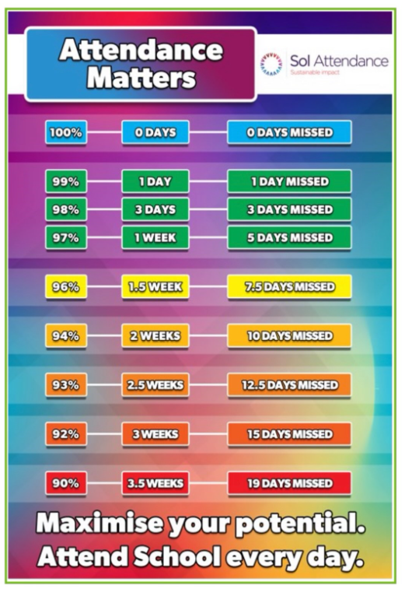 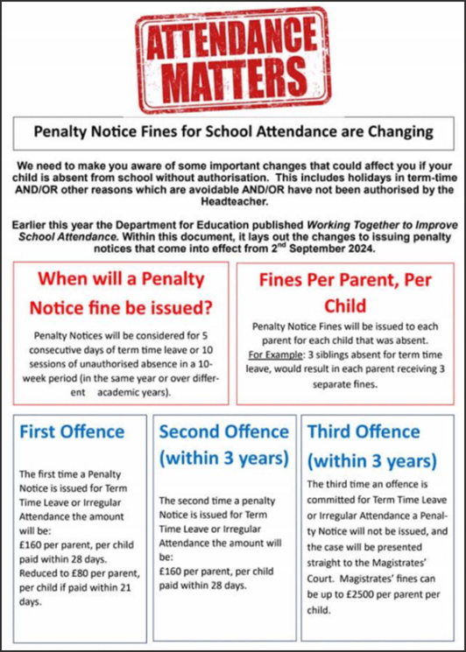
​

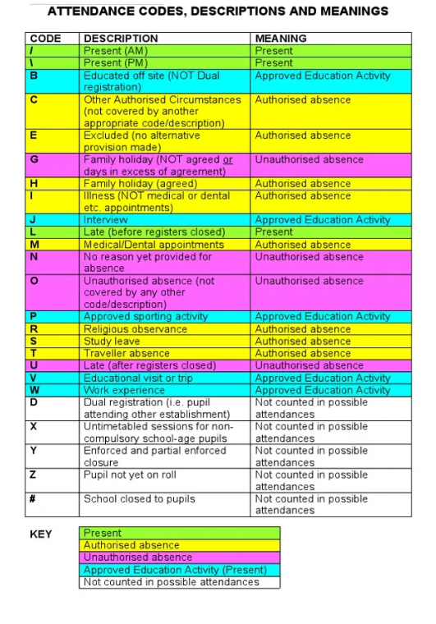

Appendix 1 – Authorised / Unauthorised absence

Authorised

- Illness
- Emergency and planned medical appointments
- Days for specific religious observance
- School closure

May be authorised in exceptional circumstances

- When a family needs to spend time together to support each other during or after a crisis
- Family wedding / civil partnership
- Educational opportunity
- Visit to a new school
- Service personnel who are prevented from taking holidays outside term time

Unauthorised

- Family holidays
- Family trips
- Birthdays and other celebrations
- Poor weather where the school remains open
- Trips overseas to complete administration tasks

