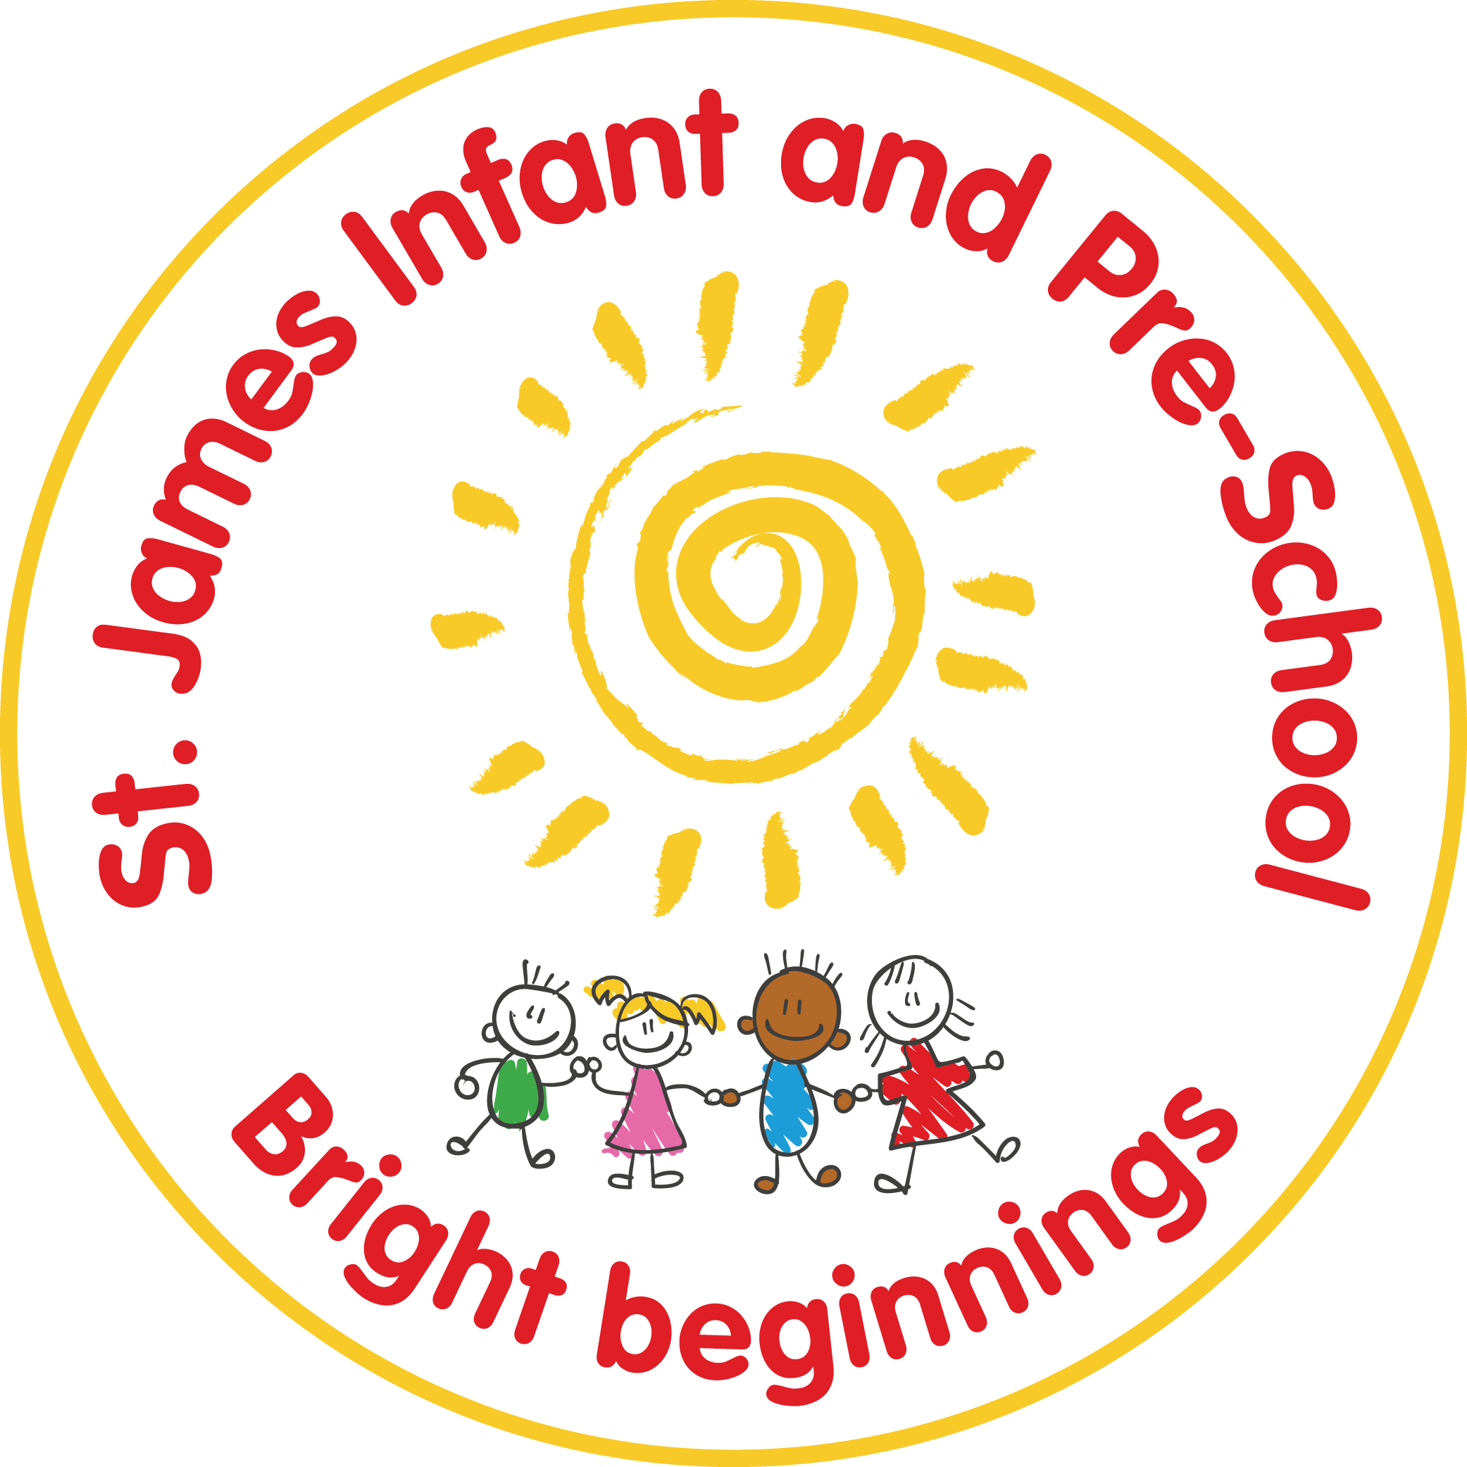
St James Infant & Pre-School
Positive Touch Policy
Intimate Care,
Continence and Changing Policy

Statutory / Non-statutory
Date policy adopted |  | Spring 1 2020
Review date | Spring 1 ‘20 | Jan ‘22 | Feb 24
Reviewer’s name | S O’Shea | C. Cousins | C Cousins
Next review due by | January 2022 | Jan ‘24 | Feb 2026
Annual review / 2 yearly review

Introduction:
The Children Act 1989 and 2004 makes it clear that the paramount consideration in any decision should be in the best interest of the child concerned. Paramount in this context means that it should be the first thing people think about and it takes precedence over other considerations. There are many circumstances where touch is a necessity. Physical contact should always be about meeting the needs of the child.
Actions that can be ambiguous are open to misinterpretation. Staff should always think before making any physical contact. They should be clear about why their actions are in the best interest of the child concerned. They should remember that some children like physical contact and some do not.
Aims:
Children have the right to independence and choices, and we seek to provide opportunities for personal growth and emotional health and wellbeing. However, rights also involve responsibilities, such as not harming other people’s rights. Children unable to control their actions or unable to appreciate danger have a right to be protected; and staff have a duty of care to exercise.
Rationale:
Children learn who they are and how the world is, by forming relationships with people and things around them. The quality of a child’s relationship with significant adults is vital to their healthy development and emotional health and wellbeing.
Many children who require emotional support from school may have been subject to trauma or distress or may not have had a positive start in life. It is with this in mind that staff seek to respond to children’s developmental needs by using appropriate safe touch.
Attachment theory and child development identifies safe touch as a positive contribution to brain development, mental health and the development of social skills.
Our policy rests on the belief that every member of staff needs to know the difference between appropriate and inappropriate touch. Hence, staff need to demonstrate a clear understanding of the difference. Equally, when a child is in deep distress, staff need to know when and how sufficient connection and psychological holding can be provided without touching.
All staff need to be clearly aware of procedures within this policy. The policy should be seen in the wider context of the ‘Behaviour Policy’ and the ‘Safeguarding and Child Protection Policy’. Staff always need to be mindful of appropriate behaviour. All Staff are Team Teach trained in order to understand appropriate touch and very occasionally restraint.
Any physical interventions are logged in a bound book in line with Team Teach Practice. Physical interventions Plans are written for children where physical interventions may be used more frequently. These are always shared by staff with parents and is part of a behaviour plan.
Positive Touch
Different types of touch
- Casual / informal / incidental touch
Staff use touch with pupils as part of a normal relationship, for example comforting a child, giving reassurance and congratulating. This might include taking a child by the hand (if age appropriate), patting on the back or putting an arm around the shoulders. The benefit of this action is often proactive and can prevent a situation from escalating.
2. General reparative touch
This is used by staff working with children who are having difficulties with their emotions. Healthy emotional development requires safe touch as a means of calming, soothing and containing distress for a frightened, angry or sad child. Touch used to regulate a child’s emotions triggers the release of the calming chemical oxytocin in the body. Reparative touch may include stroking a back, squeezing an arm, rocking gently, cuddling, tickling or sitting on an adults’ lap, hand or foot massage. These types of touch would be clearly defined within the orchard school policies and appropriateness of staff actions. Because of the complex needs of our children reparative touch is used many of the children.
3. Play contact/interactive
Play contact is used by staff adopting a role similar to a parent in a healthy child-parent relationship. This will only take place when the child has developed a trusting relationship with the adult and when they feel completely comfortable and at ease with this type of contact. Contact play may include rough and tumble, tickle games, being supported to explore in messy play, being held or rocked in physical play or being helped to access playground equipment. This sort of play releases the following chemicals in the brain: Opiodes – to calm and soothe and give pleasure; Dopamine – to focus, be alert and concentrate; BDNF (Brain Derived Neurotropic Factor) – a brain ‘fertiliser’ that encourages growth.
4. Positive handling (calming a dysregulating child)
Staff may use force as is reasonable in all the circumstances to prevent a pupil from doing, or continuing to do, a type of behaviour that may result in them harming themselves or another. It may also be a way of providing support for the child for them to regulate their emotions or their sensory needs. Staff are trained to use Team Teach to support a dysregulated child and only as a last resort. (see Behaviour and Relationships policy)
5. Using Touch to Communicate and Teach
Because of the complex nature of the children at St. James Infant and Pre-School it is often appropriate and very important to use touch to communicate with them e.g. Through on body signing or to alert a child that they are about to be asked to be moved or to guide children in completing a task as part of a learning program or to find out about something by exploring materials and objects.
How Do We Use Touch?
Hugging
At this school, staff that are using touch for comfort or reward use a ‘school hug’. This is a sideways on hug, with the adult putting their hands on the child’s shoulders. This discourages ‘front on’ hugging, and the adult’s hands on the shoulders limits the ability of the child to turn themselves into staff. This can be done either standing or sitting.
Handholding
We recognise that children, especially young children sometimes enjoy being able to hold hands with adults around them. As with any form of touch, the child needs to be asked first.
Lap sitting
At St James Infant and Preschool, we recognise that some children, especially very young children derive comfort from lap-sitting. Children should be encouraged to seek comfort/attention through other means, for example the school hand hold or hug, as they mature. Lap sitting should be used as a short-term strategy to re-assure and calm children if it seems appropriate. When using lap-sitting we would sit the child on one knee, or for younger children sideways on.
Please note that although we have a positive touch policy and believe that contingent touch can be a positive experience for the children that we care for, this does not mean that staff have to touch children, it should also be recognised that some children will not want to be touched and it can act as a trigger for emotional outbursts if it causes anxiety for a child.
7. In Self-care activities
Many children at St. James Infant and Pre-School need their personal care needs met by staff and children will be assisted to take part in self-care activities such as feeding, washing or dressing. Children will also have their intimate care needs met when having their nappy or pad change. An intimate care plan is agreed and shared with parents.

CONTINENCE AND CHANGING SOILED OR WET CHILDREN POLICY

Aims:
Education providers have an obligation to meet the needs of children with delayed personal development in the same way as they would meet the individual needs of children with delayed language, or any other kind of delayed development. Children should not be excluded from normal preschool activities solely because of incontinence.
(Including Me. Managing Complex Health Needs in schools and early years settings DfES)

This policy sets out St. James school procedures for handling these situations with dignity and kindness to ensure the needs of individual children are met and health and safety standards are maintained.

What happens if a child is admitted to school who is incontinent?
St. James Infant and Pre- School acknowledges that this is a developmental or medical problem and will work with parents to establish a mutually acceptable care and changing plan which is likely to cover the following points:
Parents
- Agreement with parents to ensure that the child is changed at the latest possible time before being brought to the setting/school.
- Provision by parents of spare nappies and /or underwear and a change of clothing.
- Agreeing the procedures that will be followed when the child is changed at school including the use of any cleanser or the application of any cream.
- Agreement that parents inform the setting/school should the child have any marks/rash.
- Agreeing to a ‘minimum change’ policy i.e. the setting/school would not undertake to change the child more frequently than if s/he were at home.
- Agreement to review arrangements should this be necessary.

School
- Agreeing to change the child during a single session should the child soil themselves or become uncomfortably wet.
- Agreeing how often the child would be changed should the child be staying for the full day.
- Agreeing to report should the child be distressed, or if marks/rashes are seen.
- Agreeing to review arrangements should this be necessary.

Hygiene Procedures to follow for changing a soiled nappy or soiled underwear/ clothing
- Staff to wear disposable gloves and aprons while dealing with the incident.
- Soiled nappies to be double wrapped, and placed in a hygienic disposal unit.
- Changing area to be cleaned after use.
- Hot water and liquid soap available to wash hands as soon as the task is completed.
- Hot air dryer or paper towels available for drying hands.

Staff Guidelines for dealing with a soiled child
For children in the Foundation stage the teaching assistant will be responsible for:-
- Changing the soiled child (the teacher may also but this would be on a voluntary basis).
- Older children will be supported in cleaning and changing as determined by their level of independence to do so.

Note: these guidelines are for children who are too young to clean themselves effectively or who have some developmental difficulties. These guidelines are not for occasions where the incident is a ‘one off accident’ and the child is sufficiently independent to clean themselves. However, the same levels of dignity, privacy and kindness should be extended. In these incidents soiled underwear should be double wrapped and placed in the child’s school bag for washing at home and parents informed.

For children requiring support:
The teaching assistant will inform the teacher discretely that they are going to change a child.
The Teaching assistant will explain to the child what they are going to do to help clean them up.
The adult will take the child to the toilet area in the foundation stage or Pre-School or if the child is in an older year to the relevant toilet area, ensuring dignity and privacy are respected.
The child will normally be asked to stay standing.
Adult should wear disposable rubber gloves.
Only essential garments should be lowered or removed.
Remove soiled pad/ nappy/ underwear.
When washing or wiping, always do this front to back to prevent infection.
Ensure skin is dry using paper towels (child should be encouraged to help if able to do so).
Replace pad/ nappy/ underwear (child should be encouraged to help if able to do so).
Encourage child to wash and dry hands.
Tidy and clean changing area disposing of soiled items as per above hygiene guidelines.
Wash own hands.

What to do if a child become distressed during the changing process
- Talk the child through each step and reassure them that they will feel much better when they are clean.
- If the distress is such that it is difficult to continue then stop the changing process.
- If this results in a hygiene issue then parents should be contacted to explain the situation and an agreed course of action established.
- In any event a record must be made of distress, whether or not the changing was completed and parents informed as soon as possible.
- If there is any concern re child protection issues these should be dealt with in accordance with school policy.

What to do if any marks or redness are seen
If marks or redness are seen then this should be recorded and reported to the child’s parents as soon as possible. If there are any child protection concerns these should be dealt with in accordance with school policy.

Access to Relevant Training
This policy and guidance does not replace the need for appropriate staff training where this is felt necessary and the school will work with parents and relevant agencies to ensure staff are adequately trained for dealing with incontinence issues.

