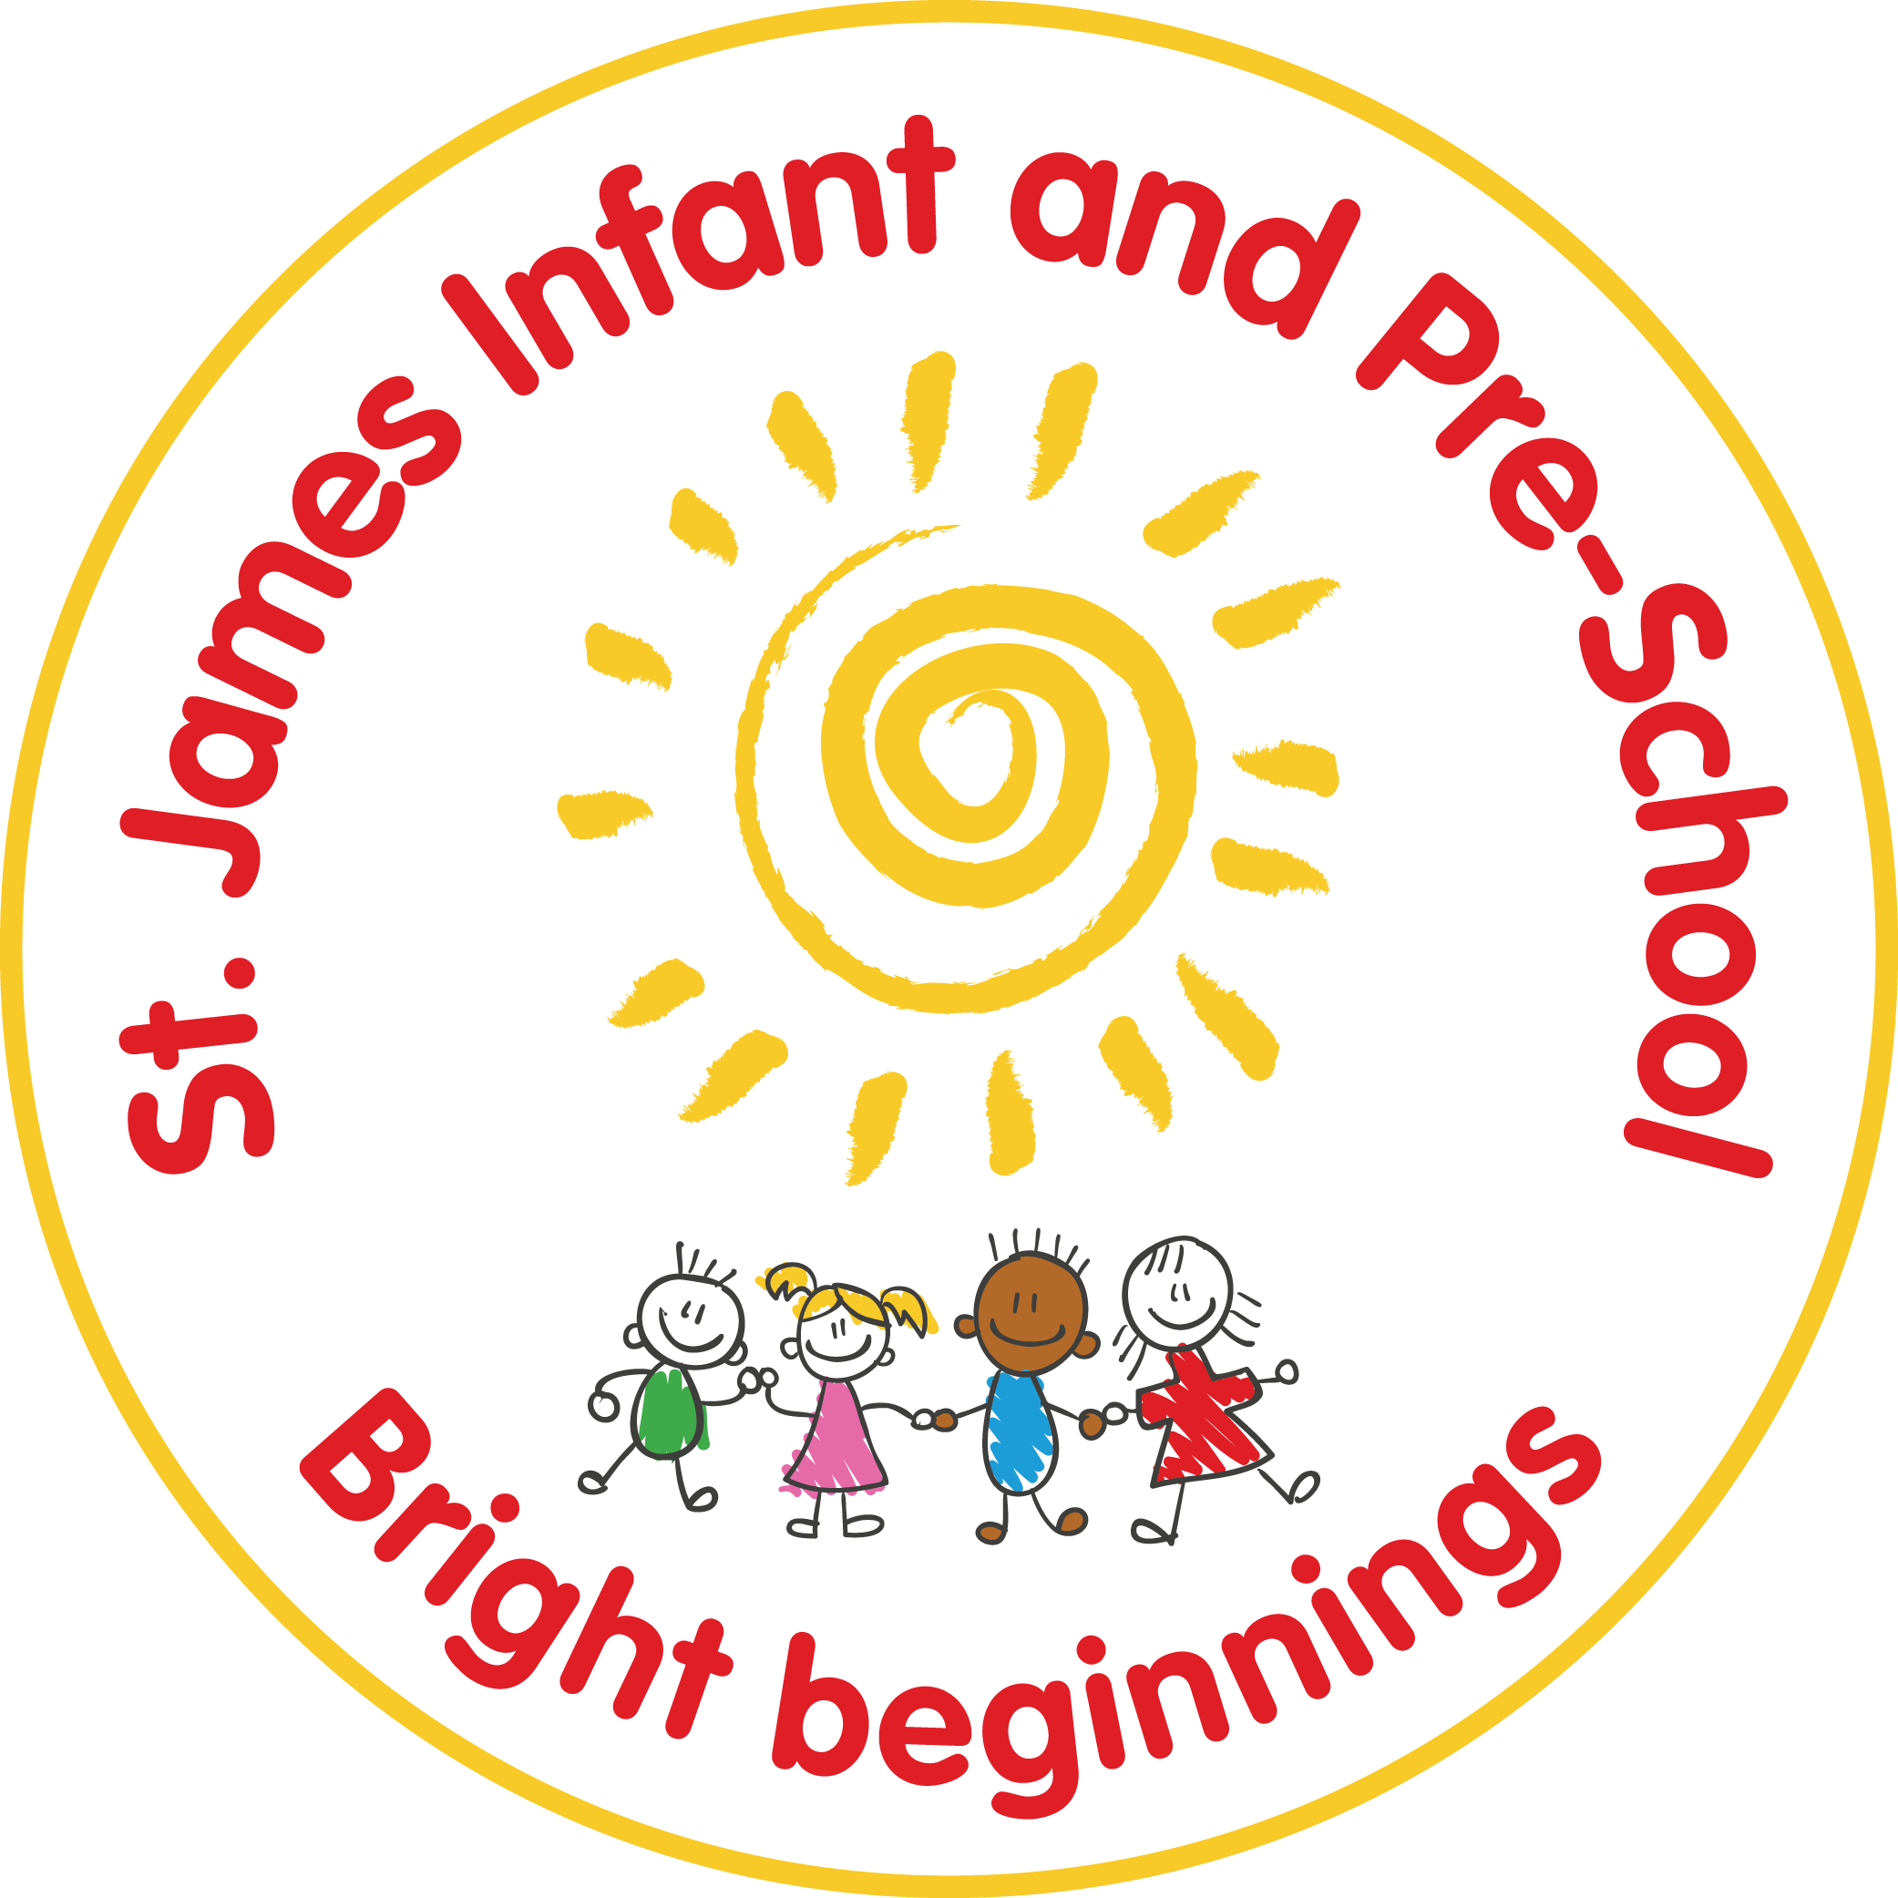

St James Infant & Pre-School
Communication Policy
Statutory / Non-statutory
Date policy adopted | May 2018
Review date | May 2018 | June 2020 | June 2021 | June 2022 | June 23 | Sept ‘25
Reviewer’s name | S O’Shea | S O’Shea | GG | GG | SOS | SOS
Next review due by | June 2020 | June 2021 | June 2022 | June 2023 | June 24 | Sept ‘27
Annual review / 2 yearly review

Aim
To ensure that St. James Infant School is a thriving and successful school, we must communicate effectively with each other, with our pupils, with their parents and with other members of the wider community. We need to ensure that communications between all members of the school community are clear, professional, timely and appropriate.

Responsibilities
Senior leadership:
• To ensure information is made available to staff in a timely manner and via appropriate channels, where practicable face to face.
• To ensure that staff have the relevant information available to communicate with colleagues effectively.
• To maintain open channels of two-way communication and to listen to feedback and comment from all staff.
• To keep Governors informed of developments and concerns.
All staff:
• To communicate regularly with each other, preferably face to face, to ensure information is available and understood within the context of the classroom and working environment.
• To ensure they are informed and have access to information to be as effective as possible in their role and to support their work within the school.
• To use open channels of two-way communication to keep the leadership team and colleagues informed.

Internal methods of communication
• A copy of the Staff Handbook is updated annually, providing staff with important information about the organisation and procedures within the school.
• Staff attend both formal and informal meetings: e.g. staff meetings, teaching assistant meetings, lunchtime assistant meetings, and curriculum meetings.
• All formal meetings should be structured and minuted, and members invited to contribute to the agenda.
• Information and notification of initiatives are communicated through the use of email, where appropriate. Email is a quick, effective way of communicating information, however it should not replace face to face meetings where discussion is required.
• Written communications should be handed to staff personally or emailed.
• The school calendar is accessible online and all members of staff can access it. Events are discussed in meetings, but staff also have the responsibility to check future actions.

External methods of communication
Schools have many lines of communication to maintain: with parents and carers, other schools, the community and with outside agencies. Our aim is to have clear and effective communications with all parents and the wider community. Effective communications enable us to share our aims and values through keeping parents well informed about school life. This reinforces the important role that parents play in supporting school.
The school encourages parents to share any issues about their child at the earliest opportunity. Teachers will arrange to see parents as soon as possible. Parents have the opportunity to have a brief word with the teacher before and after school or make an appointment for a meeting.
Whilst staff will always seek to establish open and friendly relationships with parents, they will also ensure that the relationships are professional.

Communications with parents:
Letters: Any letter of complaint must be referred to the Headteacher immediately.
A year group curriculum letter is sent to parents each half term via Dojo. It contains general details of school events and activities. We send other letters of a general nature when necessary and store copies on the school’s website. All letters will be available on Dojo.
Class Dojo: Staff may choose to communicate class messages and notices using Class Dojo. Teachers can use this platform to communicate informal messages, such as reminders for trips or mufti days related to their class. Photos can also be uploaded.
E mail: The school has an email system it uses to communicate with parents. If a parent communicates with the school using email. Staff should forward relevant emails from parents to the HT and should always do so if the content is a complaint. All emails requiring an answer should be responded to within 48 hours (2 school days).
Telephone calls: Office staff will take written notes from callers and pass the details onto the member of staff. Some calls may be recorded.
Facebook: The school has two Facebook accounts: one for St. James Infant School, and another for St. James Infant School and The Abbey Academy combined. Staff will not communicate with parents or pupils via social networking sites or accept them as “friends”.
Written Reports: Once a year, we provide a full written report to each child’s parents on their progress and attainment in each area of learning. This report identifies areas of strengths and areas for future development. Pupils are also given an opportunity to comment on their progress.
Parents’ Evening: Parents meet their child’s teacher twice during the year for a private consultation at Parents’ Evening with an option to meet for a third time following the end of year report.
IEP meetings: Parents of SEND children will meet with their class teacher and the SENCO three times a year, in addition to Parents’ Evenings. This gives them the opportunity to celebrate their child’s successes, and to support their child in areas where there is a particular need for improvement.
School Prospectus: The school prospectus contains a range of specified information to give parents a full picture of provision in our school. This is given out annually to the parents of the new Reception cohorts, and to the parents of any other mid-year admissions.
Safeguarding Leaflet: Our school Safeguarding Leaflet will be given out on a yearly basis. It provides information about how we safeguard all children at St. James’.
School Website: The school website offers information about the school and provides an opportunity to promote the school to a broader audience.
Home visits: Home visits take place during the Autumn Term for those families with children in the Reception Class, and in the Autumn term, Spring term and Summer term for our new Poppies children.

Conduct
It is expected that both parents and staff use all methods of communication in a professional and courteous manner, particularly on-line methods of communication, eg. Facebook. Grievances and complaints must be dealt with in a confidential manner with the Headteacher and Governing Body as stated above.
Any personal or derogatory comments about staff or the school will be removed and the complainant will be spoken to by the school.

Safeguarding Children
We recognise that children have a fundamental right to be protected from harm; that their protection is a shared responsibility, and that St. James Infant School should provide a safe and secure environment. We are the people most in contact with our children, and we are therefore in a unique position to identify and help any child needing protection. When any member of staff has concerns about a child, these will be passed to the Designated Safeguarding Lead or the Deputy Designated Lead, who may share this information with Children’s Services.

Written by S O’Shea
Written: May 2018
Reviewed: Sept ‘25

