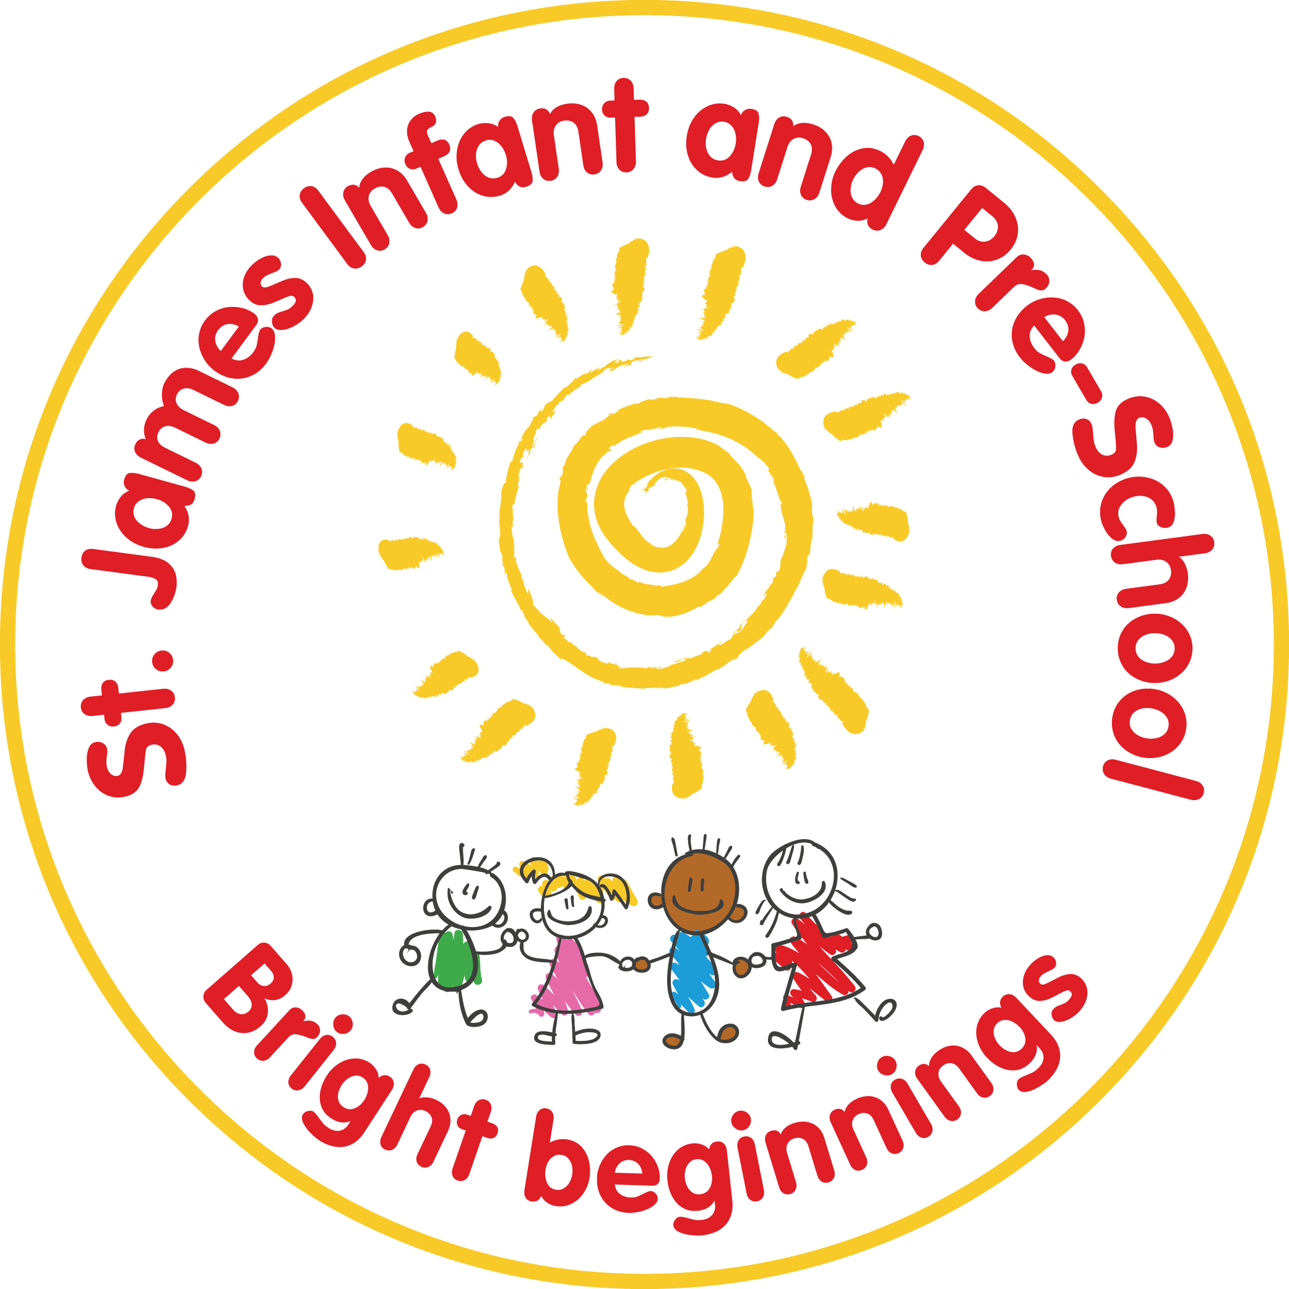

St James Infant & Pre-School
Behaviour and Relationships Policy
Statutory / Non-statutory
Annual review / 2 yearly review
Date policy adopted | Nov ‘19
Review date | Autumn 1 2019 | 15.9.20 | 17/11/21 | 1.9.22 | Sept ‘ 23 | Sept ‘24 | Sept ‘25
Reviewer’s name | C Cousins | C Cousins | C Cousins | C Cousins | SO’S | SO’S
Date minuted by committee meeting | 3.12.19 | Aut 1 meeting | Aut 1 meeting
Next review due by | Autumn 1 2020 | Autumn 1  2021 | Autumn 1  2022 | Autumn 1 2023 | Sept ‘24 | Sept ‘25 | Sept ‘26

Behaviour and Relationships Policy

Introduction
This policy is intended to set out the standards of behaviour expected of staff, pupils, parents, governors and visitors to St James Infant and Pre-School and ensure that there is a consistent approach to behaviour management. This is fundamentally based on our whole school values of respect, kindness, inclusion and teamwork.
Good behaviour and positive relationships are central to a good education at St James Infant and Pre-School.
Aims
- To ensure St James provides a pleasant learning environment where the highest standards of behaviour are expected.
- To praise and reward good behaviour for individuals and groups.
- To encourage all stakeholders to uphold the school values
- To encourage individuals to take responsibility for their own behaviour.
- To minimise the proportion of lessons disrupted by inappropriate behaviour.
- To ensure we speak in a calm and appropriate manner at all times without shouting.
- To challenge all incidents of inappropriate behaviour, quickly and impartially.
- To apply sanctions at an appropriate level, which reflect the severity of the behaviour.

In meeting these aims, we will uphold the Trust’s vision of enabling each child to flourish and achieve their full potential.

Standards of Behaviour
It is expected that all school users will adhere to the school agreement which states that we will all:
- Be the best that we can be
- Follow the school values- respect, kindness, inclusion, teamwork
- Be good listeners and learners
- Always use good manners

In order to achieve these, we will ensure that the school has:
- A consistent approach to behaviour management
- A strong leadership team which consists of; Behaviour Lead: Clare Cousins, SLT: Stephanie Cooney, Sarah O’Shea
- Effective classroom management
- A consistent use of rewards and sanctions
- An effective system of staff development and support
- Strong pupil support systems
- Regular liaison with parents and other agencies (See appendix 2; Home-School Agreement)
- Restorative Behaviour approach, which begins with creating class agreements at the beginning of each school year
- An effective system of managing pupil transition
- Routines and facilities which facilitate positive behaviours

Rewards
Children who adhere to the school agreement will be rewarded, thereby ensuring that every child becomes to know what good behaviour looks like.

Challenging inappropriate behaviour in children
To ensure the standards of behaviour we expect are upheld; ensuring that children’s behaviour does not normally disrupt teaching, learning or school routines, it is necessary to challenge inappropriate behaviour, including child-on-child abuse, at the first opportunity. This will ensure that any adverse issues can be reduced; lost learning time, child-on-child abuse, anxiety, bullying, violence or distress.

Challenges to inappropriate behaviour must be done in a calm and sensitive manner whilst maintaining empathy for the individual at all times. Whenever possible, investigations to establish facts should be conducted privately. The Restorative Approach will be used in this situation. This supports children in taking ownership of their own poor behaviour and in deciding how to ‘put things right again’.
Conversations around behaviour must end with a discussion around the school values….. ‘teamwork makes the dream work’, ‘kindness costs nothing’.

Wherever possible, consideration should always be given to how to prevent such behaviour occurring again. This should include anticipating any likely triggers and putting in support to prevent them.
Children who are emotionally distressed are not able to think and respond logically and may need time to calm down before the incident is addressed.

Children who demonstrate repeated inappropriate behaviour will be given a “behaviour support plan”. This identifies appropriate methods for de-escalating difficult situations, procedures for managing the consequences and a common script for all adults to use. It will be written by the Headteacher, in consultation with the classteacher and SENDCo. If necessary, outside agencies may be contacted to support the creation of the support plan.

Special Educational Needs
At St. James, we are aware that certain types of behaviour can be associated with particular types of SEND. Any behaviour is therefore considered in relation to the child’s SEND. A graduated approach will be taken; assessing, planning, delivering and reviewing the impact of the support provided.

Strategies for relatively minor incidents (see Graduated Behaviour Approach)
At St. James we avoid raising our voices and do not become involved in arguments with a child. Raising a hand or clapping patterns are used to gain the attention of the class. Strategies to be used for those children not adhering to the school agreement are in the following order:
- Non-verbal messages including a ‘look’, moving closer, visual prompts
- Tactical or planned ignoring
- Simple, clear statements of desired behaviour using the phrase “you need to ….” And also referring to the school values
- Reminder of school agreement
- Choice or consequence given e.g. “Jane if you continue to disturb Jack, you are choosing to work alone”
- A ‘needs work’ statement will be recorded on the Class Dojo page and at least one minute of ‘treat time’ will be lost
- Time out within the classroom
- Time out in a different classroom – this level of sanction is deemed a serious sanction and should only be used when other behavioural strategies have been attempted.

Dealing with challenging behaviour (see Graduated Behaviour Approach)
In most instances an adult’s usual control and professionalism will be enough to diffuse any problematic situation. However, where inappropriate behaviour is likely to escalate or to prove damaging to people or property staff must intervene. Dialogue and diversion strategies should always be the first steps. If necessary, the child should be isolated from the other children. Y1 children will be removed to a Y2 class and vice versa.
Depending on the severity of the incident there may be the need to formally report to parents and a meeting arranged with them.
Severe behavioural incidents will need to be reported to a member of the Senior Leadership Team and recorded. These include:
- Physical confrontations between pupils and staff
- Child on child abuse
- Any incident which requires physical restraint
- Violence where a pupil causes injury
- Bullying
- Prejudice relating to race, gender, disability, religion or belief
- Deliberate damage to property
- Swearing
- Smoking, solvent or drug abuse
- Absence from the site without permission
- Malicious accusations against members of staff
(Equality Act, 2010)

All responses must be proportionate and the pupil’s age, special educational needs or disabilities and any religious requirements must be taken into account at all times. (Education and Inspections Act, 2011)

Clear routines and expectations should be established rapidly to promote high standards of behaviour:
References should consistently be made to the whole school values and Learning Pirates
Greeting the children with a smile
Making reference to the school values when passing the children around the school
Lining up – Still, straight, silent, superheroes
Gorilla sitting and hedgehog hands
Hands on hips when walking to and from assembly
Walking in the corridors
Moving around the classroom during transitions, eg, 3, 2, 1….
Tidying up- Choose It, Use It, Put It Away
Stop signals- hand up, count down, sing a song, clapping rhythm
Communication lanyards

Anti-Bullying
Bullying is any repeated behaviour, action, suggestion or words which make another person feel unhappy, unsafe or afraid.
See our ‘Anti- Bullying Policy’ for further information.

Positive Handling
In a situation where a child is presenting a danger to himself / herself or another person, it will be necessary to intervene physically. This will take the form of restrictive intervention. Staff have completed a certificated course on the use of safe restraint: Sarah O’Shea, Clare Cousins, Shannon Harris, Jade Caygill, Ria Kendall-Kelly. Where this occurs, parents must be informed, and the incident must be recorded in the Bound and Numbered book, signed by the Head Teacher and Chair of the LAC. A child who repeatedly requires intervention will have a “positive handling plan”.
All members of school staff have the legal power to use reasonable force in certain circumstances. Staff who are likely to need to use reasonable force and/or other restrictive interventions should be adequately trained in its safe and lawful use and in preventative strategies.
Refer to the Restrictive Intervention and Positive Handling Policy.

Exclusion
In the case of premeditated, deliberate physical harm caused to any other individual, the Head Teacher reserves the right to consider exclusion. However, exclusions will only be made after every other strategy has been exhausted. Staff will comply with the practices and procedures in the ‘InMAT Trust Exclusion Policy’. The LAC must be informed at the earliest convenience. Parents must be informed in writing and have the right to appeal against the decision.

Behaviour outside school
Where negative behaviour is witnessed by staff outside of school, the child may be disciplined in the same manner as highlighted in the behaviour policy if the child is:
- On a school visit
- Travelling to or from school
- Wearing school uniform
- In some way identifiable as a pupil at the school

Misbehaviour at any other time can also be challenged outside school if it:
- Could have repercussions for the orderly running of the school
- Poses a threat to another pupil or member of the public
- Could adversely affect the reputation of the school

This policy has been written with reference to the DfE documents:
Behaviour in Schools 2022
https://assets.publishing.service.gov.uk/government/uploads/system/uploads/attachment_data/file/1101597/Behaviour_in_schools_guidance_sept_22.pdf
Equality Act (2010)
Children and Families Act (2014)

All stakeholders are aware of and have agreed to uphold this policy.

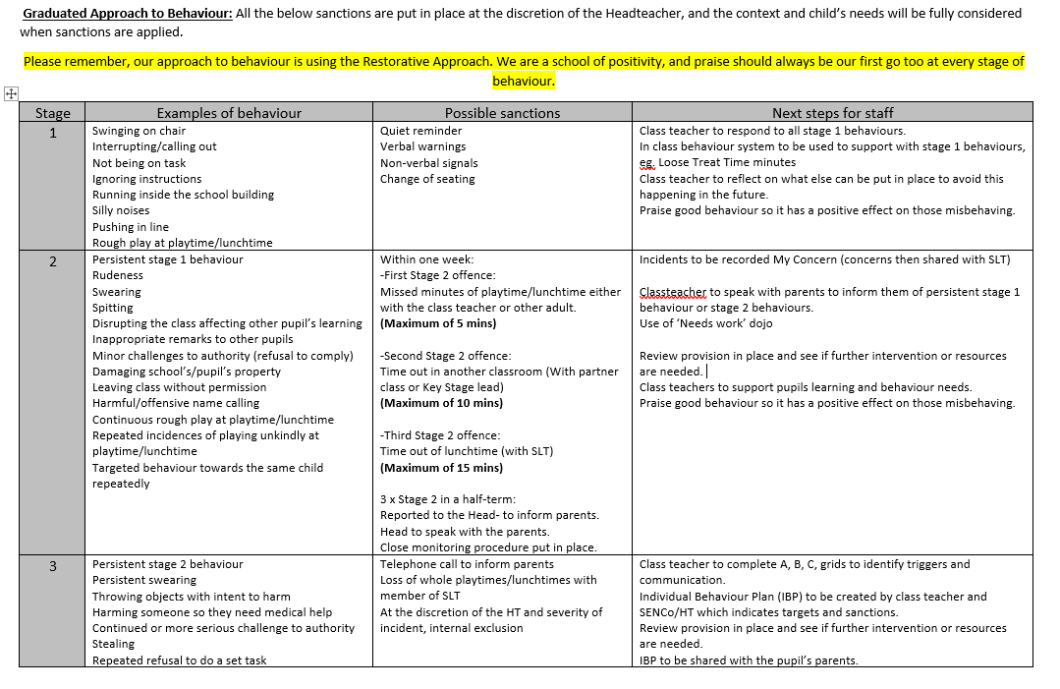

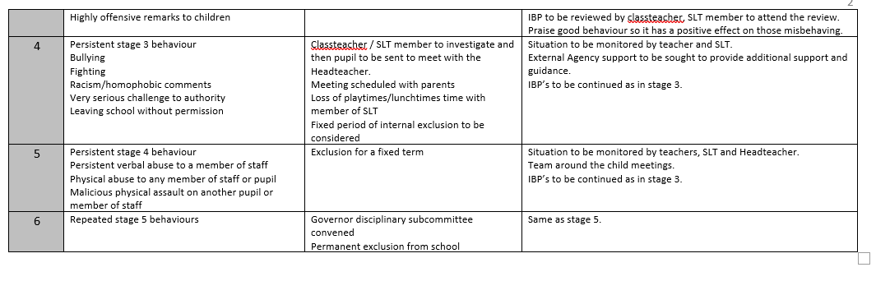

Reviewee: C Cousins
 These are our rewards:

Treat Time
Sunshine of the Week
Smiley face
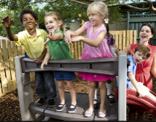
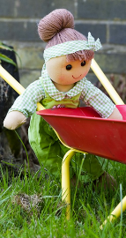
Stickers


WAGOLL
What A Good One Looks Like
Thumbs up
Class treats

Class treats
Showing work to Mrs O’Shea 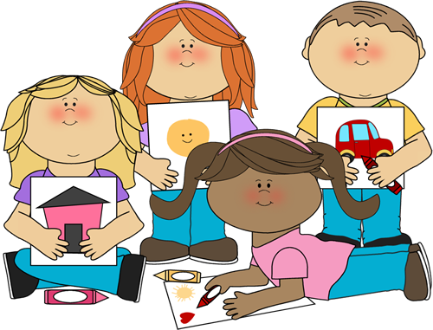

Dojo points
Learner of the Week


