Pupil premium strategy 2025 – 2026

School overview
Detail | Data
Number of pupils in school | 187
Proportion (%) of pupil premium eligible pupils | 37 chn (20%)
Academic year/years that our current pupil premium strategy plan covers | Sept’25 – Sept’28  Reviewed and adapted regularly
Date this statement was published | September 2023
Date on which it will be reviewed | July 2024
Statement authorised by | Sarah O’Shea and Stephanie Cooney
Pupil premium lead | Stephanie Cooney
Governor / Trustee lead | Sarah Muddiman

Funding overview
Detail | Amount
Pupil premium funding allocation this academic year | £59,200
Pupil premium (and recovery premium*) funding carried forward from previous years (enter £0 if not applicable) | £0
Total budget for this academic year  If your school is an academy in a trust that pools this funding, state the amount available to your school this academic year | £59,200

Part A: Pupil premium strategy plan

Statement of intent
Statement of Intent
At St James Infant School, our vision is for every child to “be the best that they can be.”
We are committed to ensuring that all pupils, regardless of background or starting point, are given the opportunities and support they need to thrive.
We recognise that our children face a range of contextual challenges, and we are determined to remove barriers to learning and personal growth so that disadvantaged pupils can achieve outcomes in line with, or exceeding, national expectations. Our approach is rooted in evidence-based practice, guided by the Education Endowment Foundation (EEF) and our own rigorous data analysis.
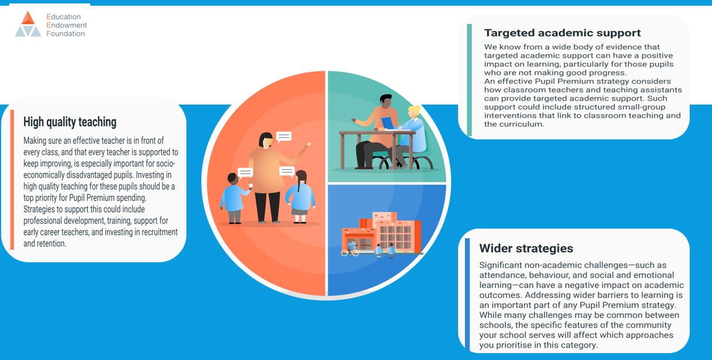
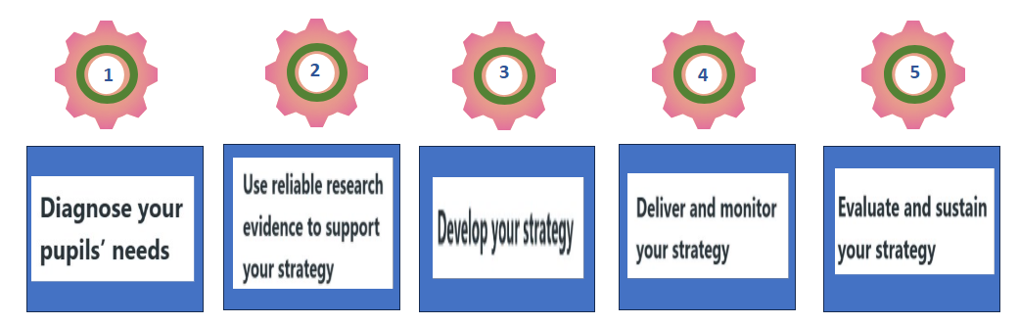
We invest our Pupil Premium funding to:
- Provide high-quality teaching that meets the needs of all learners.
- Deliver targeted academic and pastoral interventions to address specific gaps.
- Support families to strengthen engagement in learning both at school and at home.
- Promote attendance, well-being, and confidence for all pupils.
Our approach is responsive, regularly reviewed, and adapted to ensure sustained impact over time.
School Context
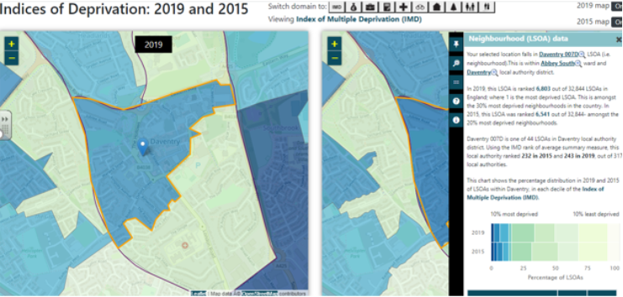
St James Infant School is located in the heart of Daventry Town. The 2019 Indices of Multiple Deprivation (IMD) identify our local area (LSOA) as being within the 30% most deprived neighbourhoods in England. Many of our families face socio-economic challenges that can impact educational engagement, well-being, and access to resources.
We therefore place significant emphasis on ensuring that our most disadvantaged pupils receive bespoke support—academically, socially, and emotionally—to achieve their full potential.
Ultimate Aims
- To improve the overall well-being, involvement, and self-esteem of all children.
- To improve oral language skills and communication across the school.
- To ensure attainment in reading, writing, and maths for children in receipt of Pupil Premium is in line with, or above, national averages.
- To strengthen family engagement with school life and learning.
- To improve attendance, achieving at least 95% overall.

Key Principles and Strategies
1. High-Quality Teaching for All
- Ensure all teaching and learning opportunities meet pupils’ individual needs.
- Provide continuous professional development (CPD) for staff to maintain high-quality classroom practice.
- Monitor teaching through subject leadership, phase leadership, and SLT reviews to ensure consistency and excellence.
2. Targeted Support and Interventions
- Identify gaps in learning early through rigorous assessment and data analysis.
- Deliver immediate, evidence-informed interventions to address misconceptions or pre-teach new content. “Keep up, not catch up”.
- Use individual needs analysis for every Pupil Premium child to plan tailored support.
3. Wider Strategies
- Provide high-quality pastoral care to support emotional well-being and readiness to learn.
- Strengthen communication and partnerships with families through platforms such as Class Dojo.
- Provide learning resources to ensure equitable access to home learning opportunities.
- Address barriers to attendance and punctuality through family support and engagement.

Monitoring and Evaluation
- Progress and outcomes for disadvantaged pupils are tracked rigorously throughout the year.
- Regular core group meetings review data and adapt provision where necessary.
- Impact is measured through academic outcomes, attendance data, engagement levels, and well-being indicators.
- The strategy is reviewed annually and updated termly in response to ongoing evaluation.
Our Commitment
At St James Infant School, we are unwavering in our commitment to equity, excellence, and inclusion.
We believe that through a culture of high expectations, rich opportunities, and strong relationships, every child can and will succeed.
“Every child matters, every moment counts.”

Challenges
This details the key challenges to achievement that we have identified among our disadvantaged pupils.
Challenge number | Detail of challenge
1  Attendance an persistent absence. | A proportion of pupils in receipt of Pupil Premium have low attendance and/or high persistent absence compared to non-PP pupils. This results in lost learning time, gaps in phonics, reading and maths teaching and slower progress. Patterns show that absence is often linked to wider vulnerabilities (SEMH, social care involvement, housing, parental mental health).  Evidence we hold / will hold: attendance tracking by group (PP vs non-PP), number of pupils below 90% (persistent absence), bi-weekly SLT attendance reviews, individual attendance action plans.  Why this matters: pupils missing even 1 day every 2 weeks quickly fall behind cumulative curriculum content — especially phonics and early maths — and are less well settled socially.
2  SEMH, Safeguarding and SEND needs/ | A significant proportion of disadvantaged pupils also have additional needs (SEMH, safeguarding involvement, early help, or SEND). This can impact readiness to learn, emotional regulation, and ability to access whole-class instruction without additional scaffolds. In some cases, trauma or instability at home affects concentration, memory and behaviour for learning.  Evidence we hold / will hold: % of PP pupils with SEN Support / EHCPs, number on pastoral caseload, number with social care/early help involvement, in school involvement, on-going assessments.  Why this matters: these pupils often need more time for nurture, pre-teaching or regulation before they can access academic learning — without this, progress is slower than peers.
3  Parental engagement and home learning. | Engagement with school among some PP families is lower than that of non-PP families. Barriers include parents’ own negative experiences of school, limited confidence with phonics and early reading, shift work/transport, and digital access. This affects home reading routines, responding to sound videos, attendance at workshops and parents’ evenings, and can reduce the impact of school-led interventions.  Evidence we hold / will hold: attendance at parent events by group, engagement data from Class Dojo, completion/return of reading/home-learning, parent voice.  Why this matters: pupils whose parents engage with daily phonics/reading and practise taught sounds make faster progress — lower engagement widens the gap over time.
4  Attainment and progress in Reading, writing and Maths | On entry to each year group, a higher proportion of disadvantaged pupils are working below age-related expectations in RWM than their non-disadvantaged peers. Gaps are most visible in phonics/early reading, transcription and composition in writing, and mathematical fluency. This is often compounded by absence or SEMH needs.  Evidence we hold / will hold: EYFS/KS1 outcomes by group, RWI assessments, termly teacher assessments, writing assessments after each unit, WRM assessments, QLAs (highlighting calculation and crossing 10) and PLCs, ‘Closing Learning Gaps’ booklets.  Why this matters: without high quality teaching, targeted feedback and targeted “keep up not catch-up” (1:1, precision teaching, RWI regrouping, White Rose small steps), pupils won’t reach national expectations by end of KS1, and gaps become harder to close later.
5  Low oral language skills on entry | Many children, and particularly those eligible for Pupil Premium, enter EYFS with below age-related speech, language and communication skills — reduced vocabulary, limited expressive language, and less experience of high-quality dialogue. This affects access to phonics, comprehension, mathematical talk, and writing.  Evidence we hold / will hold: EYFS baseline, language assessments, SALT referrals, oracy observations, teacher checklists (Voice 21 / Tower Hamlets progression). QLA analysis highlighting vocabulary as an area for development.  Why this matters: oracy is the foundation for literacy and reasoning — if not addressed early, this leads to weaker writing, limited ability to explain thinking in maths, and less confidence in class.
6  Limited life experiences – culture capital. | Some disadvantaged pupils have fewer enrichment experiences (visits, clubs, books at home, early maths/language play, wider vocabulary exposure). This results in reduced background knowledge, smaller vocabulary, and less resilience/perseverance when faced with challenge.  Evidence we hold / will hold: pupil voice, records of club/trip uptake by PP, pastoral records, teacher observations.  Why this matters: pupils with narrower experiences often find it harder to connect new learning, write at greater length, or understand texts set in unfamiliar contexts — which can mask actual ability.
7.  Limited emotional Resilience, social skills and mental health. | A significant number of our disadvantaged pupils demonstrate low emotional resilience, underdeveloped social skills, and challenges with regulating emotions. This impacts confidence, relationships, and learning behaviours across the curriculum. These children often find it difficult to persevere with challenging tasks, recover from setbacks, or work cooperatively in groups.  Evidence we hold / will hold: Internal behaviour data: analysis of incident logs and lunchtime behaviour records shows a disproportionate number of PP pupils involved in low-level behaviour or emotional regulation incidents. Wellbeing tracker analysis.  Early years prime area data.  Why this matters: Emotional regulation and resilience are foundational for learning. Pupils with poor self-regulation and low confidence are less able to engage with challenge, sustain concentration, or respond productively to feedback. Low resilience can lead to avoidance of demanding tasks, frequent classroom disruption, and reduced participation. Social difficulties can also affect group learning, friendships, and a sense of belonging—all key factors in academic progress and well-being.

Intended outcomes
This explains the outcomes we are aiming for by the end of our current strategy plan, and how we will measure whether they have been achieved.
Intended outcome | Success criteria
 | - Overall attendance for pupils in receipt of Pupil Premium is ≥ 95%.  - Persistent absence (below 90%) among PP pupils reduced to ≤ 10%.  - Weekly SLT attendance meetings and individual attendance action plans show sustained improvement for focus pupils.  - Attendance gap between PP and non-PP ≤ 1 percentage point.
  1. Improved attendance and reduction in persistent absence among disadvantaged pupils.
 | SEMH/behaviour incidents for PP pupils reduced by ≥ 25%.  All staff confidently use Zones of Regulation and restorative approaches.  Pupil voice: ≥ 90% of PP pupils report, “I can manage my feelings and keep trying when work is hard.”
  2. Improved emotional regulation, resilience and social skills; reduced SEMH incidents.
3. Increased parental engagement in learning, communication and attendance at school events. | ≥ 70% of PP parents attend school workshops or events.  - ≥ 85% of PP parents regularly engage on Class Dojo.  - Improved engagement with Home learning (RWI/ wider curriculum (Home learning splats).  - Parent survey shows ≥ 90% agree that they feel confident supporting learning at home.
4. Accelerated progress and improved attainment in Reading, Writing and Maths for PP pupils. | ≥ 75% of PP pupils meet or exceed age-related expectations in RWM.  Y1 Phonics Screening: ≥ 75% PP pupils pass  - Internal data and QLAs show diminishing gaps at each assessment point.  - Work sampling evidences improved feedback response and writing stamina.  Phonics analysis data.
5. | EYFS Communication & Language: ≥ 80% of PP pupils reach expected levels.  - Communication and language assessments show measurable gains.  - Oracy assessments (Voice 21 / Tower Hamlets progression) show ≥ 1 step improvement for targeted pupils.  - PP pupils demonstrate greater verbal reasoning and vocabulary in classroom talk and writing.
  Improved language and communication skills, especially in EYFS and KS1.
6. Broader cultural capital and enriched experiences for PP pupils. | - 100% of PP pupils access at least 2 funded enrichment experiences (clubs, trips, performances).  - Pupil voice evidences increased confidence, curiosity, and enjoyment of learning.  - Writing and oracy outcomes show richer vocabulary and real-world references.  - subject leaders enhance enrichment opportunities throughout unit plans  - Attendance at enrichment clubs and events for PP pupils ≥ 85%.
7. Strengthened teaching quality and curriculum access through professional development. | - All teaching judged good or better in internal reviews.  - Staff demonstrate increased confidence in supporting SEMH, oracy, and mastery maths.  - Walkthrus coaching logs show improved consistency in feedback and classroom interaction.  - Pupil progress data shows narrowing of the PP / non-PP attainment gap in all subjects.
8. Enhanced well-being and sense of belonging for all disadvantaged pupils. | Pupil voice: ≥ 95% of PP pupils state they feel safe, happy, and included at school.  Zones of regulation – positive emotion increase.  - Fewer incidents of pastoral support  - Increased engagement in group learning, play and leadership opportunities.  Wellbeing trackers show increased wellbeing and involvement. (Green rag rating).

Activity in this academic year (2025-2026)
This details how we intend to spend our pupil premium (and recovery premium) funding this academic year to address the challenges listed above.

High Quality Teaching - Evidence indicates that high quality teaching is the most powerful way for schools to improve pupil attainment, especially for socio-economically disadvantaged pupils. Schools should focus on building teacher knowledge and pedagogical expertise, curriculum development, and purposeful use of assessment. This could include selection of high-quality curriculum materials or use of standardised assessments.
Activity | Evidence that supports this approach | Challenge number(s) addressed
Empower staff through continuous professional development to deliver consistent, high-quality teaching and confidently support pupils’ emotional, social and mental health needs.  Embed ‘Zones of regulation across the school’.  (£2000)  Embed Tom Sherrington’s Walkthrus across staff CPD. (Including Support staff)  (£600)  Build knowledge and expertise with opportunities to reflect regularly on 14 Teaching habits (climate for learning & pedagogical habits). (Including Support staff)  (£600)  Explicitly teach Executive function strategies (working memory, planning, inhibition).  Build and embed a mentoring and coaching system for improvement in teaching. (Appoint and train coaching lead).  (£1000)  Leaders monitoring impact in practice. (subject monitoring and planning tools to be used)  Leadership training on mechanisms for effective professional development (14 cogs- at least one from each section = more success). | The EEF Teaching & Learning Toolkit states that high-quality teaching has the greatest impact on pupil outcomes, particularly for disadvantaged pupils, and is the most cost-effective strategy schools can use.  The EEF emphasises that improving classroom practice through professional development, instructional coaching, and consistent routines leads to accelerated progress for disadvantaged pupils  “High-quality professional development has a large, positive impact on pupil learning and is essential to improving teaching quality, particularly for disadvantaged pupils.”  (EEF Effective Professional Development Report)  “Children’s executive function skills are powerful predictors of early literacy, numeracy, and emotional resilience.”  (Gathercole et al., 2019)  “Positive, predictable relationships and emotional co-regulation build the foundation for engagement and learning.”  (Centre for Attachment, 2020)  The EEF’s Effective Professional Development Guidance Report (2021) identifies that high-quality CPD—especially when built around mechanisms such as modelling, rehearsal, feedback, and coaching—has one of the largest impacts on pupil outcomes. Sustained, structured professional development improves teaching consistency and disproportionately benefits disadvantaged pupils. Research from Kraft et al., Darling-Hammond and Cordingley shows that coaching, collaborative practice and sequenced CPD lead to lasting improvements in pedagogy, self-regulation support and classroom interactions. Embedding clear mechanisms into CPD ensures that changes translate into improved practice and accelerated progress for pupils. | 2/4/7
Develop high-quality talk and interaction through oracy.  Undertake Trust Oracy CPD for all early year’s staff.  (£600)  Embedding Voice 21/ Tower hamlets oracy progression for St James into practice.  Walkthrus pedagogy CPD for staff (Including Support staff) – talk partners, think, pair, share, my turn your turn, I do, we do, you do. Scaffolding language, say it again better, modelling.  Embed St James oracy policy.  On-going staff coaching. (£650)  Use of oracy development strategies framework.  Widget symbols to be used to support children’s understanding cross all curriculum areas- school files created to ensure consistency.  Widget subscription (£200)  Leader’s monitoring impact (subject monitoring and planning tools to be used)  Embed the practice of building vocabulary banks for each unit (EYFS → Y2).  Ensure disadvantaged pupils receive additional opportunities to rehearse and embed new vocabulary through oracy routines. (Embed retravel practice cross curricular)  Allocation of inclusion lead to monitor impact. | EEF emphasises that oral language interventions have high impact (+6 months) on disadvantaged pupils.  CPD in oracy (Voice 21, Tower Hamlets progression) equips staff to:  - Model high-quality talk  - Build vocabulary  - Support emotional expression  - Improve behaviour through language for regulation  “High-quality classroom talk improves children’s reasoning, vocabulary and ability to explain their thinking.”  (EEF Dialogic Teaching RCT, 2017)  Pupils in Voice 21 schools improved significantly in spoken language outcomes compared to non-participating schools (ICF Evaluation, 2021).  Pupils exposed to explicit oracy progression demonstrated accelerated progress in vocabulary and sentence structure (TH Oracy Project Evaluation, 2019).  Research in cognitive psychology shows that:  - thinking is expressed and strengthened through language  - talk externalises thought → supports self-regulation  - high-quality modelling provides linguistic frameworks needed for reasoning  This connects directly to:  - metacognition strategies (EEF: +7 months impact)  - maths reasoning  - writing composition  https://educationendowmentfoundation.org.uk/education-evidence/teaching-learning-toolkit/oral-language-interventions  Visuals help pupils organise, connect and retrieve information more effectively.  (EEF Cognitive Science Approaches Review, 2021) | 4/5
Embed high quality, timely feedback practice to accelerate progress.  Embed Feedback in the Moment as part of daily practice across all subjects, ensuring teachers respond immediately to misconceptions and successes during learning.  - Use Walkthrus Feedback to Move Forward principles. CPD provided/ coaching.  - Embed high-quality feedback through whole-class discussions, live marking, and verbal feedback that highlights success criteria and next steps.  - Develop pupils’ metacognitive awareness by teaching them how to interpret feedback, self-assess, and set goals for improvement.  - Train all staff, including TAs, to use formative questioning and prompts that encourage reflection (“What went well?”, “What could you try next?”).  (£600)  - Build time into lessons for pupils to act on feedback through improvement tasks or “response time”. | EEF: Feedback has a high impact (+6 months’ progress). The most effective feedback is specific, actionable, and timely. It should help pupils understand both what they are aiming for and how to improve. Walkthrus and Rosenshines Principles of Instruction emphasise immediate formative feedback within a positive classroom climate. | 4
Implement White Rose Maths curriculum from EYFS2 – Year 2.  Adopt the White Rose Maths scheme to ensure consistent, mastery-based teaching across EYFS and Key Stage 1.  (£1.833.60)  - Use small-step progression, concrete–pictorial–abstract (CPA) approaches, and manipulatives to deepen understanding.  -Embed mathematical talk and reasoning, linking to the school’s Voice 21 Oracy Framework.  -Provide ongoing CPD and coaching for staff to strengthen subject knowledge and fluency in mathematical pedagogy.  Mastery Maths approach- Maths lead to provide training for all staff.  Staff development time allocated to Maths subject knowledge development.  Sequence planning sessions with support of Maths lead.  Coaching sessions with coaching lead/ maths lead.  Leader’s monitoring impact (subject monitoring and planning tools to be used)  To use white rose as a teaching tool within YR-KS1 – Training to be given to teaching staff. | https://educationendowmentfoundation.org.uk/education-evidence/teaching-learning-toolkit/mastery-learning  Pearson states that Power Maths is a maths mastery programme that is “built around a child centred lesson design that models and embeds a growth mindset approach to maths and focuses on helping all children to build a deep understanding of maths concepts.”  The EEF’s “Mastery Learning” entry in its Teaching & Learning Toolkit reports an average effect size of +5 months’ progress for pupils using mastery-learning approaches (across subjects) compared to similar pupils.
Deliver a high-quality, sequenced reading and writing curriculum that secures strong progression from EYFS to Year 2, builds vocabulary, promotes oracy, and ensures fidelity to the Read Write Inc programme.  Ensure that the curriculum from EYFS → Y1 → Y2 is carefully sequenced, building knowledge step-by-step and ensuring children start with what they know  Opportunities provided for year groups plan collaboratively / observe each other to identify:  prior knowledge  key concepts  vocabulary progression  structures and text types  Embed Writing progression that follows the school's Bridged Writing Model / success criteria of ‘High Five Heroes’, providing continuity from emergent mark-making to extended composition.  Embed a whole-school reading curriculum that explicitly teaches:  Vocabulary  Infer  Predict  Explain  Retrieve  Sequence/Summarise  Embed questioning structures to promote reasoning and full-sentence responses (Pixl)  Teach RWI with full fidelity across EYFS and KS1.  - RWI leader ensures:  consistency of routines  accurate groupings based on assessment  daily speed sound sessions  high-quality partner practice  1:1 fast-track tutoring for pupils who fall behind (targeted support)  -Weekly RWI coaching for all staff to strengthen delivery | The EEF stresses that high-quality teaching of early reading and language has the largest influence on long-term attainment, especially for disadvantaged pupils.  - Phonics (+ 5 months)  - Reading comprehension (+ 6 months)  Early reading success is strongly linked to:  - high-quality phonics teaching with fidelity to a single SSP (Read Write Inc)  - structured and progressive reading comprehension instruction  - explicit vocabulary teaching  - strong oral language and dialogic teaching  Research (Beck, Biemiller, Hart & Risley, Snow) shows that disadvantaged pupils particularly benefit from:  - systematic vocabulary teaching  - rich talk and teacher modelling  - structured reading discussions (e.g., VIPERS)  A carefully sequenced writing curriculum—bridging year groups and linking to prior knowledge—supports memory, fluency and independence, especially for pupils with weaker executive function or limited life experiences. | 4/5
Ensure responsive, formative assessment drives learning:  Data-Driven Review: Leadership use Closing Learning Gaps booklets to track progress, barriers, and actions for all disadvantaged pupils.  Frequent year group progress catch up meetings to be implemented- access barriers for individuals and next steps for each child.  Use RWI assessment every 6 weeks and immediate regrouping based on:  fluency  blending  sound knowledge  -Use Starting Strong trackers (EYFS) and termly QLAs and PLCs (KS1) to identify gaps in comprehension and writing skills.  RWI Leader, English Lead, and Assessment Team:  complete regular fidelity checks  monitor lesson quality  analyse RWI assessment data  track disadvantaged pupils closely.  - “Closing Learning Gaps” analysis informs targeted interventions.  Training to be given ‘ raising standard lead’ on I track and how to navigate and categorise groups. | “Effective formative assessment supports rapid progress by helping teachers understand what pupils do and do not know.”  (EEF, 2021)  Rapid assessment cycles (RWI, White Rose, QLAs, PLCs, Starting Strong trackers) ensure gaps are closed quickly and teaching starts from what pupils know. | 4

Targeted academic support (for example, tutoring, one-to-one support, structured interventions)

Activity | Evidence that supports this approach | Challenge number(s) addressed
Deliver structured, responsive phonics through Read Write Inc (RWI).  1:1 tutoring for pupils not on track.  - Share phonics outcomes and sound gaps with parents.  - Daily parent sound videos + weekly reading packs.  Reading Raffle challenges (£250)- teacher choice.  New kinetic letters showcased by writing lead – Resources provided for Pupil premium children. (£200)  Writing reward incentives used across the school. (£50)  Additional 1:1 reading time for Pupil Premium children to be allocated twice or more times weekly.  Oral Language interventions – NELI/ KIT INTERVENTIONS | Systematic phonics → +5 months progress (EEF).  A “keep-up, not catch-up” model prevents long-term reading failure.  The EEF’s large-scale randomised controlled trial (RCT) found that NELI produced +3 months of additional progress in language skills for children in Reception.  Reading incentives can “kick-start” habits that lead to long-term gains in reading stamina and fluency. | 4/5
Targeted language & writing support using Colourful Semantics and the ‘High Five Heroes’ writing progression.  Colourful Semantics for sentence construction and grammar.  - Implement High Five Heroes to bridge EYFS–Year 1 writing (sentence accuracy, vocabulary, structure) | EEF: Language interventions boost literacy (+6 months).  Oral language interventions improve both spoken language and literacy outcomes, especially when integrated into classroom teaching.  Research shows that children with limited language benefit significantly when sentences are broken down into semantic roles such as:  - WHO (subject)  - WHAT DOING (verb)  - WHAT (object)  - WHERE / WHEN | 4/5
Precision teaching and 1:1 tutoring across core subjects.  - Short daily sessions guided by diagnostic assessment.  - Ongoing evaluation of impact and next steps  - Post-assessment QLAs to identify misconceptions.  - PLCs inform individual planning.  - Summarised through Closing Learning Gaps booklets. | Small-group/1:1 intervention accelerate learning (+4 months).  Data driven teaching maximises efficiency. | 4

Wider strategies (for example, related to attendance, behaviour, wellbeing)
Budgeted cost:
Activity | Evidence that supports this approach | Challenge number(s) addressed
Strengthen emotional, social and mental health (SEMH) provision  Embed Zones of Regulation school-wide.  - ELSA-led nurture sessions.  - Pastoral reviews to tailor support.  - Integrate executive-function scaffolds into daily routines.  Pupil Support Worker:  Availability on the playground.  Informal coffee mornings  Early Transition arrangements- identify barriers early.  1:1 and groups SEMH sessions (Lego Therapy)  Additional Kaleidoscope sessions provided for all Pupil premium children. 1:1 session for those identified with social, emotional and mental health needs. (£2000)  Lego Therapy sessions provided- resources. (£250)  Drawing and Talking sessions provided where needed.  Play therapy-1:1 (£650) | https://educationendowmentfoundation.org.uk/education-evidence/teaching-learning-toolkit/social-and-emotional-learning  Decrease in numbers of families at EHA, CIN, CP due to increase in families accessing early intervention from home school link worker. Dedicated person in the role, who builds a relationship where the parents trust them and feels they will listen to them and provides them with the support they require, leads to improved relationships with school and home lives for the whole family. | 2/7
Develop understanding of positive relationships and restorative approaches to behaviour.  Whole-staff training on restorative conversations.  - Behaviour policy updated to reflect relational approach.  - Reinforce school values of Kindness, Inclusion, Teamwork and Respect. | EFF-Restorative practice promotes empathy and responsibility.  The EEF Teaching & Learning Toolkit identifies:  SEL approaches improve academic learning by +4 months on average  Works best when integrated into a whole-school framework (i.e., school values) | 2/7
Parental engagement opportunities:  Phonics drop ins/ workshops.  RWI videos sent home to support home learning – appropriate to group level.  Book and Biscuit sessions  Maths drop ins  Parent drop ins sessions (Half termly)  Exhibition of Learning events  Dojo videos to explain learning concepts.  Knowledge Organisers  Achievement for All meetings  Home Learning Splats  All Pupil premium children to have individual targets- shared with parents and children each term.  Resources provided for all PP children to support target development at home as well as in school. Each half term – renewed. (£800)  Class dojo platforms to support ‘flipped learning approach’ by teachers posting videos, links and teaching content to support home learning. | https://educationendowmentfoundation.org.uk/education-evidence/teaching-learning-toolkit/social-and-emotional-learning  Home–school partnership → improved outcomes (+4 months).  The EFF toolkit suggests ‘targets specific to children can be effective’  The EEF Toolkit states that “parental engagement has a positive impact on average of 4 months’ additional progress. It is crucial to consider how to engage with all parents to avoid widening attainment gaps.”  Children with opportunities to continue learning at home will retain and consolidate learning, deepening understandings.  It is crucial to consider how to engage with all parents to avoid widening attainment gaps.” Positive relationships being built with families. Pupil premium families engaging in home learning and workshops. | 3
Strengthen attendance culture and systems.  Attendance display  Embed 100% club  Half-termly treat for the class with the best attendance.  Absence letters sent out.  Attendance contracts for children persistently below 90%.  Attendance meeting with attendance lead.  Issue a formal contract – Attendance lead & Head teacher  Traffic light letter system to make parents aware of their child’s attendance.  Attendance rewards in celebration assembly.  End of term and year certificates rewarded.  Late gate implemented – stickers used for rewarding. Attendance reports to Governing body- Pupil premium  Implement Attendance Action Plan with focus children, identified barriers and clear actions.  - Family Support Worker engagement and rewards for improvement. | NCES 2009-804  February 2009 emphasizes the link between attendance and attainment stating that ‘RESEARCH SHOWS THAT ATTENDANCE IS AN IMPORTANT FACTOR IN STUDENT ACHIEVEMENT’  DfE: attendance strongly correlates with attainment | 1
Develop resilience and perseverance through Characteristics of Effective Learning (EYFS–KS1).  - Embed Characteristics of Effective Learning language and reflection across EYFS & KS1.  - Link to school values and praise systems. | EEF: Self-regulation and metacognition yield +7 months progress. | 2/7
Clubs and opportunities:  Introduce a broader range of clubs- Sports coach/ forest leader to lead clubs.  School choir- subject leader led.  Trips planned both locally and further a field  Subject leaders plan visitors in school  School trips/ experience days to be fully funded for children in receipt of Pupil premium to ensure (£300)  Pro sport Holiday club (£256)  Breakfast provided each morning (£563.00) | https://educationendowmentfoundation.org.uk/education-evidence/teaching-learning-toolkit/physical-activity  The EEF Toolkit states that Arts participation approaches can have a positive impact on academic outcomes in other areas of the curriculum for all children including those eligible for the pupil premium. In addition to this, it also highlights “wider benefits such as more positive attitudes to learning and increased well-being have also consistently been reported”. | 6

Review of strategy
Autumn Data summary:
 | Reception | Year 1 | Year 2
Reading | 13% | 43% | 47%
Writing | 13% | 36% | 40%
Maths | 13% | 54% | 87%

Spring actions:
Strengthen attendance culture and systems
Introduce ‘Zones of regulation across the school’ via CPD session
Resources provided for all PP children to support target development at home as well as in school
Math's drop-ins for parents – developing understanding.
Achievement for All meetings- All Pupil premium children to have individual targets- shared with parents and children.
Teachers use Closing Learning Gaps booklets to track progress, barriers, and actions for all disadvantaged pupils.
Undertake Trust Oracy CPD for all early year staff.

Introduce Voice 21/ Tower hamlets oracy progression for St James into practice.
Introduce a broader range of clubs
Embed and introduce new Tom Sherrington’s Walkthrus across staff CPD
1:1 and groups SEMH sessions (Lego Therapy) - established timetable for targeted individuals.
Data Summary:

Summer actions:
Data Summary:
Year summary/ Next steps for strategy:

