All schools are duty bound to follow the statutory guidance set out in Keeping Children Safe in Education- Statutory guidance for schools and colleges on safeguarding children and safer recruitment.  It’s from this document where schools develop their own safeguarding policies and procedures.  EHA (Early Help Assessment):  Occasionally, families are identified who would benefit with some help and guidance through the EHA process.  The main objective is to prevent home and school issues from escalating and becoming major concerns. It is important for children to receive the right help at the right time.  The school, parents and external agencies work together to support families through the EHA process by working on a collaborative plan to meet objectives.  The main focus is always the child/children.  Attendance  Every child’s attendance is monitored. The school will notify parents through the letter ‘traffic light system’. Each child is expected to be in school 96% of the time. Any parent wishing for their child to take time off, an appointment must be made with Mrs Cousins. Only in exceptional circumstances will it be authorised. | Useful phone numbers:  To report or discuss a safeguarding concern about a child, call the Northamptonshire MASH (Multi-Agency Safeguarding Hub) for advice:  0300 126 7000  National Society for Prevention of Cruelty to Children (NSPCC):  www.nspcc.org.uk  0808 800 5000  Childline:  www.childline.org.uk  0800 1111  For additional information, our Safeguarding and Child Protection Policy is available on our website.  sjis-head@sjis.inmat.org.uk  sarah.oshea@sjis.inmat.org.uk  clare.cousins@sjis.inmat.org.uk  Jade.Caygill@sjis.inmat.org.uk | September 2025  St. James Infant and Pre-School  - Safeguarding Information for Parents  “Safeguarding and promoting the welfare of children is everyone’s responsibility.”  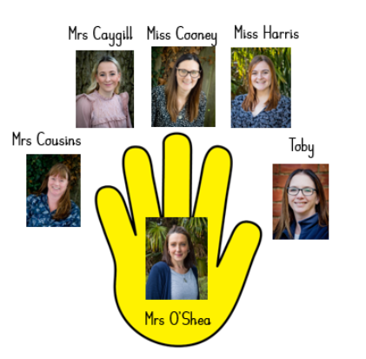
How do we support children’s social, emotional and mental health at St. James Infant and Pre-School?  St. James School believes that the emotional wellbeing of a child is absolutely paramount. We are lucky to have a Kaleidoscope room where children access a range of programmes eg: Kaleidoscope colour therapy, Protective Behaviours and Drawing and Talking, led by Mrs Caygill.  Each year, all class teachers teach Protective Behaviours to their class. Protective Behaviours is a personal safety program which covers areas like the Pants Rule, Hand of Trust and teaches the basic human right…  ‘We all have the right to feel safe all of the time’.  We are fortunate to have a team dedicated to wellbeing; Mrs Cousins and Mrs Caygill to offer support and advice to the children and their families.  Safeguarding team:  Mrs O’Shea- Head Teacher and DSL  Miss Stephanie Cooney- Assistant Headteacher- Deputy DSL  Mrs Cousins and Mrs Caygill- Wellbeing Team and Deputy DSLs  Miss Shannon Harris – Teaching Staff  Miss Toby Saul – Brambles and Lunchtime Staff | What happens when a safeguarding concern is raised:  - The concern is recorded and discussed with the safeguarding team.  - Additional information from external agencies, eg. health, may be sought.  - The concern will be discussed with parents either on the phone or in a meeting.  - In most occasions, support and advice is put in place, the concern is recorded and there is then no further action.  - If necessary, a referral may be sent to the MASH (Multi-Agency Safeguarding Hub) where a team of social workers will look at the concern in more detail.  - Parents will receive a letter from MASH notifying them of the outcome.  Occasionally, we may not follow this protocol, depending on the nature of the concern.  All details and information are kept confidentially with the safeguarding team. | Safeguarding at St James Infant and Pre-School:  St James Infant and Pre-School fully recognises the contribution it can make to protect children. The pupils’ welfare and safety is of paramount importance.  There are four main key areas of safeguarding:  - Neglect  - Emotional abuse  - Sexual abuse  - Physical abuse  At St. James Infants and Pre-School we observe the whole child and their world, including their attendance and punctuality, health, emotional wellbeing, presentation and relationships.  Sometimes we will contact other agencies, eg. health visitors, GPS, schools where siblings may attend, to share or request information about a child.  Staff, InMAT, volunteers and parents contribute towards the safeguarding of all children- it’s everyone’s business.

