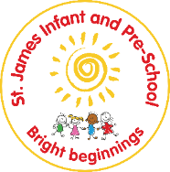
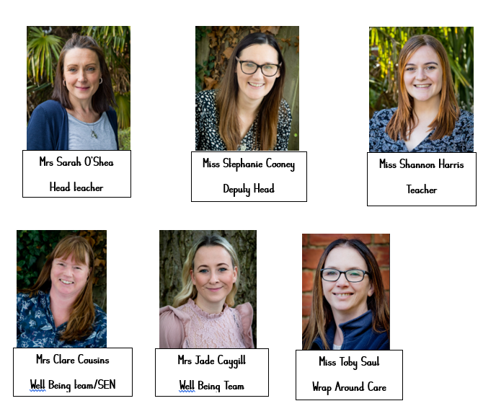
KCSIE = Keeping Children Safe in Education
-If you have a concern about a member of staff contact the Headteacher.
-If you have a concern about the Headteacher contact CEO (Helen Williams)
-These people will then contact the designated officer (LADO)
Staff have a legal duty to report FGM to the police
Safeguarding Team:
To report or discuss a safefuarding concern about a child, call the Northamptonshire MASH (Multi-Agency Safeguarding Hub) for advice:0300 126 7000
Lead DSL:
Sarah O'Shea
Deputy DSLs:
Clare Cousins, Shannon Harris, Steph Cooney, Jade Caygill, Toby Saul
4 types of abuse:
-Physical
-Emotional
-Sexual
-Neglect
Prevent – The Prevent duty requires all education providers 'to have due regard to the need to prevent people from being drawn into terrorism'.
Safeguarding is everyone’s responsibility. Always remember – it could happen here!
CSE = Child Sexual Exploitation. This involves children receiving something in exchange for sexual acts.
If a child makes a disclosure:
- Listen and be supportive
- Take the child seriously
- Reassure the child that what’s happened isn’t their fault
- Let the child guide the conversation
- Explain what you need to do next, and why – be clear about the steps that will be taken
-Ask open questions
-Write up on MyConcern
-Speak with a DSL
Safeguarding at St James Infant and Pre-School

