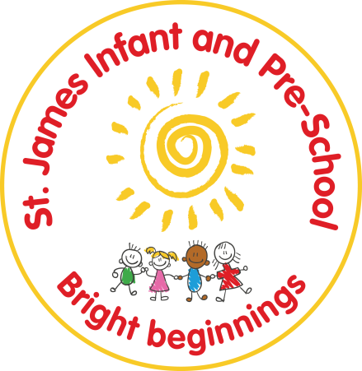
St James Infant & Pre-School

School Uniform Policy
Statutory / Non-statutory
Annual review / 2 yearly review
Date policy adopted | Sept 24
Review date | May ‘25 | Sept ‘25 | June ‘26
Reviewer's name | SO'S | SO'S | SO’S
Next review due by | Sept 25 | May ‘26 | April ‘27
December 25 - Added - There is no requirement for school-logo branded clothing.
August 2026 - Updated - Legal branded-item limit from 1 September 2026 and child-centred incorrect-uniform procedure added.

Contents
1. Aims 2
2. Our school's legal duties under the Equality Act 2010 2
3. Limiting the cost of school uniform 3
4. Expectations for school uniform 4
5. Expectations for our school community 4
6. Monitoring arrangements 5
7. Links to other policies 5

1. Aims
This policy aims to:
- Set out our approach to requiring a uniform that is of reasonable cost and offers the best value for money for parents and carers
- Explain how we will avoid discrimination in line with our legal duties under the Equality Act 2010
- Clarify our expectations for school uniform

2. Our school's legal duties under the Equality Act 2010
The Equality Act 2010 prohibits discrimination against an individual based on the protected characteristics, which include age, sex, disability, race, religion or belief, pregnancy and maternity, and gender reassignment.
To avoid discrimination, our school will:
- Avoid listing uniform items based on sex, to give all pupils the opportunity to wear the uniform they feel most comfortable in or that most reflects their self-identified gender
- Make sure that our uniform costs the same for all pupils
- Allow all pupils to have long hair, though we reserve the right to ask for this to be tied back
- Allow all pupils to style their hair in a way that is appropriate for school and makes them feel most comfortable
- Allow pupils to wear headscarves and/or other religious garments
- Allow pupils with sensory or physical needs to make reasonable adaptations to their uniform depending on their specific needs
- Allow for reasonable adaptations to our policy on the grounds of equality by asking pupils or their parents/carers to contact Mrs O'Shea, who can answer questions about the policy and respond to requests. These will be considered on a case-by-case basis

3. Limiting the cost of school uniform
Our school has a duty to make sure that the uniform we require is affordable, in line with statutory guidance from the Department for Education on the cost of school uniform.
There is no requirement for school-logo uniform.
We will make sure our uniform:
- Is available at a reasonable cost
- Provides the best value for money for parents/carers
We will do this by:
- Limiting any items with our school logo
- Considering cheaper alternatives to school-branded items, such as logos that can be ironed on, as long as this doesn't compromise quality and durability
- Avoiding specific requirements for items pupils could wear on non-school days, such as coats, bags and shoes
- Keeping the number of optional branded items to a minimum, so that the school's uniform can act as a social leveller
- Avoiding different uniform requirements for different school years
- Avoiding different uniform requirements for extra-curricular activities
- Making sure that arrangements are in place for parents/carers to acquire second-hand uniform items
- Avoiding frequent changes to uniform specifications and minimising the financial impact on parents/carers of any changes
- Consulting with parents/carers and pupils on any proposed significant changes to the uniform policy and carefully considering any complaints about the policy
Legal limit on branded items from 1 September 2026
From 1 September 2026, schools must limit the number of compulsory branded items of school uniform and PE kit to 3 or fewer. This is a legal requirement under the Education Act 1996, as amended by the Children's Wellbeing and Schools Act 2026.
At St James, school-logo clothing is optional. Families may use suitable unbranded alternatives that meet the colour and style requirements. The school therefore currently requires no compulsory logo-branded clothing.
If requirements change in future, any required branded PE kit, bags or seasonal items will count within the 3-item total. Optional branded items will continue to have a permitted generic alternative.
4. Expectations for school uniform

4.1 Our school's uniform
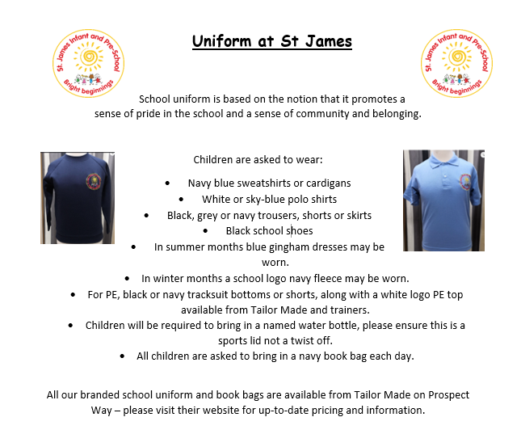

4.2 Where to purchase it
Sign Makers Northampton | Signage Creators - Tailor Made (tailormade-online.co.uk)
Rascals Uniform
We also have a wide range of second-hand uniform available from the school office.

5. Expectations for our school community

5.1 Pupils
Pupils are expected to wear the correct uniform at all times, other than specified non-school uniform days, while:
- On the school premises
- Travelling to and from school

- At out-of-school events or on trips that are organised by the school

5.2 Parents and carers
Parents and carers are expected to make sure their child has the correct uniform and PE kit, and that every item is:
- Clean
- Clearly labelled with the child's name
- In good condition
Parents/carers are also expected to contact Mrs O'Shea if they want to request an amendment to the uniform policy in relation to:
- Their child's protected characteristics
- The cost of the uniform

5.3 Staff
Staff will closely monitor pupils to make sure they are in correct uniform. They will give any pupils and families breaching the uniform policy the opportunity to comply.
Where it is suspected that financial hardship has resulted in a pupil not complying with this uniform policy, staff will take a mindful and considerate approach to resolving the situation.
5.4 If a pupil is not wearing the correct uniform
We will deal with uniform breaches fairly, proportionately and sensitively. Before taking action, staff will consider reasons outside the child's control, including cost or financial hardship, SEND, disability, sensory or medical needs, religion or belief, family circumstances, wellbeing and safeguarding. Reasonable adjustments will be made where needed.
Changing into appropriate school uniform
• Where appropriate, a child who is wearing the wrong uniform may be asked to change into suitable school uniform.
• The child's voice will be listened to and considered when they are asked to change. Staff will protect the child's dignity and privacy and take account of age, independence and individual needs.
• Some children may change independently. Others may be supported by an appropriate adult, where needed, in line with safeguarding and any relevant intimate-care arrangements.
• Parents/carers will be notified through ClassDojo or by telephone if their child is asked to change into school uniform.
• Families may keep named spare clothing or uniform in school if this is helpful, particularly where a child does not feel comfortable changing into school spare uniform.
• School spare uniform is laundered after each use and stored clean and hygienically so that it is sanitary and ready for use.
If a child is unwilling or unable to change, staff will explore the reason, make any reasonable adjustment and contact the parent/carer as appropriate. A uniform issue will not be used as a barrier to attendance, learning or participation.

6. Monitoring arrangements
This policy will be reviewed by the school every year.

7. Links to other policies
This policy is linked to our:
- Behaviour policy
- Equality information and objectives statement
- Anti-bullying policy
- Complaints policy

