EYFS Curriculum Progression
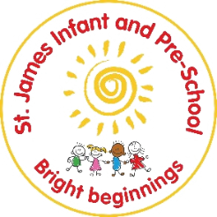
Understanding of the world
Preschool
Autumn  During the Autumn term, children will… | Spring  During the Spring term, children will… | Summer  During the Summer term, children will…
Past and Present
Start to show I know who I am in terms of preferences  Talk about myself and my immediate family | Talk about some of the ways I have changed over my life  Explore how things work. | Talk about some of my own and my family’s history (grandparents, parents, etc.)
How will this be achieved?
Topic: What if things change?  Encourage independent choices  - Introductions of learning Pirates  - ‘Pirate Pea – try something new’  Who am i? – focus ‘ All about me – starting pre-school’  My family- Focus (Immediate- talk about who with live with and wider- grandparents, aunties, uncles)  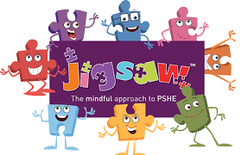  Piece 3’ Families’ Celebrating difference’  GRANDPARENTS DAY (FIRST SUNDAY OF OCTOBER)- INVITE IN FOR ACTIVITIES  Share ‘Home links’- Class dojo- what we did with our family at the week, in the holidays. - Use as regular talking points.  Exploring – Who I was before starting pre-school (Timelines- baby, Toddler, Preschool) - how have we changed? | Topic: is it moving?  Implement Visual timetables  Shows awareness of time (e.g. stating ‘next it’s lunchtime’.)  Explorations of daily routines – sequencing events.  Toys- exploring technology, toys with buttons – things that move- remote control cars, remotes, cd players, beebots.  Continue adding to timelines (turning 4- growing biggers (mathematics links to measure) Encourage talk about how they have changed (e.g. ‘My top is too small… I’ve got bigger.’) | Topic: Will it grow?  Exploration of family trees (growing families)  Inviting Family members in (Book and biscuit)  Grandparent’s morning –crafts and play.
People, cultures and communities
Start to notice some of the differences between people  Talk about different occupations and job roles | Name other countries in the world  Children are positive about the differences between people | Talk about the differences I have seen in people, countries and communities
How will this be achieved?
Topic: What if things change?  When I grow up- who would I like to be. Explorations of different occupations  - Invite in nurses, fire fighters, police, vet, dentist (PD link hygiene), visit Library (smaller groups)- Parent occupations!  Piece 1 ‘Who..me?’ – Being me  Begin to explore celebrations: Harvest  Bonfire Night / Diwali  Christmas Hanukkah | Topic: is it moving?  Building an inclusive culture- celebrating the diversity of language, countries. (Looking beyond just me)  Airport/ boats role-play (Theme) – travelling (focusing on countries they know- e.g. Poland, Romania, Asian countries – using children in settings).  Resources- other languages, multi-cultural dolls and toys.  Delve deeper into celebrations: New Year Easter Chinese New Year Holi  Pancake Day Family links – Mothers Day  Piece 4’ Houses and homes’- Celebrating differences.  Begin to explore celebrations: New Year Easter Chinese New Year Holi  Pancake Day Family links – Mothers Day  Begin to explore celebrations: New Year Easter Chinese New Year Holi  Pancake Day Family links – Mothers Day | Topic: Will it grow?  Barefoot computing – Busy Bodies  Begin to explore celebrations:  Family links – Fathers Day
The Natural World
Explore natural and man- made materials  Talk about natural materials using a wide vocabulary linked to all my senses | Show care for my environment and plant and care for plants | Talk about the key features of life cycles using key vocabulary  Talk about the world around us observing animals and plants
 | How will this be achieved?
Topic: What if things change?  Exploring materials (Name)- plastic, wool, sand, sticks, stones, metal, paper, card. Feathers, ice.  – changing ‘ice’- bending, stretching, twisting, squishing, (Playdough- dough dance)  FOREST SCHOOL- FANTASTIC (Jane consildine) focuses. ‘ Our five senses’  Beginning to make seasonal explorations ‘Autumn into Winter’ using senses  Looking after environments- tidy culture- our classroom responsibilities ‘ Choose it, use it, put it away | Topic: is it moving?  Barefoot computing – Boats Ahoy  Sorting materials (Properties- hard, soft, bendy, stretchy, and squishy.)  ‘ Our five senses’ – continue reference during activities- displaying fantastics for talking points (CAL link)  Explorations of spring – flowers blooming, plants growing.- noticing, observing.  Beginning to make seasonal explorations ‘Winter into Spring’ using senses | Topic: Will it grow?  Changes in materials (cooking, melting, freezing, mixing colours paint EAD link, sensory play- making playdough, jellibaff, soap flakes, slime.  ‘ Our five senses’ – continue reference during activities- displaying fantastics for talking points (CAL link)  EXPERIENCE- Tadpoles, caterpillars, chicks/ ducklings.  - Observing life cycles.  Planting experiences- watering, observing growing  Vegetables- growing own (Harvest Autumn)  Beginning to make seasonal explorations ‘Spring into Summer’ using senses
Key texts for Understanding of the world
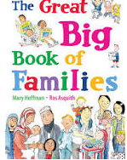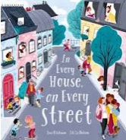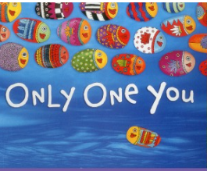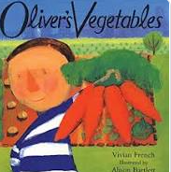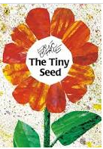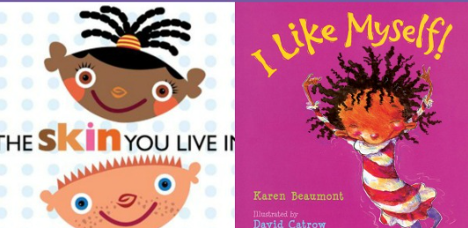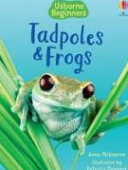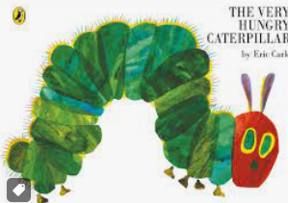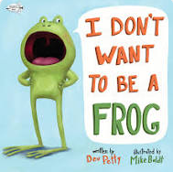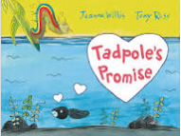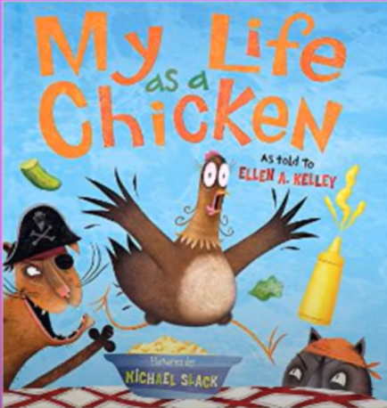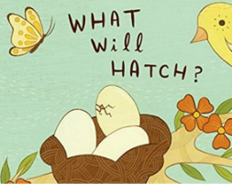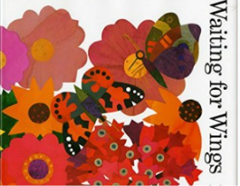

NON FICTION TEXTS- PLANTS, ANIMALS, LIFE CYCLES (SCHOOL LIBRARY)

Reception
Autumn  During the Autumn term, children will… | Spring  During the Spring term, children will… | Summer  During the Summer term, children will…
Past and Present
Talk about the different jobs people do  Name some members of my family and talk about them  Talk about myself and some of the ways I have changed  (Baseline expected ^)  Talk about changes that have happened to me throughout my life  Talk about my family and people in the community and their roles  Become more aware of the past linked to myself and my family and how it has changed  Talk about what I can see in pictures of the past (Own past) | Talk about changes that have happened within my family’s lifetimes e.g. talking to grandparents about schools etc.  Talk about the past e.g. schools and transport  Talk about what I have heard and seen in stories and picture books and how this is different/ the same | Talk about the lives of people I am familiar with  Talk about the roles of people in society  Can give similarities and differences between the past and now  Talk about the past using books and stories talking about the characters, settings and events  (See key texts)
How will this be achieved?
BIG QUESTION: What if Paddington was lost in Daventry?  LANGUAGE OF TIME TO BE USED DAILY DURING CALENDER, TIMETABLING, REFLECTION AND REVIEWS (YESTERDAY, LAST WEEK, LAST YEAR, BEFORE AND TOMORROW, NEXT, FUTURE  Starting school – exploring what came before- what will come next. (Timelines)- Who are we- meeting Paddington the bear? (Recalling knowledge from Pre-school/ building upon)  Taking Paddington to our houses ‘Teaching him about all of our different homes and peoples who live there- older and younger- showing him favourite places, people (Grandparents etc.)  SIGNIFICANT PERSON- EXPLORATION OF GUY FAWKES (TIMELINE- relating to own timeline- plotting teachers born etc. to help understanding how long ago.  VOCABULARY- Long ago, in the past, before. | BIG QUESTION: I wonder what is behind the door.  Door into the past- what would we find- begin to explore differences of times long ago – toys, transport, clothing, school.  Conversations with grandparents- home learning link – find out about their childhood.  (See key texts) | BIG QUESTION: What if the world had no colour?  Door into the past- what would we find- begin to explore differences of times long ago – Television – black and white into colour (Timelines).  Significant person – Louis Braille (Imagine no sight, no colour)  VOCABULARY- Long ago, in the past, before now.
People, cultures and communities
Explore the world around me with all my senses  Accepting and positive about people’s differences  Know there are different countries in the world  (Baseline expected ^)  Make detailed observations of the world around me thinking about my senses- feel, hear, see, smell  Starting to explore the natural world  Talk about how different people celebrate  Start to use stories and pictures to talk about differences in life in other countries  Talk about religion and culture within my country (UK) | Explore and talk about the natural world using what I know from stories/ non-fiction  Draw information from a simple map  Talk about some special places for people in our and other communities  Talk about what is the same and different in life in this country and in other countries  Talk about religion and culture within my country (UK) | Describe the school environment using what I know from  Observation  Discussion  Stories/ non-fiction  Maps  Talk about religion and culture within my country (UK)
How will this be achieved?
BIG QUESTION: What if Paddington was lost in Daventry?  FOREST SCHOOL- FANTASTICS LENSES (Jane consildine)- exploring with our senses- fantastic linked to learning activities as a talk vehicle (literacy lesson plot point links)  Hands on experiences (Using senses)– world around (local area)  Explore maps of local area – noticing, locating key places. (following community walks)  Provide stimulai for children to explore creating maps of local key (small focus) – use of junk modelling, photo graphs- talk about and begin to describe simple routes.  Community walks –What and who is in our local area?  Make a display with the children showing Paddington all the people who we know make up the community.  Talk about and describe people and places in the  local area. Talk about similarities and differences  between places, e.g. the school playground and  the town park. Talk about different ways to  travel, e.g. on foot, by car, train, bus etc- referring to how paths, roads and streets also make up our town.  Use simple geographical words to describe  physical features- e.g. roads, path, street, town, house, shops, church, fields, parks.  Having explore ‘ HOME’ look at the ‘AWAY’ focusing on – South America ‘Peru’- where Paddington is from.  Whats different? Similar?  Delve deeper into celebrations: Harvest  Bonfire Night / Diwali  Christmas Hanukkah  REFERENCE TO RELGIONS -why we celebrate. | BIG QUESTION: I wonder what is behind the door?  FOREST SCHOOL- FANTASTICS LENSES (Jane consildine)- exploring with our senses- fantastic linked to learning activities as a talk vehicle (literacy lesson plot point links)  Doors into places of worship- begin to explore temples, churches- linked to children in cohorts- special places for families (where is special to you and why?)  Doors into different countries- passport day (what would it be like to be here- finding out about life in different countries contrasting to her- children step through the door imagining they have arrived there- find out about- constant reference to difference and similarities  Creating Maps of a place behind the door- e.g. map of bedroom, forest school and classroom. Traditional tale location (see literacy) – creating a simple key for features.  - Reading other maps- teacher models (Locating) find the..  BEGINNING EXPLORATIONS OF GLOBES, ATLASES, MAPS – GOOGLE EARTH  Delve deeper into celebrations:  Family links – Father’s Day  REFERENCE TO RELGIONS – why we celebrate.  Delve deeper into celebrations: New Year Easter Chinese New Year Holi EID  Pancake Day Family links – Mothers Day  REFERENCE TO RELGIONS -why we celebrate. | BIG QUESTION: What if the world had no colour?  FOREST SCHOOL- FANTASTICS LENSES (Jane consildine)- exploring with our senses- fantastic linked to learning activities as a talk vehicle (literacy lesson plot point links)  Hands on experiences – world around (colourful plants, animals) – looking at school environments, immediate environments.
The Natural World
Talk about what I can see outside using a wide vocabulary  Change materials e.g. adding water to cornflour, mixing paint etc.  (Baseline expected ^)  Describe what I can see, hear and feel outside  Talk about the area I live in, including the weather etc.  Talk about forces I feel e.g. push, pull etc.  Talk about the differences in materials | Describe animals and plants (both from photos and real life experiences)  Describe my own environment and local area  Describe another environment e.g. desert, Artic, forest etc.  Talk about the weather linked to seasonal change  Talk about changes e.g. freezing, melting (linked to baking, paint mixing, mud play, etc.) | Explore the natural world  Make observations of animals and plants and use these observations to draw pictures  Contrast the natural world around me with different environments  Talk about some of the changes in the natural world (including seasons and changing states of matter)
How will this be achieved?
BIG QUESTION: What if Paddington was lost in Daventry?  OUR SENSES EXPLORATIONS (See people cultures and communities)  BAREFOOT COMPUTING AWESOME AUTUMN  Community walks –What and who is in our local area?  Make a display with the children showing Paddington all the people who we know make up the community.  Talk about and describe people and places in the  local area. Talk about similarities and differences  between places, e.g. the school playground and  the town park. Talk about different ways to  travel, e.g. on foot, by car, train, bus etc- referring to how paths, roads and streets also make up our town.  Use simple geographical words to describe  physical features- e.g. roads, path, street, town, house, shops, church, fields, parks.  What animals could Paddington meet here? – Woodland (explore closely those getting ready to hibernate, minibeasts, pets)  What animal friends would Paddington have in Peru? Explore differences. (see literacy link- we’re roaming in the rainforest link)  Provide opportunities for children to monitor, talk about and record the weather (Daily weather watchers)  Seasonal explorations to be provided- Autumn – what happens? What do we notice? What changing? Why?  PD link – push and pull (Kinetic letters gross motor movements)  EAD Link – materials (Paddington’s slipper designs- particular materials – what would be best?) | BIG QUESTION: I wonder what is behind the door?  OUR SENSES EXPLORATIONS (See people cultures and communities)  BAREFOOT COMPUTING MAP FUN (DUR TO CONTENT) (OFFICAL TITLE SUMMER FUN)  Hands on experiences (Using senses)– world around (woodland/ other places through the doors- Antartica, desert (contrasting environments)  Using geographical words to describe  physical features- woodland, forest, hills, burrow, trees desert, ice sheet, snow (Polar desert), ice bergs, igloo  Explore animals through the doors- desert, artic, animals in our area.  Exploring plants- using seasonal explorations  Provide opportunities for children to monitor, talk about and record the weather (Daily weather watchers) – reflect on weathers of previous seasons – talk about clothing choices, effects on environments.  Seasonal explorations- winter -exploring freezing closely – melting/ freezing process- set up experiments will it freeze?  Spring – signs of- what has changed? Why? What do we notice? | BIG QUESTION: What if the world had no colour?  OUR SENSES EXPLORATIONS (See people cultures and communities)  BAREFOOT COMPUTING GROWING TIME (OFFICAL TITLE SPRING TIME)  Digging deeper into contrasting environment ‘Antartica’ – exploring differences through colour to there and our immediate environments.  Planting own plants – exploring cycles and growth- what they need. – drawing diaries of a cress plant for example.  Provide opportunities for children to monitor, talk about and record the weather (Daily weather watchers) – reflect on weathers of previous seasons – talk about clothing choices, effects on environments.  Seasonal explorations- Summer – what’s changed? Why? What do we notice?
Key texts for Understanding of the world
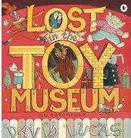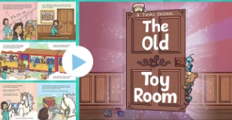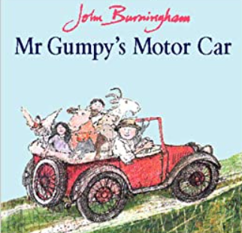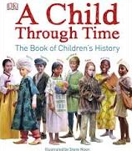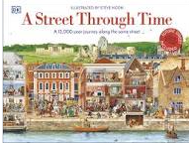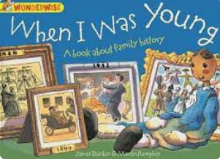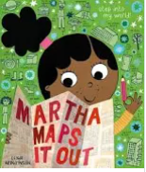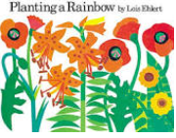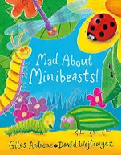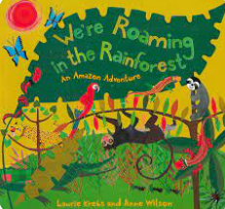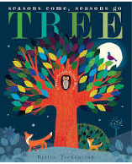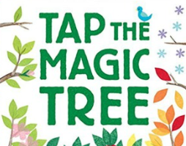
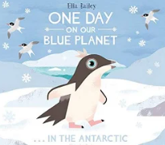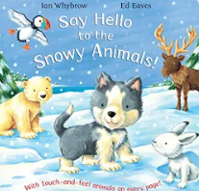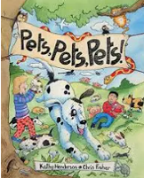

NON FICTION TEXTS- PLANTS, ANIMALS, SEASON, SCIENTIFIC CHANGES (ICE), WEATHER, ANIMALS, CONTRASTING ENVIRONMENTS – DESERT, ARTIC, SOUTH AMERICA, ATLASES (SCHOOL LIBRARY)
Assessment
Half termly assessment trackers completed
Weekly evaluations.
Observations
Review and reflect – assessment questions (plan in review to check knowledge)
Plenaries
Interventions
Pre-teach

