EYFS Curriculum Progression
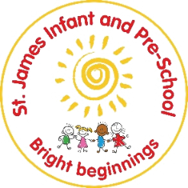
Physical Development
Preschool
Autumn  During the Autumn term, children will… |  |  | Spring  During the Spring term, children will… | Summer  During the Summer term, children will…
Healthy living and hygiene |  | By the end of Autumn term, children will use the toilet independently. | Manage all toileting hygiene needs including washing and drying hands  Know how to handle some of my own hygiene needs e,g. teeth brushing, hand washing | Use toilets and are dry throughout the day.  Know how to make healthy choices and comment on why we need to.
Gross Motor Skills |  | Run, jump and hop  Climb stairs using alternate feet | Decide how to match my movements to the task e.g. run to play chase, crawl through a tunnel, etc. | Balance (balance bikes, scooters, climbing)  Skip, hop and stand on one leg.  Use large scale muscle movements
Fine Motor Skills |  | Starting to use motor skills to carry out tasks e.g. pouring drinks and exploring tools (playdough tools etc.)  Show a preference for a dominant hand. | Start to eat using a knife and fork  Start to manage zips, putting on coats etc. | Use one handed tools confidently  Use a comfortable grip with good control when using pencils
How will this be achieved?
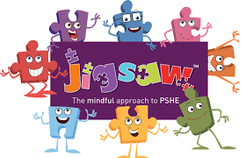  Piece 1 ‘Everybody’s body’ (Healthy me)  Piece 2 ‘ We like to move it, move it’  Daily personal hygiene encouragements/ modelling- reward systemes for toileting needs.  Visual prompts introduced and daily references.  Fine motor skills:  Scissor skills – Card 1  Independent snack times implemented- hygiene and prepartations.  Frequent mark making opportunities- large and small scale.  Write dance introduced (Continued across the year)  Dough Dance introduced (Continued across the year)  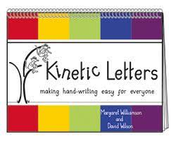  Riding bikes and scooters  Can ‘walk’ a balance bike - Can use feet to scoot a balance bike and maintain balance - Can maintain balance while Manoeuvring around corners |  |  | TOPIC: IS IT MOVING? – exploring what need to make our bodies function to the best of their ability for variety of purposes.  Piece 3’ Food glorious food’  Piece 4 ‘ Sweet Dreams’  Developing personal hygiene understanding ‘Home learning links- tooth brushing’ – visit from the dentist/ dental nurse- promoting oral health- Provision role play opportunities.  Fine motor skills:  Scissor skills – Card 2  Line dancing (LITERACY WRITING) up, down, side to side.  Wavy lines, zig zags, arches.  Continue to develop finger strength -  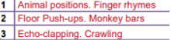  Riding bikes and scooters  Stops a bike effectively using brakes - Pedals and maintain balance for a few feet down a slight incline  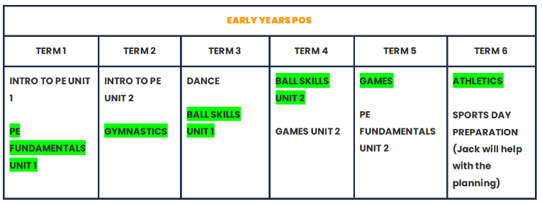 | Embed – healthy choices- stories, social stories.  Piece 5 ‘Keeping Clean’  Fine motor skills:  Scissor skills – Card 3  Line Dancing (LITERACY WRITING)  Circles, name writing.  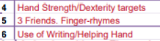  Introduce Brave and Scared Monkeys  Riding bikes and scooters  Pedals and maintain balance for a few feet on a flat surface - Can brake at a specific point with control  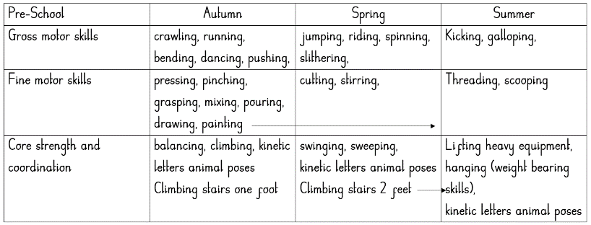
Reception
Autumn  During the Autumn term, children will… |  |  | Spring  During the Spring term, children will… | Summer  During the Summer term, children will…
Healthy living and hygiene | Understanding healthy choices and why this important. |  | Develop a further understanding of how to keep yourself healthy. |  | Develop all the skills they need to manage the day. –personal hygiene
Gross Motor Skills | Confidently climb stairs using alternate feet  Develop movement (using age appropriate bikes, scooters etc.)  Work with others to manage large items  Use lots of different ways of moving appropriately  Climb over, under and through obstacles |  | Throw, kick, pass and catch a large ball  Move and use both large and smaller scale equipment (building blocks etc) |  | Travel around space and obstacles safely  Show strength, balance and co-ordination in movement  Move in different ways- run, jump, skip, climb
Fine Motor Skills | Show a preference for a dominant hand with a comfortable pencil grip  Draw pictures with some detail  Show good pencil control when mark making and drawing  Knows how to use cutlery and other one handed equipment |  | Sit at a table to write  Hold a pencil in a tripod grip  Use scissors. |  | Hold a pencil effectively (tripod)  Use a range of tools e.g. scissors  Draw with accuracy
How will this be achieved?
Piece 1 ‘Everybody’s body’ (Healthy me)  Piece 2 ‘ We like to move it move it’  Piece 3 ‘Food Glorious food’  Our healthy lunchboxes- starting school, having lunch, our good choices.  Fine motor Skill: Scissor development- card 4 /5  Pencil control: ART UNIT PLAN COVERAGE  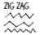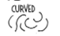  Using a variety of media and variety of scale, children practice and refine their pencil control – to create the types of lines above.  Children can work on paper, walls, the floor  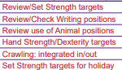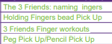  Gross motor skills development:  Riding bikes and scooters: follows at a sensible distance behind another rider - Pedals and maintain balance while manoeuvring around obstacles - Follows a path set by another ride.  Across the year outdoor provisions mirror skill progression from PE to support and consolidate |  |  | (Healthy me)  Piece 4’ Sweet dreams’  Piece 5 ‘Keeping Clean’ – glitter germs  FUNKY FINGERS STATION-BESPOKE TO CHILDREN’S NEEDS  Fine motor Skills: Scissor development- card 6/7  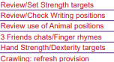  ART UNIT PLANS- DRAWING PROGRESSION  Riding bikes and scooters: Turning in directions – left, right. - introducing language. |  | Embedding taught elements- recapping!  Healthy lifestyle texts-  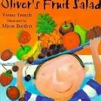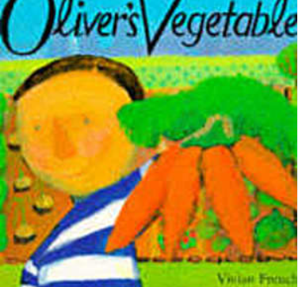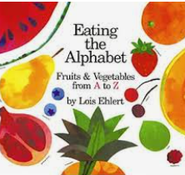  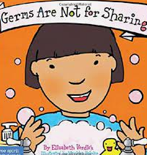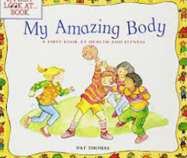  FUNKY FINGERS STATION-BESPOKE TO CHILDREN’S NEEDS  Scissor development- card 8- embedding skills  ART UNIT PLANS- DRAWING PROGRESSION  Riding bikes and scooters: Turning, following routes, speed, direction, stopping.
 |  |  | 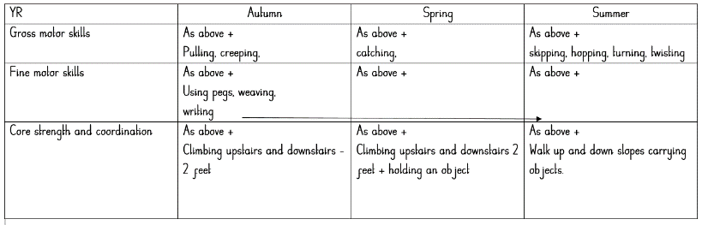
Assessment
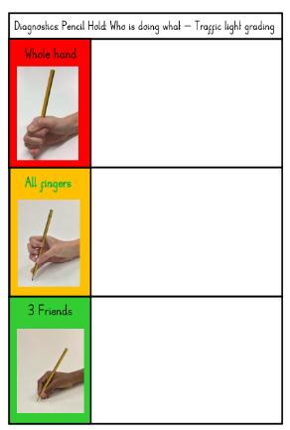
Half termly assessment trackers completed- Observations (Ongoing)
Weekly evaluations.
Pencil grip—

PE ASSESSMENTS TERMLY- COACH

Interventions
Prime interventions tool kit – implement to support specific areas of needs with childrens daily learning and play.
Narrowing the gap- fine motor development targets
Targetted independent learning practise.

