EYFS Curriculum Progression

Literacy (Writing)
Preschool
Autumn  During the Autumn term, children will… |  |  | Spring  During the Spring term, children will… | Summer  During the Summer term, children will…
Writing
Letter formation  (LINKS WITH PD) |  | Know how to start to make marks with a variety of materials e.g., sticks in mud, flour, paint, etc.  Know how to demonstrate good gross motor skills in making large marks e.g. playground chalk, water painting etc. | Know how to demonstrate good fine motor control when using tools e.g. scissors, threading, etc. | Know how to write some letters with good formation e.g. the letters from my name
Spelling |  | Know how to tune into sounds during listening games  Know how to tune into the sounds in words- showing understanding e.g., Phase 1 Toy Talk for blending and segmenting | Know how to show awareness of alliteration e.g. the sssssliperry ssssnake  Know how to segment words in the order in which they occur (with support)  Know to change the initial sound orally to make new words e.g., at- hat, cat, mat, sat | Know how to orally segment single sound CVC words e.g. c-a-t  Know to say the initial sounds in most words
Composition |  | Know how to add marks to pictures giving meaning to them  Know how to write the first letter of my name | Know how to use a wider print knowledge for writing.  Children will write some of my name e.g. first two letters. | Know how to apply print knowledge to my emergent writing.  Know how to and will write my own name  Know how to add marks to show their name and can use and can apply some print knowledge to writing e.g. m for mummy
How will this be achieved?
(Phase 1 letters and sounds tuning into sounds provided across the year in adult led and provision opportunities.)  Environmental sounds, instrumental sounds, body percussion, Rhythm and rhyme, alliteration, voice sounds, oral blending and segmenting.  Key texts (See literacy READING to provide opportunities for mark making- reason for writing exposure)  Adults continously modelling mark making with writing and drawings. This will be subconsiously providing children will pre-teaching awareness of letter shapes, combination of letters in words, breaks between words (finger spaces). |  |  | PD LINKS – SEE PD PROGRESSION FINE MOTOR SKILLS/ SCISSOR DEVELOPMENT CARDS.  (Phase 1 letters and sounds continued)  Continuous provisions to allow opportunities to mark make throughout the entire year using a variety of mediums to develop both gross and fine motor skills, indoors and outdoors.  Writing area on going all year with free access to various materials for mark making. | (Phase 1 letters and sounds continued)    Begins  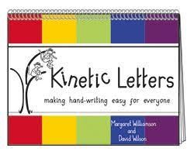  Begin to explore letter moves for single letters.
Reception
Autumn  During the Autumn term, children will… |  |  | Spring  During the Spring term, children will… | Summer  During the Summer term, children will…
Writing
Letter Formation  (LINKS WITH PD) | Know how to write some letters from their name.  Know and will write some lowercase letters correctly.  Know and will form some uppercase letters that they know (e.g. own name, Mum, Dad, sibling name, etc) |  | Know how to write most lowercase letters correctly  Know how to write some uppercase letters correctly  Know and will use a tripod grip |  | Know how to write most upper- and lower-case letters correctly  Know how to consistently hold their pencil in a good tripod grip
How will this be achieved?

(PD LINKS-STRENGTH, DEXTERITY, WRITING POSITIONS AND PENCIL PICK UP ROUTINES)
SEE CHART FOR TERMLY BREAKDOWN BELOW
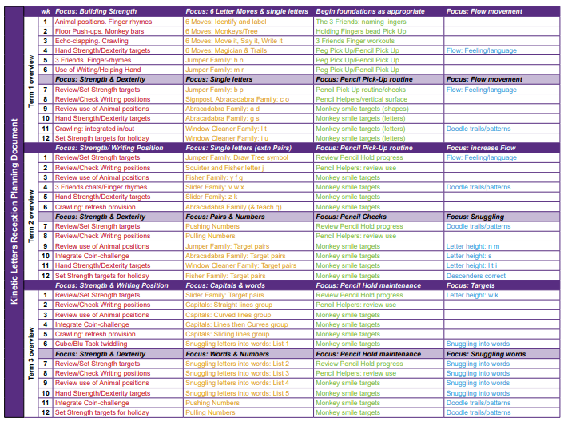
Spelling | Knows how to and will orally segment single sound CVC words e.g. c-a-t.  Knows how to and will hear and say the initial sounds in most words.  Knows how to identify known letters to match initial sounds.  Knows to match (RWI-set 1) letters and sounds  Knows how to and will write CVC words and labels e.g. c-a-t |  | Knows how to and will match Set 1 and 2 sounds speedily letters and sounds.  Knows how to write CVC words and labels.  Knows how to spell some RWI red words (band 1) |  | Knows how to accurately and consistently write CVC words with sounds and letters I know  Knows how to write tricky words taught accurately
Composition | Knows and will write some initial sounds  Knows and writes their own name  Knows how to and will write simple labels (using simple vc/cvc word)  Knows how to and will start to write simple captions  Knows how to say a simple sentence for writing (orally and count words) |  | Knows how to write captions  Knows how to write short sentences (set 1/ 2 sounds –cvc)  Shows awareness and start to use finger spaces between my words.  Knows how to read sentences back |  | Knows how to and will write simple sentences  Knows how to and will read their own sentences and teachers can read individual’s  Sentences- knows how finger spaces are used.  Knows about and shows an awareness of capital letters.
How will this be achieved? (BE MINDFUL OF THOSE NEEDING PHASE 1 (PRE-SCHOOL INTERVENTIONS FOR TUNING INTO SOUNDS)
Literacy reading/ writing Unit plans  - Name writing  - Initial sound labelling  - Initial and final sound labelling  - CVC word labelling  - Oral composing simple captions- writing.  (Exploring various genres for writing- narrative, letter) |  |  | Literacy reading/ writing Unit plans  -CVC labelling  - Orally composing simple sentence ideas. (Lots of T4W)  - building sentences using CVC words.  Introducing and using ‘High five heroes.  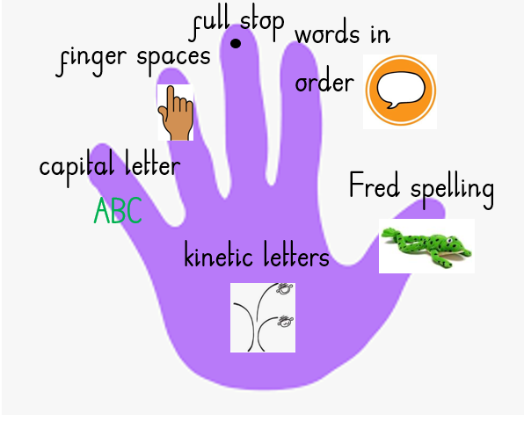  (Exploring various genres for writing- narrative, non-fiction, Recount (Journey), instructions) |  | Literacy reading/ writing Unit plans  - Writing in sentences  - Orally composing  - Own ideas  Consistently using:  (Exploring various genres for writing- narrative, poetry)
Assessment
Half termly assessment trackers completed
Weekly evaluations.
First of the month – assessment writing piece
Provision books.
On-going formative observations
Kinetic pencil grip trackers

Interventions
Narrowing the gap- targeted children
Adult led- target misconceptions there and then.
Busy blocks jobs- unique child targeted independent practise.
Purposefully planned practise and consolidation provisions.

