EYFS Curriculum Progression
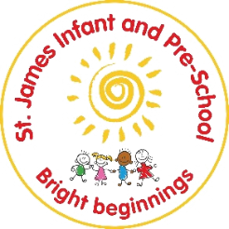
Literacy (Reading)
Preschool
Autumn  During the Autumn term, children will… |  | Spring  During the Spring term, children will… | Summer  During the Summer term, children will…
Reading
Word reading  (Phase one phonics) | Notices print e.g. familiar logos, bus numbers, my name/ first letter (Baseline expectation)  Has an understanding of letters and print e.g. page sequencing, book parts, etc.  Knows how to and is starting to notice rhyme and can clap syllables | Know how to hear the sounds in words and am starting to blend them back together  Knows how to spot words with the same initial sound | Knows how to use good phonological awareness including oral blending skills, rhyme, alliteration and syllables
How will this be achieved?
Language RICH Environment- use of familiar print (logo books), names.  Reading areas- access to books.  Phase 1 phonics – tuning into sounds |  | Phase 1 phonics-  Aspect 4: Rhythm and rhyme ■ Aspect 5: Alliteration ■ Aspect 6: Voice sounds ■ Aspect 7: Oral blending and segmenting | 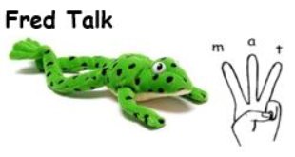  Phase 1 phonics-  Aspect 4: Rhythm and rhyme ■ Aspect 5: Alliteration ■ Aspect 6: Voice sounds ■ Aspect 7: Oral blending and segmenting
Comprehension  (Recall, retell and sequence) | Enjoys stories, songs and rhymes (Baseline expectation)  Knows how to start to develop play around my favourite stories and props. | Knows how to sequence events from stories that have been heard. | Knows how to and can talk about stories that have been heard  Knows how to and can retell some familiar stories
Comprehension  (vocabulary) | Knows they can repeat words and phrases a familiar book  Knows how to join in with some words in familiar songs.  (Baseline expectation)  Knows and starts to join in with familiar stories, rhymes and songs. | Know key vocabulary and is starting to use different vocabulary from books in my play. | Knows and join in with familiar rhymes and songs (and some patterned stories).  Knows and uses some story language or new vocabulary in my play.
How will this be achieved?
 (See also EAD)  ON-GOING ACCESS TO RHYMES  CROSS CURRICULAR  USE OF T4W STRATEGIES WHEN EXPLORING KEY TEXTS  USE OF FANTASTICS (Jane considine to develop story based language.  Role play and small world opportunities linked to key texts.  Reading for pleasure texts: PIE CORBETT READING SPINE TEXTS  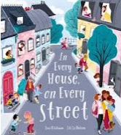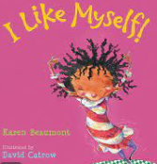  (See other strands for further for links to other key texts) |  | Role play and small world opportunities linked to key texts.  Reading for pleasure texts: PIE CORBETT READING SPINE TEXTS  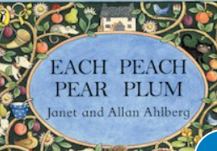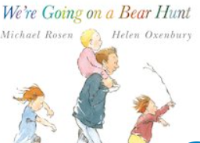  (See other strands for further for links to other key texts) | Role play and small world opportunities linked to key texts.  Reading for pleasure texts: PIE CORBETT READING SPINE TEXTS  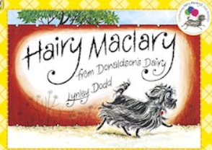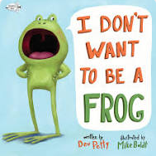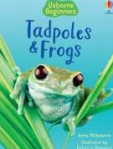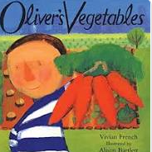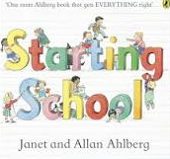  (See other strands for further for links to other key texts)
Key Texts
Topic:What if things change?  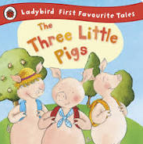 (Materials UW link)  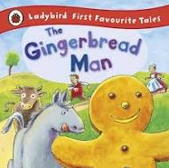  (See also nursery rhyme progression across the year in EAD)  Poems- 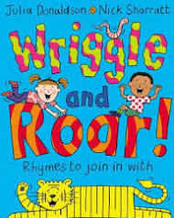 |  | Topic: Is it moving?  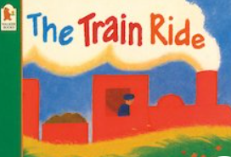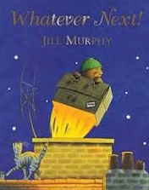  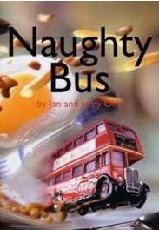  Poems-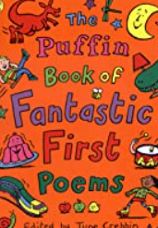 | Topic: Will it grow?  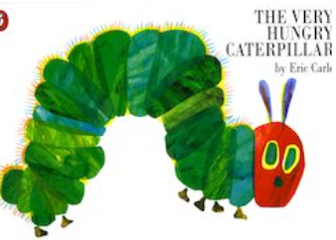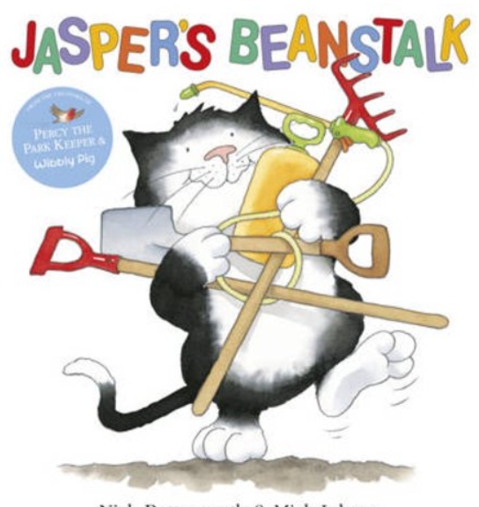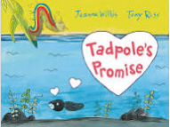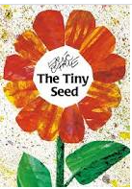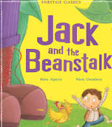  Poems- Revisiting favourite rhymes and poems
Reception
Autumn  During the Autumn term, children will… |  | Spring  During the Spring term, children will… | Summer  During the Summer term, children will…
Reading
Comprehension (Understanding and retelling) | Knows how to talk about stories I have heard  (Baseline expectation)  Knows how to retell the key events in stories  Knows how to and is starting to recall facts from non-fiction | Knows how to retell key events from stories have been read  Knows how to describe the key events in detail  Knows and recall facts from a non- fiction book |  | Knows how to explain what I have read or has been read to them  Knows how to retell simple stories  Knows and recall facts from information
Comprehension (Prediction) | Knows how to talk about stories I have heard  (Baseline expectation)  I can talk about what has happened in the story so far | Knows how to predict and says what might happen next linked to other similar stories |  | Knows and say what they think might happen next with increasing confidence.
Comprehension  (Vocabulary) | Knows and join in with familiar rhymes and songs (and some patterned stories)  (Baseline expectation)  Knows how to listen carefully to stories, rhymes, non-fiction and songs | Knows how to talk about stories, rhymes, non-fiction and songs. |  | Knows and can use new vocabulary throughout my play
How will this be achieved?
Reading for pleasure texts. Echolalic, calm, responsive, DEAR and performance. (across the year reads- ensuring all techniques are used)  Wide range of Paddington stories (Theme based)  Jex Alborough – My Friend Bear, Where’s the Teddy, It’s the Bear  ‘Old Friends’ - preschool reading spine books plus books from Autumn 1  Wide range of Paddington stories  Slowly. Slowly, Slowly said the Sloth – Eric Carle  One Day on our Blue Planet  Rosie’s Walk  ‘Old Friends’ - preschool reading spine books plus books from Autumn 1  (SEE EAD)  ROLE PLAY/ SMALL WORLD OPPORTUNITIES. (Unit plans incorporating Pie Corbett (T4W/ Jane consildine fantastic) into small term plans to feature elements of drama, key vocabulary exploration, retelling plot points) |  | Fiction – You Choose Fairy Tales by Pippa Goodhart  Fiction – Pick a Story by Sarah Coyle  Alternative fairy tales such as A Chair for Bear / Beware of the Bears / Goldilocks and Just One Bear / Keep out, Bears About!  Non-fiction – Penguins (Usborne beginners)  Poems – Antartic Antics – poems about penguins Fiction – Variety of traditional tales Fiction – Shhh! – Sally Grindley  Fiction – The Jolly Pocket Postman  Fiction – Little Read Riding Hood  (hashtag list to be built up of key elements of traditional tales)  Non-fiction – Look Inside the Woods (Usbourne)  Non-Fiction – A Walk in the Woods – Flora Martyn and Hannah Tolson (seasons)  Poetry – There was a princess long ago (song linked to Sleeping Beauty)  Poetry – When Goldilocks went to the house of the Bears (song)  ROLE PLAY/ SMALL WORLD OPPORTUNITIES.  (Unit plans into small term plans to feature elements of drama, key vocabulary exploration, retelling. prediction plot points)(Unit plans incorporating Pie Corbett (T4W/ Jane consildine fantastic) |  | The Colour Monster  The mixed up chameleon  Wake up Color Pup  The day the crayons quit  Usborne big book of colours – non-fiction  Say hello to snowy animals non-fiction  One day on our blue planet – non-fiction  The Little Plant – Kate L Brown  Mixed – Aree Chung  Swatch; The Girl Who Loved Color – Julia Denos  Colour Blocked – Ashley Sorenson  My Many Coloured Days – Dr Seuss  Mix it up  ROLE PLAY/ SMALL WORLD OPPORTUNITIES.  (Unit plans into small term plans to feature elements of drama, key vocabulary exploration, retelling. prediction plot points  (Unit plans incorporating Pie Corbett (T4W/ Jane consildine fantastic)
Key Texts
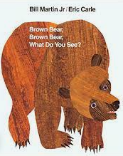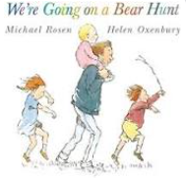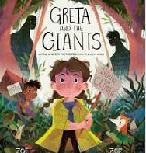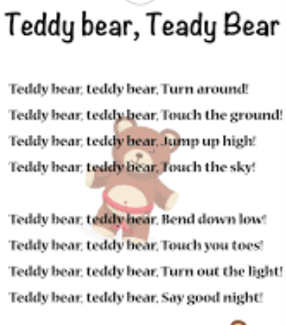 (Poem focus) 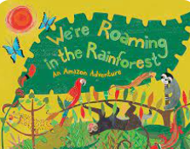 Nursery rhyme anthology/ Teddy bears picnic poem |  | 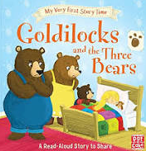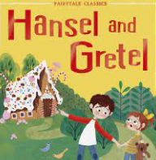 (Hansel and Gretel performance poem)  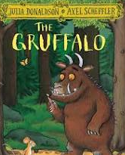 (Focus poem- gruffalo poem/ performance) |  | 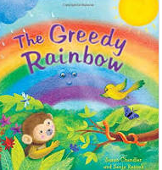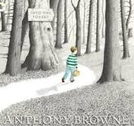(with reference to previous taught traditional tales featuring – Role play)  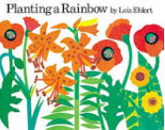 (Focus poem Colour by Christina Rosetti)  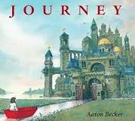 (no word text)  (Focus poem- when I grow up by William wise)
Grapheme (phoneme matching) | Knows how to hear and say initial sounds for words  Knows and can say the sound for some letters (e.g. from my name or familiar names- Mum, Dad, etc.)  (Baseline expectation)  Knows how to match most of the set 1 letters and sounds | Knows how to match all set 1 single letters and sounds  Knows and can identify some digraphs (Set 1 special friends) |  | Knows and can match the letter and sound for all set 1 single sounds and digraphs (Special friends)  Knows and can match the letter and sound for at least 10 special friends.  Vocab development  Unit plans  Fantastics  T4W
Blending and segmenting | Knows how to orally segment words (e.g. adult says cat and child says c-a-t)  Knows how to orally blend words (e.g. adult says m-a-n and child says man)  (Baseline expectation)  Knows and say the set 1 sounds in CVC words  Knows how to start to blend the sounds together  Knows how to segment and blend CVC words  Knows how to and it starting to read captions e.g. the cat and the dog | Knows how to segment the sounds in CVC words for reading  Knows how to blend the sounds in CVC words for reading  Knows how to segment and blend simple words matched to their phonics knowledge  Knows how to and can read captions  Knows how to read some of the set 1 red words |  | Know how to read CVC words containing all set 1 sounds  Knows how to read CVC words containing known set 1 special friends  Knows how to read simple sentences and books matched to my phonics  Knows how to read tricky words from set 1 correctly.
How will this be achieved?
Assessment
Half termly assessment trackers completed
Half termly RWI assessments completed
Weekly evaluations.
On-going formative observations

Interventions
Narrowing the gap- targeted children
Adult led- target misconceptions there and then. - pinny time, FTT
Busy blocks jobs- unique child targeted independent practise.
Purposefully planned practise and consolidation provisions.

