EYFS Curriculum Progression
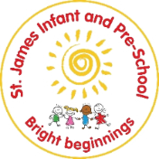
Expressive Arts and Design
Preschool
Autumn  During the Autumn term, children will… | Spring  During the Spring term, children will… | Summer  During the Summer term, children will…
Creating with materials
Know how to explore art materials for large- and small-scale art e.g., drawing, paint, sculpture  Know how to use different art materials and am starting to refine my ways of creating art.  Know how to explore colour, shape and lines | Know how to ese self- chosen materials to create my own ideas  Know how to explore colour, shape and lines | Know how to use a range of art materials and explore joining.  Know how to explore colour mixing purposefully and freely  Know how to draw with increasing complexity and details.  Know how to show different emotions in their drawings and paintings.
How will this be achieved?
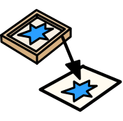      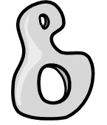  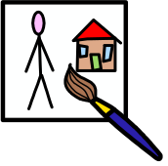  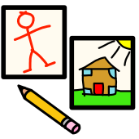  Children will experience activities that allow them to explore materials in lots of different ways:  Drawing = circles and shapes  Use different lines to show emotions and  feelings  Begin to represent objects, e.g. a person  Use pencils with some control  Painting = with a variety of tools; rollers,  toothbrushes, kitchen utensils / easel  painting (familiar items from home)  Recognnise that when colours are mixed a  new colour is made.  Sculpture = playdough – pressing, rolling, flattening,  squeezing, etc Talk about how it has  changed.  Collage = Begin to use scissors to snip paper  Textiles = X  Printing = X  Work of other artists = Illustrators  – see Literacy plans.  Eric Carle,  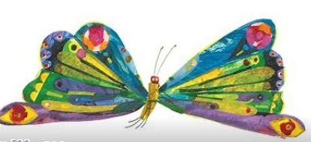  Identify how their work is similar to that of the artist | Children will experience activities that allow them to explore materials in lots of different ways:  Drawing = enclosing shapes using continuous lines, to  represent objects e.g. vehicles  Draw from observation and from  imagination.  Use drawing to represent loud noises  Use pencils with confidence  Painting = Use paint using fingers and other parts  of bodies, e.g. finger prints / footsteps,  etc  Make paint move – spraying, rolling watery  paint, rolling objects through paint  Begin to name colours, possibly make a  Colour choice  Sculpture = Make simple models of vehicles – junk  modelling / recycled materials  Collage = Cut pieces of paper with purpose –  creating animals and transport – build up a  animal environment e.g. farm or road scene  Textiles = X  Printing = see painting above / using wheels of  different sizes to print with  Work of other artists = Illustrators  – see Literacy plans.  Lois Ehlert  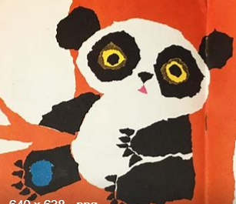  Identify how their work is similar to that of the artist | Children will experience activities that allow them to explore materials in lots of different ways:  Drawing = use pencils with good control and a comfortable grip  Painting = watercolour painting, squirting paint, splatter painting (soaked sponges)  Sculpture = animals that live in water – using papier mache technique  Collage = Cut shapes out using scissors – paper, tissue paper, fabric to build an under water scene  Textiles = paint onto fabric  Printing = stamping with sponges  Work of other artists = Illustrators  – see Literacy plans.  Axel Scheffler  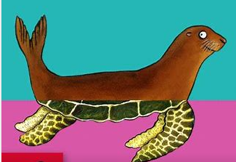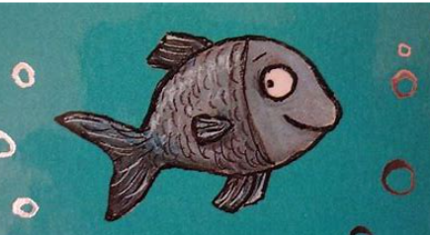  Identify how their work is similar to that of the artist  Continous provisions to allow self expression with independent access to open ended materials allowing them to explore and inquire in an active and participatory way, expressing their thoughts, actions and ideas in many ways.
Music
Know how to enjoy joining in with songs, rhymes and music  Know how to make rhythmic sounds e.g. banging a drum  Know and remember and sing a range of familiar songs  Know how to explore the different sounds musical instruments make | Know how to sing own created songs and follow pitch, melody and tone  Know how to play musical instruments with greater control and purpose | Know how to sing, respond to and create music with instruments showing understanding of pitch, melody and rhythm.
How will this be achieved?
Aspect two – general sounds discrimination (Instrumental sounds) – Phase 1 phonics.  Musical Jam sessions  Explore songs- beginning to notice and hear changes, fast, slow, loud, quiet- encouraging expression of feelings towards music. Encouraging movement to music- developing rhymthic movements.  National Nursery Rhyme week (learning popular rhymes) – Miss Polly had a dolly (doctor role play link), twinkle twinkle little star- opportunity to explore innovated versions, dingle dangle scarecrow.  Also mathematics links – Two dicky birds  Action songs  Use of key texts to develop rhythm.  Christmas Nativity. | Aspect two – general sounds discrimination (Instrumental sounds) – Phase 1 phonics.  Learning new nursery rhymes  - Old mcdonal had a farm  - Baa baa black ship  - Mary had a little lamb  - Row, row, row your boat – opportunity to explore innovatated versions)  - The wheels on the bus  Use of key texts to develop rhythm.  Parents – rhyme time sessions – show what we know.  Continous provisions to allow for continous access to music and movement- area designated with varying instruments, stage, music. Enhanced with key rhymes, texts, songs learnt e.g. at christmas time- nativity/christmas songs. | Aspect two – general sounds discrimination (Instrumental sounds) – Phase 1 phonics.  Write dance (responding to musical sounds)  Learning new nursery rhymes  - There’s a worm at the bottom of the garden  - Incy wincy spider  - Sessel is my caterpillar  Use of key texts to develop rhythm.  Parents – rhyme time sessions – show what we know.
Being imaginative and expressive
Know how to express my ideas through play, particularly pretend play  Know how to engage in simple pretend play, using some objects to represent others | Know how to reate more complex small world set ups to adapt and create stories | Know how to start to develop own stories linked to what children know through role and small world play
How will this be achieved?
Topic: What if things change?  Role play: Changing room- fancy dress shop- who can I become?  Home corner  Occupations- police, fire station, doctors.  Loose parts and small and large construction opportunitites.  Role play experiences linked to key texts (see Literacy progression) – modelled retelling | Topic: Is it moving?  Role play- home to away- bus stops, train station, airport (Including travel to children in settings home countries), boats.  Animal movements- farm, zoo.  Role play experiences linked to key texts- modelled retelling | Topic: Will it grow?  Continous provisions to allow for role play and small world play experiences at all times- mixing both planned (topic/ key text linked role play and small world experiences with child initiated, interest driven ideas.  Role Play: Garden centre, vegetable store/ supermarkets.  Transition support- school role play  Role play experiences linked to key texts- modelled retelling
Key texts for Expressive Arts and Design
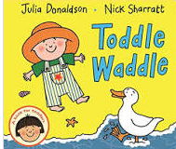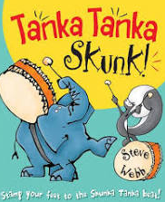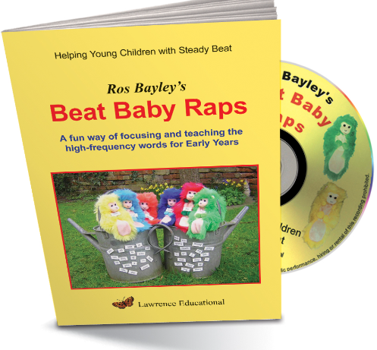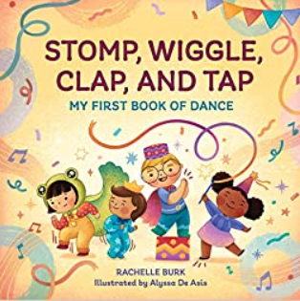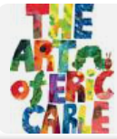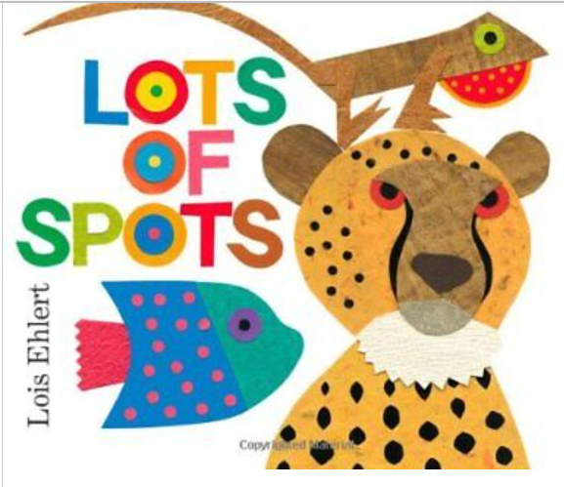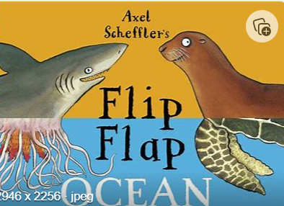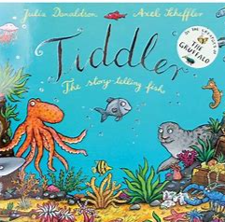
Reception
Autumn  During the Autumn term, children will… | Spring  During the Spring term, children will… | Summer  During the Summer term, children will…
Creating with Materials
Know how to join materials together  Know how to explore art materials and colour and colour mixing.  Know how to develop my own ideas for art  Know how to use various tools for artwork and design e.g. playdough tools  Know how to select own art and design materials to create with  Know how to develop own ideas for art and start to talk about them (with adult support)  Can tell others what their artwork is and signal key parts e.g. this is mummy, this is her hair etc. | Know how to uses scissors and one-handed tools to create art safely and more accurately (playdough tools, paintbrushes etc.)  Know how to combine different techniques e.g. collage, paint, crayon, clay to create art  Know how to talk about own artwork or designs- linked to some of the materials/ techniques used | Know how to safely use tools with control e.g. scissors  Know how to explore using materials and techniques  Know how to design art/ a product thinking about colour, texture, material and function  Know how to explain what they have made  Know how to talk about how they made it
How will this be achieved?
Drawing – To show control using pencil or  black felt tips – producing a variety of line  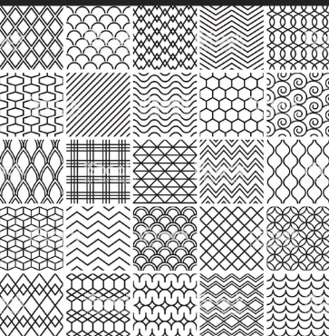 line art  Develop this by using Inca patterns as a basis  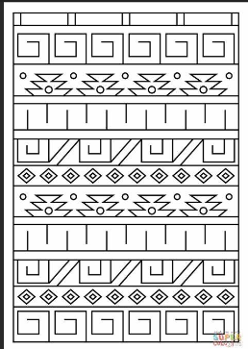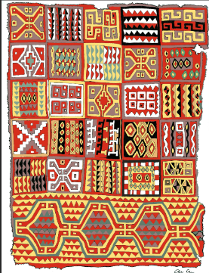  Inca pattern  To make patterns using other line makers;  fingers, sticks, brushes, - in sand, in paint, in  glitter  To draw recognisable shapes; circles,  rectangles, crosses (possibly triangles and  diamonds)  To draw Paddington and his family, compare  with a drawing of own family – talk about it.  (Enclosing shapes to make recognisable  shapes and objects)  To colour in – staying in the lines.  Painting – To name primary colours (relating  it to Paddington’s hat and coat and wellies +  found objects in their environment)  To paint pictures of Paddington – choosing a  colour for his coat and explaining  preferences. Compare to the illustrations in  the book.  To trial mixing primary colours together –  observe what happens – do they know that  they have made orange, green, purple?  To roll out playdough tile and draw faces /  animals into it  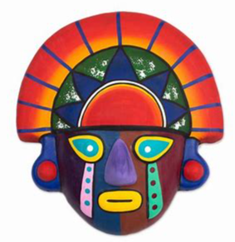  Collage – Sort and arrange a variety of  materials into colour groups.  Explore repeating patterns by using squares  of different materials.  Textiles – to use fabric to create patterns  Printing – use wood blocks, stamps to press  on and take off to reveal the print  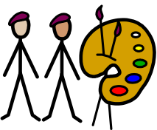  Look at the illustrations of Peggy Fortnam,  Inca art  Other pattern work that could be used; Wassily Kandisky, Paul Klee  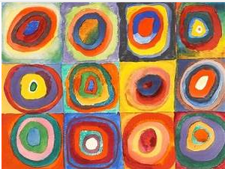  Seasonal experiences;  - Describe the colours of the seasons; autumn and winter  - Fireworks  - Christmas crafts and cards  Across the year scissor skills development (See PD scissor development cards)  Continous provisions to allow self expression with independent access to open ended materials allowing them to explore and inquire in an active and participatory way, expressing their thoughts, actions and ideas in many ways.  Specific key vocabulary allows children explain procress and outcomes with confidence using subject specific vocabulary. | Use imaginations to create art work  Drawing = To use different materials to  draw – pastels, chalk, felt tips  To combine shapes together to make images –  e.g. house, sun etc (whatever they can see  behind a door) / referencing surrealist art  To colour in staying in the lines, making  correct colour choices / or purposefully  choosing incorrect colours to imagine strange  images. Explain this.  Painting = Name primary colours and begin  to name secondary colours / add white and  black to create shades / Brush control, use  of different size brushes, Use junk materials  to apply paint.  Sculpture = To use playdough and straws to  create Dali’s Space Elephant or other  imagined creatures – what things can they  distort and change?  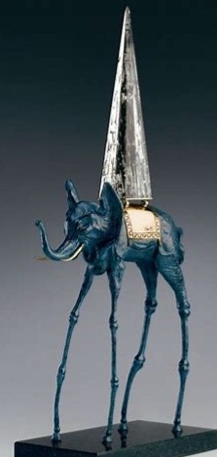  Balance shapes on top of each other –  working like Miro. (junk modelling, playdough)  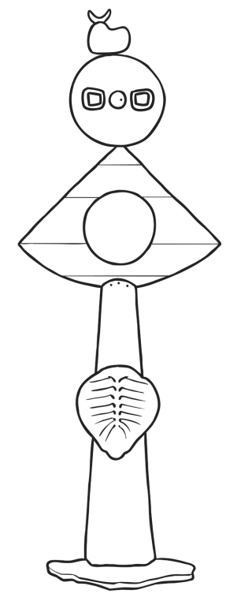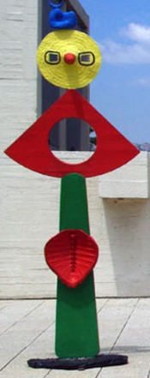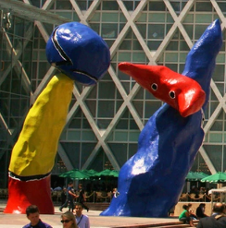  Collage = To develop cutting skills –  creating shapes and imagination to create  own work. (Automatic drawing and creating –  just like Surrealists)  Textiles = Gluing and sticking fabric over  and under to create images.  Printing = Use mathematical shapes to print  with.  Work of other artists = with support  describe the work of an artist / use key  vocabulary to demonstrate knowledge and  understanding  Salvador Dali, Joan Miro  Surrealism | Tate Kids  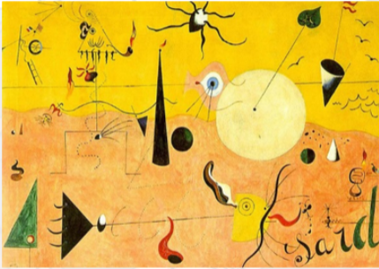  Seasonal experiences;  - Describe the colours of the seasons: spring  - Easter crafts, cards  - Mothers’ day cards | Drawing = To use different materials to  draw with – pastels, chalk, felt tips, charcoal  – comparing black with colourful  Draw a self-portrait – including details such  as eyes and lots of detail)  Draw a self-portrait in the style of Picasso  – lots of colour used (work on top of  photograph of themselves)  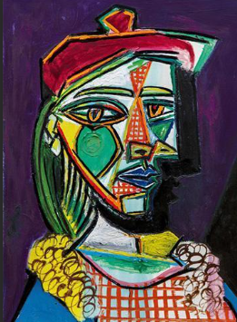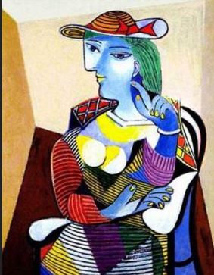  Painting = Name primary colours and begin  to make changes to colours by adding white  and black or mixing colours together  Brush control, use of different size brushes  Copy one of the artists’ work – working from  the picture  Sculpture = X  Collage = Sort and arrange materials (into  colour groups)  Matisse style 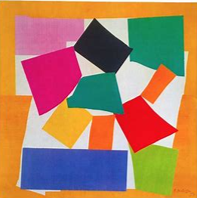 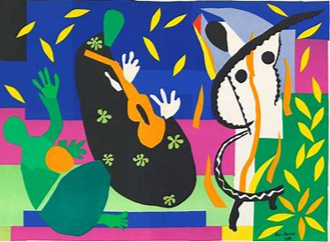  Textiles = As above – to use squares of  fabric to create art work.  Printing = X  Work of other artists = with support  describe the work of an artist  Surrealist; Pablo Picasso  Post-impressionist; Henri Matisse  Seasonal experiences;  - Describe the colours of the seasons: summer  - Fathers’ day (special person) cards  - End of year activities
Music
Remember most of a song to sing  Make up my own “silly” songs  Remember and sing songs  Knows how to start to match the melody and pitch of others  Know some popular songs and can sing them supported by an adult  Knows how to listen and respond to sounds  Knows how to sing with others and supported by an adult | Knows how to sing well known songs in a group or alone and match the pitch and melody  Knows how to listen carefully to music and start to move to it  Knows how to join in with singing and dancing | Knows and sings well known nursery rhymes  Knows and sings some familiar songs (Christmas play, singing assembly songs etc.)  Knows how to perform songs, rhymes, poems and stories alone and with others  Knows how to try to move in time with music
How will this be achieved?
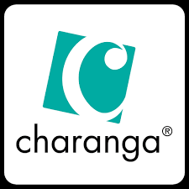 Units: Me, My stories  - Listen and respond  - Explore and create – including explorations of pitch, pulse (steady beat) and rhythm.  - Singing  - Beginning to share and perform.  National Nursery rhyme week- Grand old duke of York, humpty dumpty (previous taught rhymes)  Changing the words to know rhymes and songs.  (Innovations)  Throughout the year- exploration of number songs are evident through NCETM maths  Christmas performances- dancing and singing  Harvest performances -- dancing and singing  Weekly singing assemblies | Units: Everyone, Our world  - Listen and respond  - Explore and create – including explorations of pitch, pulse (steady beat) and rhythm.  - Singing  - Beginning to share and perform.  Continued explorations of nursery rhymes. E.g hey diddle diddle, hickory dickory dock, Old mother hubbard (potential mothers day focus rhyme)  (Creating music maps-  Changing the words to know rhymes and songs.  Throughout the year- exploration of number songs are evident through NCETM maths  Parents – show what we know performances.  Weekly singing assemblies  Continous provisions to allow for continous access to music and movement- area designated with varying instruments, stage, music. Enhanced with key rhymes, texts, songs learnt e.g. at christmas time- nativity/christmas songs.  Daily adult led tasks to frequently include musical elements. | Units: Big Bear funk (Transition unit preparing for key stage one progression) and reflect, rewind and replay.  - Listen and respond and appraise  - Explore and create – including explorations of pitch, pulse (steady beat) and rhythm.  - Singing and improvising  - Perform and share  Continued explorations of nursery rhymes. E.g Jack and Jill, Little miss muffet,  Throughout the year- exploration of number songs are evident through NCETM maths  Weekly singing assemblies
Being imaginative and expressive
Knows how to start to develop own stories linked to what they know through role and small world play  Knows how to start to recreate familiar stories (with adult support)  Knows how to use imagination in play to help support own role play and create small world set ups.  Knows how to recount and retell familiar stories with friends and adults (small world/ role play)  Knows how to role play imaginary scenarios linked to experiences | Knows how to use materials and props to retell stories and create imaginary situations linked to what they know  Knows how to adapt well known stories and narratives and small world/ role play them with others  Knows to use what they know and have read to help create own stories | Knows how to adapt and recount narratives and stories with friends and adults  Knows how to invent own stories
How will this be achieved?
Continous provisions to allow for role play and small world play experiences at all times- mixing both planned (topic/ key text linked role play and small world experiences with child initiated, interest driven ideas.  Topic- What if Paddington got lost in Daventry?  Role play- Key features of Daventry – following community walks e.g. supermarkets, individual shops e.g clarks, opticians, card factory.  (Key text role play opportunities)  Small world- mirroring key text explorations or elements of unit plans e.g. mini Daventry.  Loose parts and small and large construction opportunitites.  Junk modelling- creating props  Literacy Unit plans- (See literacy progression for key texts) – Development using T4W writing strategies, slow plot pointing of key texts, application of drama through key text explorations) | ,k  Topic- What’s behind the door?  Role play- gruffalo café, Goldilocks (Three bears cottage) , Hansel and Gretel – sweet house, UW (places) role play- antartica.  Forests, enchanted woods.  (Key text role play opportunities)  Small world: mirroring key text explorations or elements of unit plans  Loose parts and small and large construction opportunitites.  Literacy Unit plans- (See literacy progression for key texts) – Development using T4W writing strategies, slow plot pointing of key texts, application of drama through key text explorations) | Topic- What if the world had no colour?  Role play- Art studio- colour focus!  (Key text role play opportunities)  Small world: mirroring key text explorations or elements of unit plans  Loose parts and small and large construction opportunitites.  Literacy Unit plans- (See literacy progression for key texts) – Development using T4W writing strategies, slow plot pointing of key texts, application of drama through key text explorations)
Assessment
Half termly assessment trackers completed
Weekly evaluations.
In the moment – observations and formative assessment
Interventions
Narrowing the gap- targeted children
Adult led- target misconceptions there and then
Busy blocks jobs- unique child targeted independent practise.
Purposefully planned practise and consolidation provisions.

