Characteristics of Effective Learning
Playing & Exploring  -Children investigate and experience things, and ‘have a go’  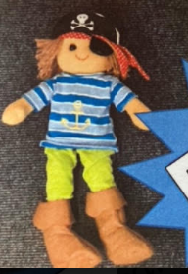(Pirate Pea) | - Plan and think ahead about how they will explore or play with objects.  - Guide their own thinking and actions by talking to themselves while playing. For example, a child doing a jigsaw might whisper under their breath: “Where does that one go? – I need to find the big horse next.”  - Make independent choices - Do things independently that they have been previously taught.  - Bring their own interests and fascinations into early years settings. This helps them to develop their learning.  - Respond to new experiences that you bring to their attention.
Active Learning  -Children concentrate and keep on trying if they encounter difficulties, and enjoy achievements  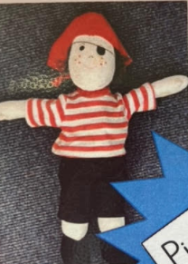 (Pirate Al) | - Begin to predict sequences because they know routines.  - Show goal-directed behaviour - Use a range of strategies to reach a goal they have set themselves.  - Begin to correct their mistakes themselves. For example, instead of using increasing force to push a puzzle piece into the slot, they try another piece to see if it will fit.  - Keep on trying when things are difficult – For example, trial and error, asking a friend or adult for help.
Creating & Thinking Critically  - Children have and develop their own ideas, make links between ideas, and develop strategies for doing things  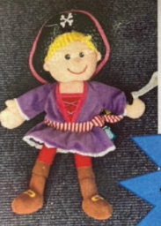(Pirate Cat) | - Take part in simple pretend play. For example, they might use an object like a brush to pretend to brush their hair, or ‘drink’ from a pretend cup.  - Sort materials. For example, at tidy-up time, children know how to put different construction materials in separate baskets.  - Review their progress as they try to achieve a goal. Check how well they are doing.  - Solve real problems: for example, to share nine strawberries between three friends.  - Use pretend play to think beyond the ‘here and now’ and to understand another perspective.  - Feel confident about coming up with their own ideas, making more links between those ideas.  - Concentrate on achieving something that’s important to them. They are increasingly able to control their attention and ignore distractions.

