Term/Topic | NC objectives (composite knowledge) | Lesson Objectives (component knowledge) | Sources | Key vocabulary  (see art vocab progression document)
Autumn  Why is our world a place of wonder? | Can use a range of materials creatively to design and make products.  Can use drawing, painting and sculpture to develop and share their ideas, experiences and imagination.  Is able to develop a wide range of art and design techniques in using colour, pattern, texture, line, shape, form and space.  Knows about the work of a range of artists, craft makers and designers. Is able to describe the differences and similarities between different practices and disciplines, and is able to make links to their own work.  - Drawing – line, shape  - Printing – pattern  - Colour  - African art | 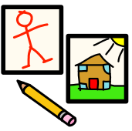  Begin to use different types of lines  whilst sketching different types of animals.  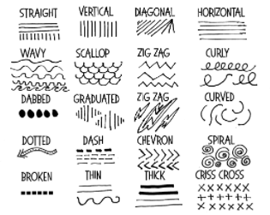  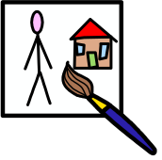  To match colours and name them. (primary)  To paint with rollers and different sized brushes.  To use different types of brushes and painting  tools  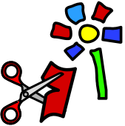  To re-visit sketches of different animals and add  texture to work by mixing different materials  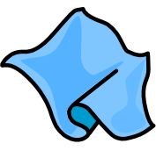  To print on top of fabric – inspired by the work  of Edward Tingatinga  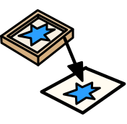  To roll, press, stamp or rub to create prints.  Exploration in sketch books.  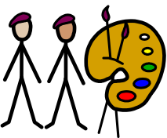  To develop observation skills so that work of  another artist can be talked about.  To begin to use key vocabulary to describe work. | African art; Edward Tingatinga  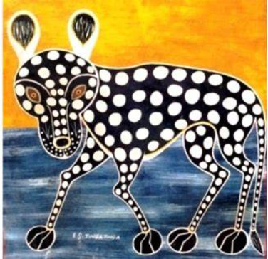  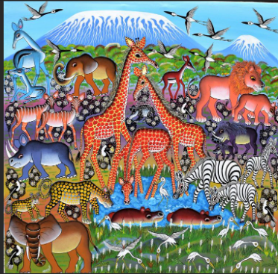  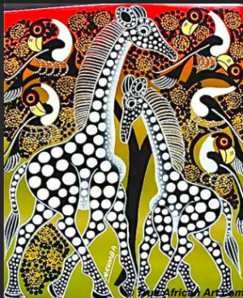 | General = primary colour names  Exploring = focus, design, improve  Drawing = Soft, detail, bold, line, line drawing, hatching, stippling  Painting = layering, strokes, light/dark,  Collage = Sort, arrange, gaps  Textiles = Fabric  Printing = Print, Roll, press, stamp, rub, smudge
Spring  What if it wasn’t today? | Can use a range of materials creatively to design and make products.  Can use drawing, painting and sculpture to develop and share their ideas, experiences and imagination.  Is able to develop a wide range of art and design techniques in using colour, pattern, texture, line, shape, form and space.  Knows about the work of a range of artists, craft makers and designers. Is able to describe the differences and similarities between different practices and disciplines, and is able to make links to their own work.  - Line  - Colour  - Different landscapes; urban / rural  - History of art | To master the use of different line  whilst sketching different types of  landscape.  To use different types of brushes and painting  tools.  To mix paint to create secondary colours.  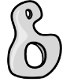To manipulate materials; pipe cleaners, salt dough,  rolled newspaper, to create a planned effect;  produce a figurine  To cut, bend, join materials.  To re-visit sketches and add texture to work by  mixing different materials – referencing  landscape descriptors.  To use fabric to collage with / decorate textiles  with glue to add detail.  To look at the work of other artists and describe  their work.  To use key vocabulary to demonstrate knowledge. | Compare art over time – what does it reveal about the past?  Impressionism; Claude Monet  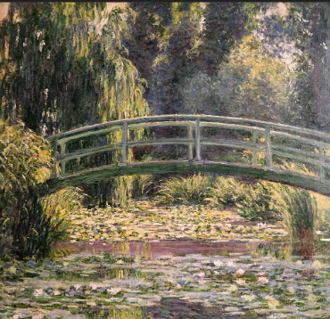  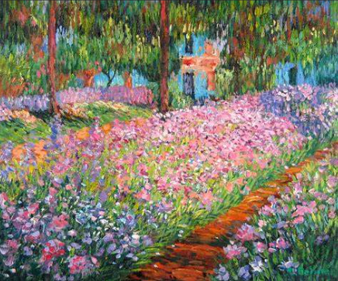  - Mid-20th century; LS Lowry  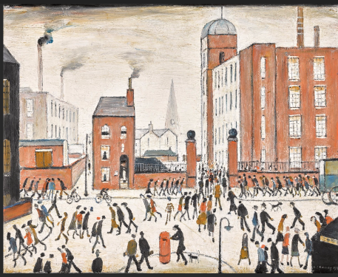 | General = secondary colour names  Exploring = focus, design, improve  Drawing = detail, bold, light/dark, line, wavy, scallop, zig-zag, curly, spiral, broken  Painting = warm/cool colours, strokes, bold, shades  Sculpture = cut, bend, join, Statue, model  Collage = Sort, arrange, gaps  Textiles = apply decoration, cut, shape  Printing = Roll, press
Summer  What if you went down to the woods today? | Can use a range of materials creatively to design and make products.  Can use drawing, painting and sculpture to develop and share their ideas, experiences and imagination.  Is able to develop a wide range of art and design techniques in using colour, pattern, texture, line, shape, form and space.  Knows about the work of a range of artists, craft makers and designers. Is able to describe the differences and similarities between different practices and disciplines, and is able to make links to their own work.  - Sculpture  - Pattern  - Texture  - Form  - Environmental art / Nature art | To use dots and lines to demonstrate a repeating  pattern  To paint using watercolours  To paint using bold brush strokes  To recognise sculptural forms in the environment  (see environmental art)  To produce own environmental art – using a variety  of natural materials, 2D and 3D  To manipulate materials (clay) to create textured  relief.  To mix a variety of materials to develop an  understanding of texture  To weave – placing one material over and under  another  To use a variety of materials e.g.  vegetables, resources sourced from nature and  develop accuracy  To explore pattern using colour / repetition  To understand that printing is transferring an  image from one surface to another  To independently describe the work of an artist  using key questions. (see below)  To use key vocabulary to demonstrate knowledge  and understanding.  - Spend a few minutes looking closely and write down 5 things you notice  - If this artwork could produce sound, what would they be?  - How does this artwork make you feel?  - Can you think of 3 words to describe this artwork? | Environmental artists; Andy Goldsworthy, Nils-Udo, Richard Shilling  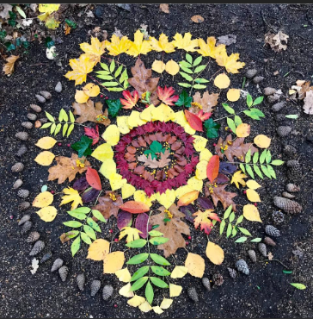  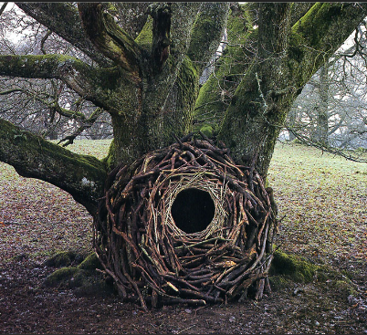  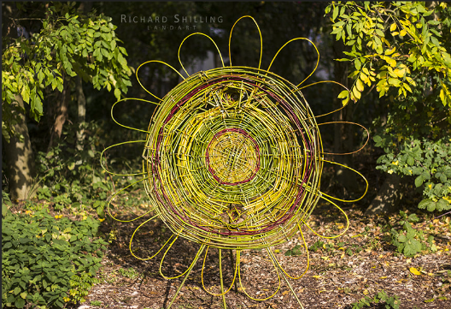 | General = Spirals, Circles, Pattern, Permanent / temporary, experiment  Exploring = Observe, Starting point  Drawing = thick, thin, broad, narrow, wavy, wrinkly, bumpy, nature  Painting = Watercolour – sweep, wash, dab  Sculpture = sculpture, 3D, 2D, land art  Collage = arrange, fix  Textiles = Weave, over, under, decoration  Printing = shape, printing, colour, relief printing, print making, texture

