Term/Topic | (composite knowledge) | Lesson Objectives (component knowledge) | Field work | Key Vocabulary
Autumn  Why is the world a place of wonder?  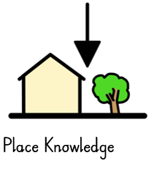  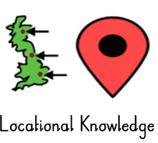  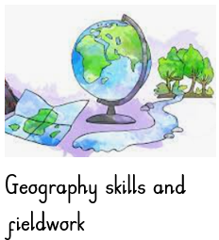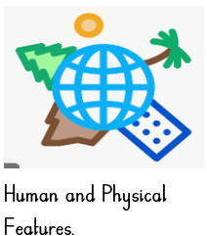 | To study a contrasting non-European country by exploring human and physical features.  Children can name the four countries that make up the United Kingdom.  To compare small area with a contrasting non-European country by exploring human and physical features. | To identify where we live (Daventry, England, Europe, Earth).  To know their address, including post-code.  To identify Physical and Human features in Daventry .  To study a non-European contrasting country (Africa- Handa’s surprise literacy Link) and identify Physical and Human features in Kenya .  To compare similarities and difference between Daventry and the Africa (cliffs, beaches, forests, islands (is Kenya an island?).  To undertake fieldwork within the school locality.  To identify the seasonal and daily weather patterns in the United Kingdom | - To use maps.  - To use atlases  - To use globes  - To explore photographs/ books  - To carry out research into contrasting environments. | Continent  Near  far  location  Map  Atlases  Globe  Human and physical features  Africa – features see unit plans  Daventry  (roads, streets, shops, school, park, church- see EYFS vocabulary- opportunities for consolidations)
Spring 1  What if it wasn’t today? | Name and Locate the four countries of the United Kingdom and their Capital Cities. | To name and locate the four countries of The United Kingdom. (UK island of Europe – islands that surround)  To name and locate the Capital cities of the countries in the United Kingdom. | - To use aerial photographs  - To ask simple geographical questions  - Using Maps on the United Kingdom  - To carry out research into human and physical features. | Capital  City  United Kingdom  England, Scotland, Wales, Ireland.  London, Edinburgh, Belfast, Cardiff  Human features: Big Ben, London eye, Tower Bridge.  Physical features: River, park.
Spring 2 | Explore the Human and Physical features in United Kingdom capital cities. | To distinguish between human and physical features.  To identify the human and physical features making up Daventry including aerial photos. (the stream that leads to the river Nene)  To compare the human and physical features of Daventry with London including aerial photos. (the river Thames – leading to cliffs).  To identify the seasonal and daily weather patterns in the United Kingdom  To explain some of the advantages and disadvantages of living in a city or town.  (Literacy Link ‘ The Queens hat’ – features of London)
Summer 1  What can you find in the woods? | Draw own maps and use basic symbols as a key.  Explore the Human and Physical features in our local area. | To explore the environment in ‘Little Red riding hood’ and create a map of her route using a key. (Literacy link)  To know and use the terminology of left, right, below, next to.  To use aerial photos and construct aerial maps.  To compare woodland and forest to local town area using human and physical features. | - Trip to Country Park/ Everdon.  - Compass points  - To create a map (Linked to Literacy – Little Red riding hood)  - To carry out research  - To use photographs/ books. | Key  Map  route  Compass  direction  North  South  East  West  Forest, woodland, park,  City  Village  Town  (Vocabulary taken from London explorations, local areas- previous terms consolidations)
Summer 2 | Use simple compass directions (North, South, East, West)  To compare area of The United Kingdom (e.g. Daventry, Norton, London) using human and physical features. | To use a compass and describe using compass directions.  To identify human and physical features of a town, village and city and compare similarities and differences.  To identify the seasonal and daily weather patterns in the United Kingdom

