Term/Topic | NC objectives (composite knowledge) | Lesson Objectives (component knowledge) | Sources | Key vocabulary  (see art vocab progression document)
Autumn  What is home? | Can use a range of materials creatively to design and make products.  Can use drawing, painting and sculpture to develop and share their ideas, experiences and imagination.  Is able to develop a wide range of art and design techniques in using colour, pattern, texture, line, shape, form and space.  Knows about the work of a range of artists, craft makers and designers. Is able to describe the differences and similarities between different practices and disciplines, and is able to make links to their own work.  - Line  - Shape  - Colour  - Jungle art | 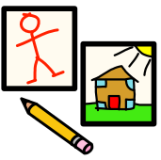  To represent all of kinds of animals  To place objects on a baseline e.g. on the  ground  To show depth and distance – drawing objects  closer and further away  To make realistic colour choices  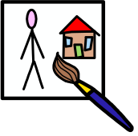  To work in the style of a famous artist  (control / art appreciation)  To name primary and secondary colours  To know the colour wheel  To know what to choose to create lighter /  darker colours  To describe what sclupture is  To use paper folding and cutting skills to  create trees  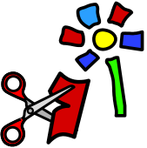  To select the most appropriate adhesive  To describe what collage is  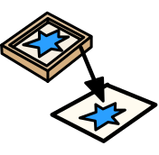  To carry out different printing techniques;  to draw into the surface of a material to  produce intaglio printing (using clay and clay  tools)  To produce a wax resist  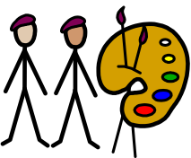  To develop observation skills so that work of  another artist can be described.  To respond to ‘describe it / interpret it’  questions to inform observations. (See art  questions document)  To begin to use key vocabulary to describe  work. | Post-impressionist: Henri Rousseau  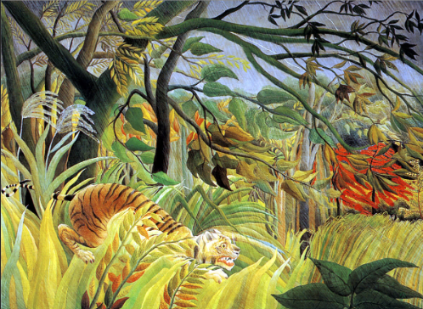  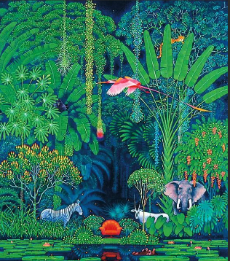  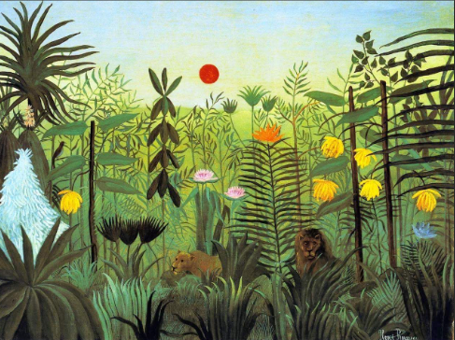 | General = primary colour names, secondary colour names, size, scale, perspective  Exploring = focus, design, improve  Drawing = Soft, detail, bold, light/dark, line, line drawing,  Painting= layering, strokes  Sculpture = Fold, cut, sculpture  Collage = Fold, crumple, overlay, tear  Printing = press, stamp, rub, wax resist, mono-print
Spring  What do we know about our planet? | Can use a range of materials creatively to design and make products.  Can use drawing, painting and sculpture to develop and share their ideas, experiences and imagination.  Is able to develop a wide range of art and design techniques in using colour, pattern, texture, line, shape, form and space.  Knows about the work of a range of artists, craft makers and designers. Is able to describe the differences and similarities between different practices and disciplines, and is able to make links to their own work.  - Space art  - Pop art  - Printing | To experiment with different types of line;  especially zig-zag, straight, diagonal,horizontal,  thick and thin    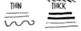  To form good circles, squares, rectangles,  Triangle and diamonds in their drawings  To show gender, hair colour and clothing when  drawing a person  To use bold brushstrokes  To use monochrome colours (a picture  produced in black and white or in varying  tones of only one colour)  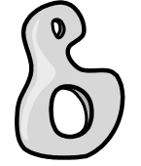  Use a variety of junk materials for  sculpting; 2D and 3D (See DT)  To add texture to work by mixing  materials (paper, fabric)  To use paper collage to create workinspired  by Andy Warhol or Roy Lichenstein (fold,  crumple, tear, overlap)  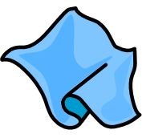  To know that textiles are different types  of fabric which create texture to a piece  of work.  To make fabric choices to enhance their  collage work.  To use a variety of materials, e.g. press print  To describe the work of an artist  independently  To use key vocabulary to demonstrate  knowledge and understanding  To respond to ‘relate it’ and ‘evaluate it’  questions (see art questions document) | - Contemporary – pop art: Andy Warhol – ‘Moonwalk 1987’, 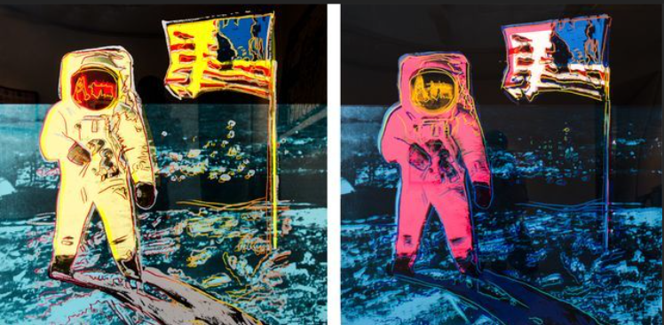  Roy Lichenstein – ‘Whaam’  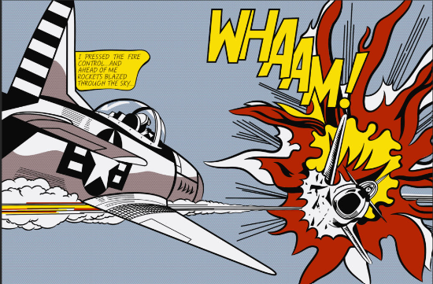  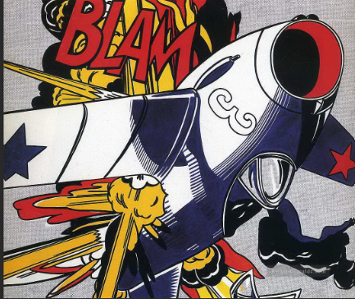 ‘Blam’ | General = monochrome, press print, pop art, space art  Exploring = Observe, Starting point  Drawing = line, size, straight, vertical, diagonal, horizontal, thin, thick  Painting = black, white, bold, monochrome  Sculpture = X  Collage = Fold, crumple, overlay, tear  Textiles = strips, cut, round, mixed media, (names of fabric)  Printing = shape, printing, colour, press print, impress
Summer  What happened in the past? | Can use a range of materials creatively to design and make products.  Can use drawing, painting and sculpture to develop and share their ideas, experiences and imagination.  Is able to develop a wide range of art and design techniques in using colour, pattern, texture, line, shape, form and space.  Knows about the work of a range of artists, craft makers and designers. Is able to describe the differences and similarities between different practices and disciplines, and is able to make links to their own work.  - Paint techniques  - Texture - collage  - Form  - Japanese art | To experiment with different types of line to  enclose shapes to represent objects (boats  (linked to literacy), houses (linked to history)  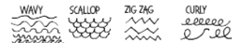  To experiment with line choices to create  movement of water – waves in the sea  To investigate tone by drawing light and dark  lines  To develop own style of drawing  To show movement – waves splashing, rising up  and down etc.  To experiment with different types of  brushes and painting tools.  To experiment with adding lots of water to  paint  To use paints and inks to produce a marbling  effect  To imagine (visualize in mind’s eye) before  painting  To experience colouring fabric by printing or  dipping, inspired by Katushika Hokusai  To create a curved line by stitching onto the  fabric  To add texture to work by mixing different  materials  Using fabric/decorative pieces to collage with  To use cut out stencils to create (Hokusai  inspired)  To use key vocabulary to demonstrate  knowledge and understanding  To respond to ‘describe it’ and ‘analyse it’  questions (see art questions document) | Modern art: Japanese art – Katsushika Hokusai  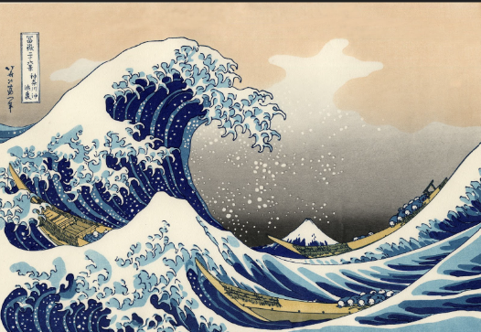  ‘The Great Wave’ | General =  Exploring = focus, design, improve  Drawing = detail, light/dark, line, wavy, scallop, zig-zag, curly, spiral,  Painting = shades, strokes, bold, marbling  Sculpture = X  Collage = Sort, arrange, gaps  Textiles = apply decoration, cut, shape  Printing = Stencils

