Term/Topic | (composite knowledge) | Lesson Objectives (component knowledge) | 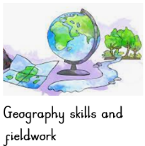  Field work
Autumn  What is home?  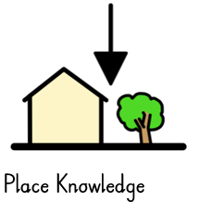  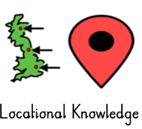  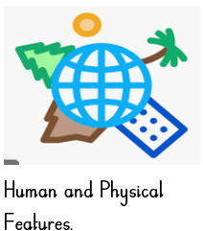 | To name and locate the world’s seven continents.  To compare small area (Daventry) to contrasting Non-European country (Africa- Botswana) by exploring human and physical features.  To identify and locate places studied on a map. | - To know where we live (lesson 1)  - To know the key human and physical features of Daventry (Lesson 2)  - To know and locate a contrasting Non-European country (Africa – Botswana) Botswana – compare mountains in UK with hills, Lake Ngami (seasonal lake – why? Link to weather climate). Landlocked country – Island. (lesson 3)  - To know the key human and physical features of Botswana and compare them to Daventry. (lesson 4)  - To know how to create simple maps with a key (using next, left and right) (lesson 5)  - To use observe and record daily weathers in Daventry and Compare to daily weathers in Botswana (lesson 6) | - Maps of Daventry  - Maps of Botswana  - Create a key on a simple map  - Aerial photos of Daventry/Botswana  - Globes  - Atlases  - To carry out research  - To make comparisons  - To identify physical and human features.  - To comment and ask questions about what has been observed referencing key geographical features.
Spring  What do we know about our planet? | Confidently name and locate the world’s Seven continents.  Confidently name and locate the world’s five oceans.  Identify and locate continents and link to the poles and the equator. | - To recall and locate the world’s seven continents using globes and maps. (Lesson 1)  - To know and locate the poles and the equator on a map and identify the key weathers within these areas, (lesson 2)  - To identify and locate the 5 oceans. (Lesson 3) | - To use maps  - To use globes  - Use Atlases  - To carry out geographical research
Summer  What happened in the past? | Confidently name and locate the world’s  Seven continents.  Identify and locate continents and link to the poles and the equator.  Confidently name and locate the world’s five oceans. | - To identify the 4 countries of the United Kingdom and the seas surrounding it. (lesson 1)  - To identify the 4 capital cities within the United Kingdom and identify characteristics (landmarks) of them (Edinburgh, Belfast) (lesson 2)  - To identify the 4 capital cities within the United Kingdom and identify characteristics (landmarks) of them. (Cardiff, London) (lesson 3)  - To know how to use a compass and identify the directions (N,S,E,W).  - To explore a coastal town (Dover) and the features within it. (lesson 4)  - To compare a city (London) to a town (Daventry). (lesson 5) | - To use photographs and books to identify landmarks  - Use and create simple maps with a key,  - Explore Aerial photos  - Use globes  - Use maps  - Use atlases

