Term/Topic | EY objectives (composite knowledge) | Lesson Objectives (component knowledge) | Sources | Key vocabulary  (see art vocab progression document)
Autumn  What would happen if Paddington was lost in Daventry? | Join materials together  Explore art materials and colour and colour mixing.  Develop my own ideas for art  Use various tools for artwork and design e.g. playdough tools  Select own art and design materials to create with  Develop own ideas for art and start to talk about them (with adult support)  Can tell others what their artwork is and signal key parts e.g. this is mummy, this is her hair etc. | 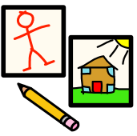  -To show control using pencil or black felt tips –  producing a variety of line  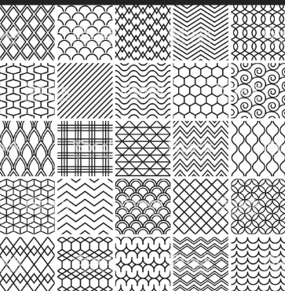 line art  -Develop this by using Inca patterns as a basis  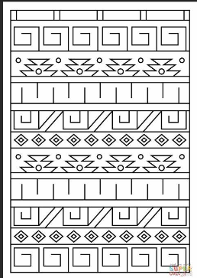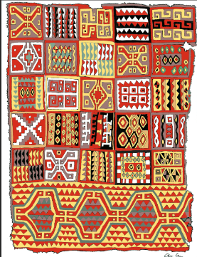  -To make patterns using other line makers;  fingers, sticks, brushes, - in sand, in paint, in  glitter  -To draw recognisable shapes; circles,  rectangles, crosses (possibly triangles and  diamonds)  -To draw Paddington and his family, compare  with a drawing of own family – talk about it.  (Enclosing shapes to make recognisable  shapes and objects)  -To colour in – staying in the lines  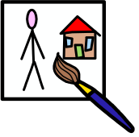  -To name primary colours (relating it to Paddington’s hat  and coat and wellies + found objects in their  environment)  -To paint pictures of Paddington – choosing a colour for  his coat and explaining preferences. Compare to the  illustrations in the book.  -To trial mixing primary colours together – observe what  happens – do they know that they have made orange,  green, purple?  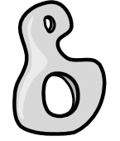  - To roll out playdough tile and draw faces /animals into  It  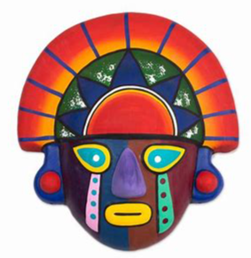  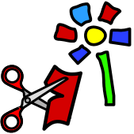  -To sort and arrange a variety of materials into  colour groups.  -To explore repeating patterns by usijng squares  of different materials  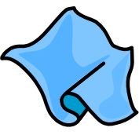  - To use fabric to create patterns  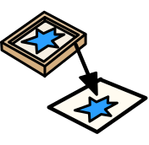  . –To use wood blocks, stamps to press on and take  off to reveal the print  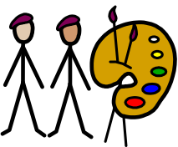  -To look at the illustrations of Peggy Fortnam  -To use Inca pattern to inspire their own work  -To look at the pattern work of Wassily Kandisky  and Paul Klee. Inspire own work.  Seasonal experiences;  - Describe the colours of the seasons; autumn and winter  - Fireworks  - Christmas crafts and cards | Illustrations of Peggy Fortnam 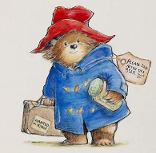  Inca patterns and masks  The pattern work of  Impressionists; Wassily Kandinsky  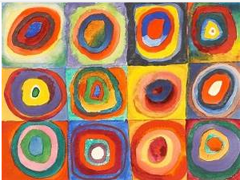  The pattern work of Paul Klee  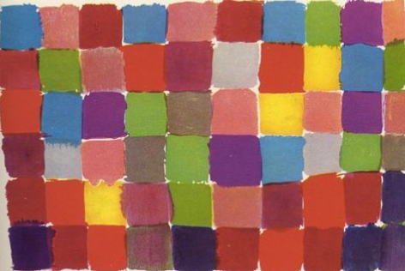  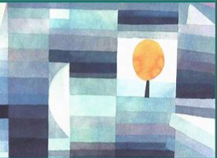 | General = primary colour names  Exploring = focus, design, improve  Drawing =Thin, thick, light, dark, strong, soft, hard, circle, cross, rectangle  Painting = Red, yellow, blue, mixing  Sculpture = Roll  Collage = Cut, shapes, sticking, texture  Textiles = Cutting, weave, texture, fold, decoration  Printing = Print, repeat, patterns
Spring  I wonder what is behind the door? | Uses scissors and one-handed tools to create art safely and more accurately (playdough tools, paintbrushes etc.)  Combine different techniques e.g. collage, paint, crayon, clay to create art  Talk about own artwork or designs- linked to some of the materials/ techniques used | - -To use different materials to draw – pastels,  - chalk, felt tips  -To combine shapes together to make images – e.g.  house, sun etc (whatever they can see behind a  door) / referencing surrealist art  -To colour in staying in the lines, making correct  colour choices / or purposefully choosing  incorrect colours to imagine strange images.  Explain this.  - To name primary colours and begin  to name secondary colours  -To add white and black to create shades  -To use a brush with control, using different size  brushes,  -To use junk materials to apply paint.  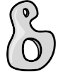- To use playdough and straws to create Dali’s  Space Elephant or other imagined creatures –  what things can they distort and change?  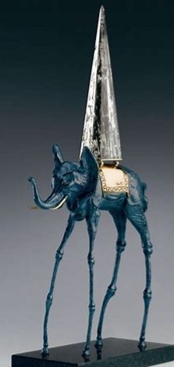  -To balance shapes on top of each other – working  like Miro (junk modelling, playdough)  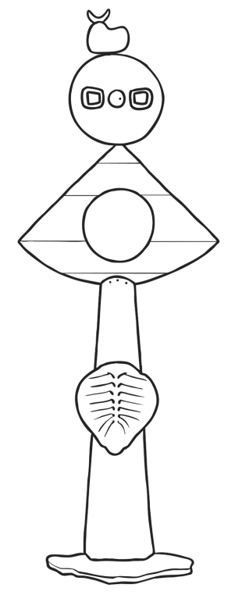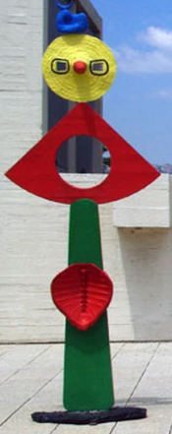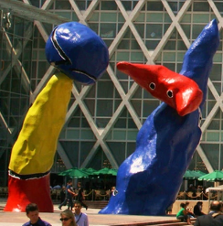  - To develop cutting skills – creating shapes and use  imagination to create own work. (Automatic  drawing and creating – just like Surrealists)  -To glue and stick fabric over and under to create  images.  -To use mathematical shapes to print with.  . – To, with support describe the work of an artist /  use key vocabulary to demonstrate knowledge  and understanding  Salvador Dali, Joan Miro  Surrealism | Tate Kids  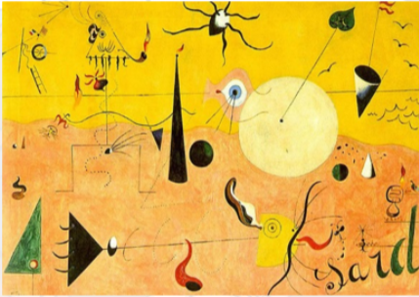  Seasonal experiences;  - Describe the colours of the seasons: spring  - Easter crafts, cards  - Mothers’ day cards | Surrealist art;  The work of Salvador Dali -  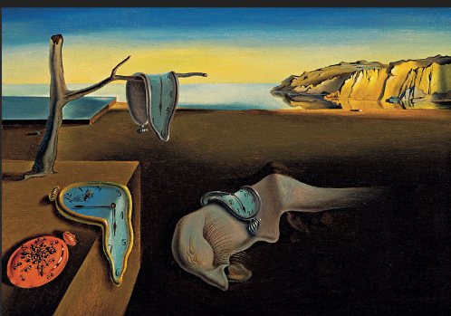  The sculptures of Joan Miro; | General = secondary colour names  Exploring = focus, design, improve  Drawing = Pastels, chalk, felt tips  Painting = Primary, black, white, shade  Sculpture = Sculpture, balance  Collage = Cut, shapes, sticking, texture  Textiles = Cutting, weave, texture, fold, decoration Printing = Shapes, smudge, roll
Summer  What if the world had no colour? | Safely use tools with control e.g. scissors  Explore using materials and techniques  Design art/ a product thinking about colour, texture, material and function  Explain what they have made  Talk about how they made it | - To use different materials draw with – pastels,  chalk, felt tips, charcoal  – To compare black with colourful line makers  -To draw a self-portrait – including details such  as eyes and lots of detail)  -To draw a self-portrait in the style of Picasso –  lots of colour used (work on top of photograph of  themselves)  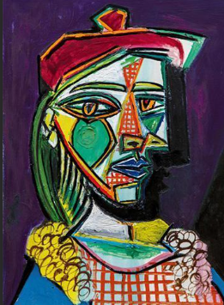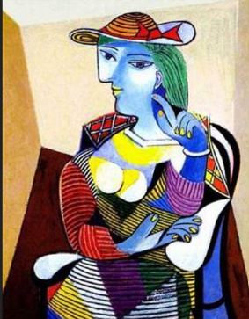  -To name primary colours  -To begin to make changes to colours by adding  white and black or mixing colours together  -To master brush control, use of different size  brushes  -To copy one of the artists’ work – working from  the picture  X  -To sort and arrange materials (into colour groups)  Matisse style 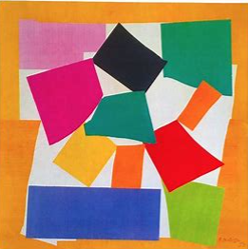 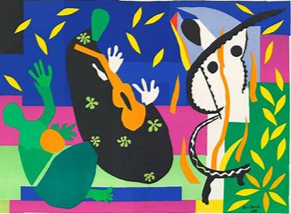  - As above – to use squares of fabric to create art work.  - To use stencils to create Matisse style shapes  -To describe, with support the work of an artist,  stating preferences  Surrealist; Pablo Picasso  Post-impressionist; Henri Matisse  Seasonal experiences;  - Describe the colours of the seasons: summer  - Fathers’ day (special person) cards  - End of year activities | Surrealist art; The portrait work of Pablo Picasso  Post-impressionist work; The collages of Henri Matisse | General = Colour  Exploring = Observe, Starting point  Drawing = self-portrait  Painting = Light, dark, bright, dull, colourful  Sculpture = Bend, fold, clay  Collage = Cut, shapes, sticking, texture  Textiles = Cutting, weave, texture, fold, decoration  Printing = Stencil

