Term/Topic | (composite knowledge) | Lesson Objectives (component knowledge) | Field work | Key Vocabulary
Autumn 1  What if Paddington got lost in Daventry? | Make detailed observations of the world around us thinking about our senses- feel, hear, see, smell  Talk about what we can see outside using a widening vocabulary.  Talk about the area that we live in. | To use our senses to explore the world around us (town/ school).  To describe what we notice in our local area.  To explore maps and notice key features  To collaboratively build maps with key features of our local area. | - Community walks - make observations of immediate environments.  - Begin to draw information from a map. | Map  Town  Daventry  Features; school, Road, Path, Street, field, shops, houses, park, station,  Direction route
Autumn 2  What if Paddington got lost in Daventry?  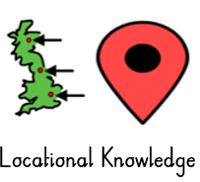  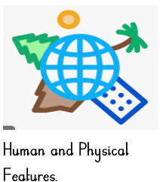 | Know there are different countries in the world  Start to use stories and pictures to talk about differences in life in other countries | To name different countries and explore key features.  To explore some similarities and difference between home and Peru. | - Make observations of familiar environments.  - Beginning to make some comparisons and talk about similarities and differences. | Country  Far  Rainforest  Peru  South America
Spring 1  What is behind the door?  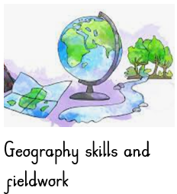  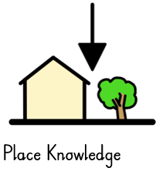 | Draw information from a simple map  Describe my own environment and local area | To use a simple map and locate key features.  To create own map of a familiar place.  Creating Maps of a place behind the door- e.g. map of bedroom, forest school and classroom. Traditional tale location (see literacy) – creating a simple key for features. | - Draw information from a simple map | Map  Route  Key  Directions
Spring 2  What is behind the door? | Talk about what is the same and different in life in this country and in other countries. | To describe another environment using noticing eyes and key features.  To compare other environments to Daventry describing some similarities and differences.  Doors into different countries- passport day (what would it be like to be here- finding out about life in different countries contrasting to here- children step through the door imagining they have arrived there- find out about- constant reference to difference and similarities | - Make comparisons and talk about similarities and differences. | Desert  Artic  Ice  snow  Forest  Woodland  Beach  Planet Earth  Country place names.
Summer 1  What if the world had no colour? | Describe the school/ Local environment using what I know from  Observation  Discussion Stories/ non-fiction | To use our senses to explore our school environment.  To use our sense to explore another part of our local area. | - Visits to parks (country park)  - Community walking | Woodland, forest, hills, trees, flowers, field, streets, town, path, tunnel (recap Autumn taught vocabulary)  Weathers  Environment.
Summer 2  What if the world had no colour? | Contrast the natural world around me with different environments | To explore the natural world in Antartica.  To compare the natural world in Antartica to Daventry.  Digging deeper into contrasting environment ‘Antarctica’ – exploring differences through colour to there and our immediate environments. | - Photographs  - Nonfiction texts  - Globes  - Atlases | Ice sheet, snow (Polar desert), ice bergs, igloo  continent  Antarctica  Planet Earth

