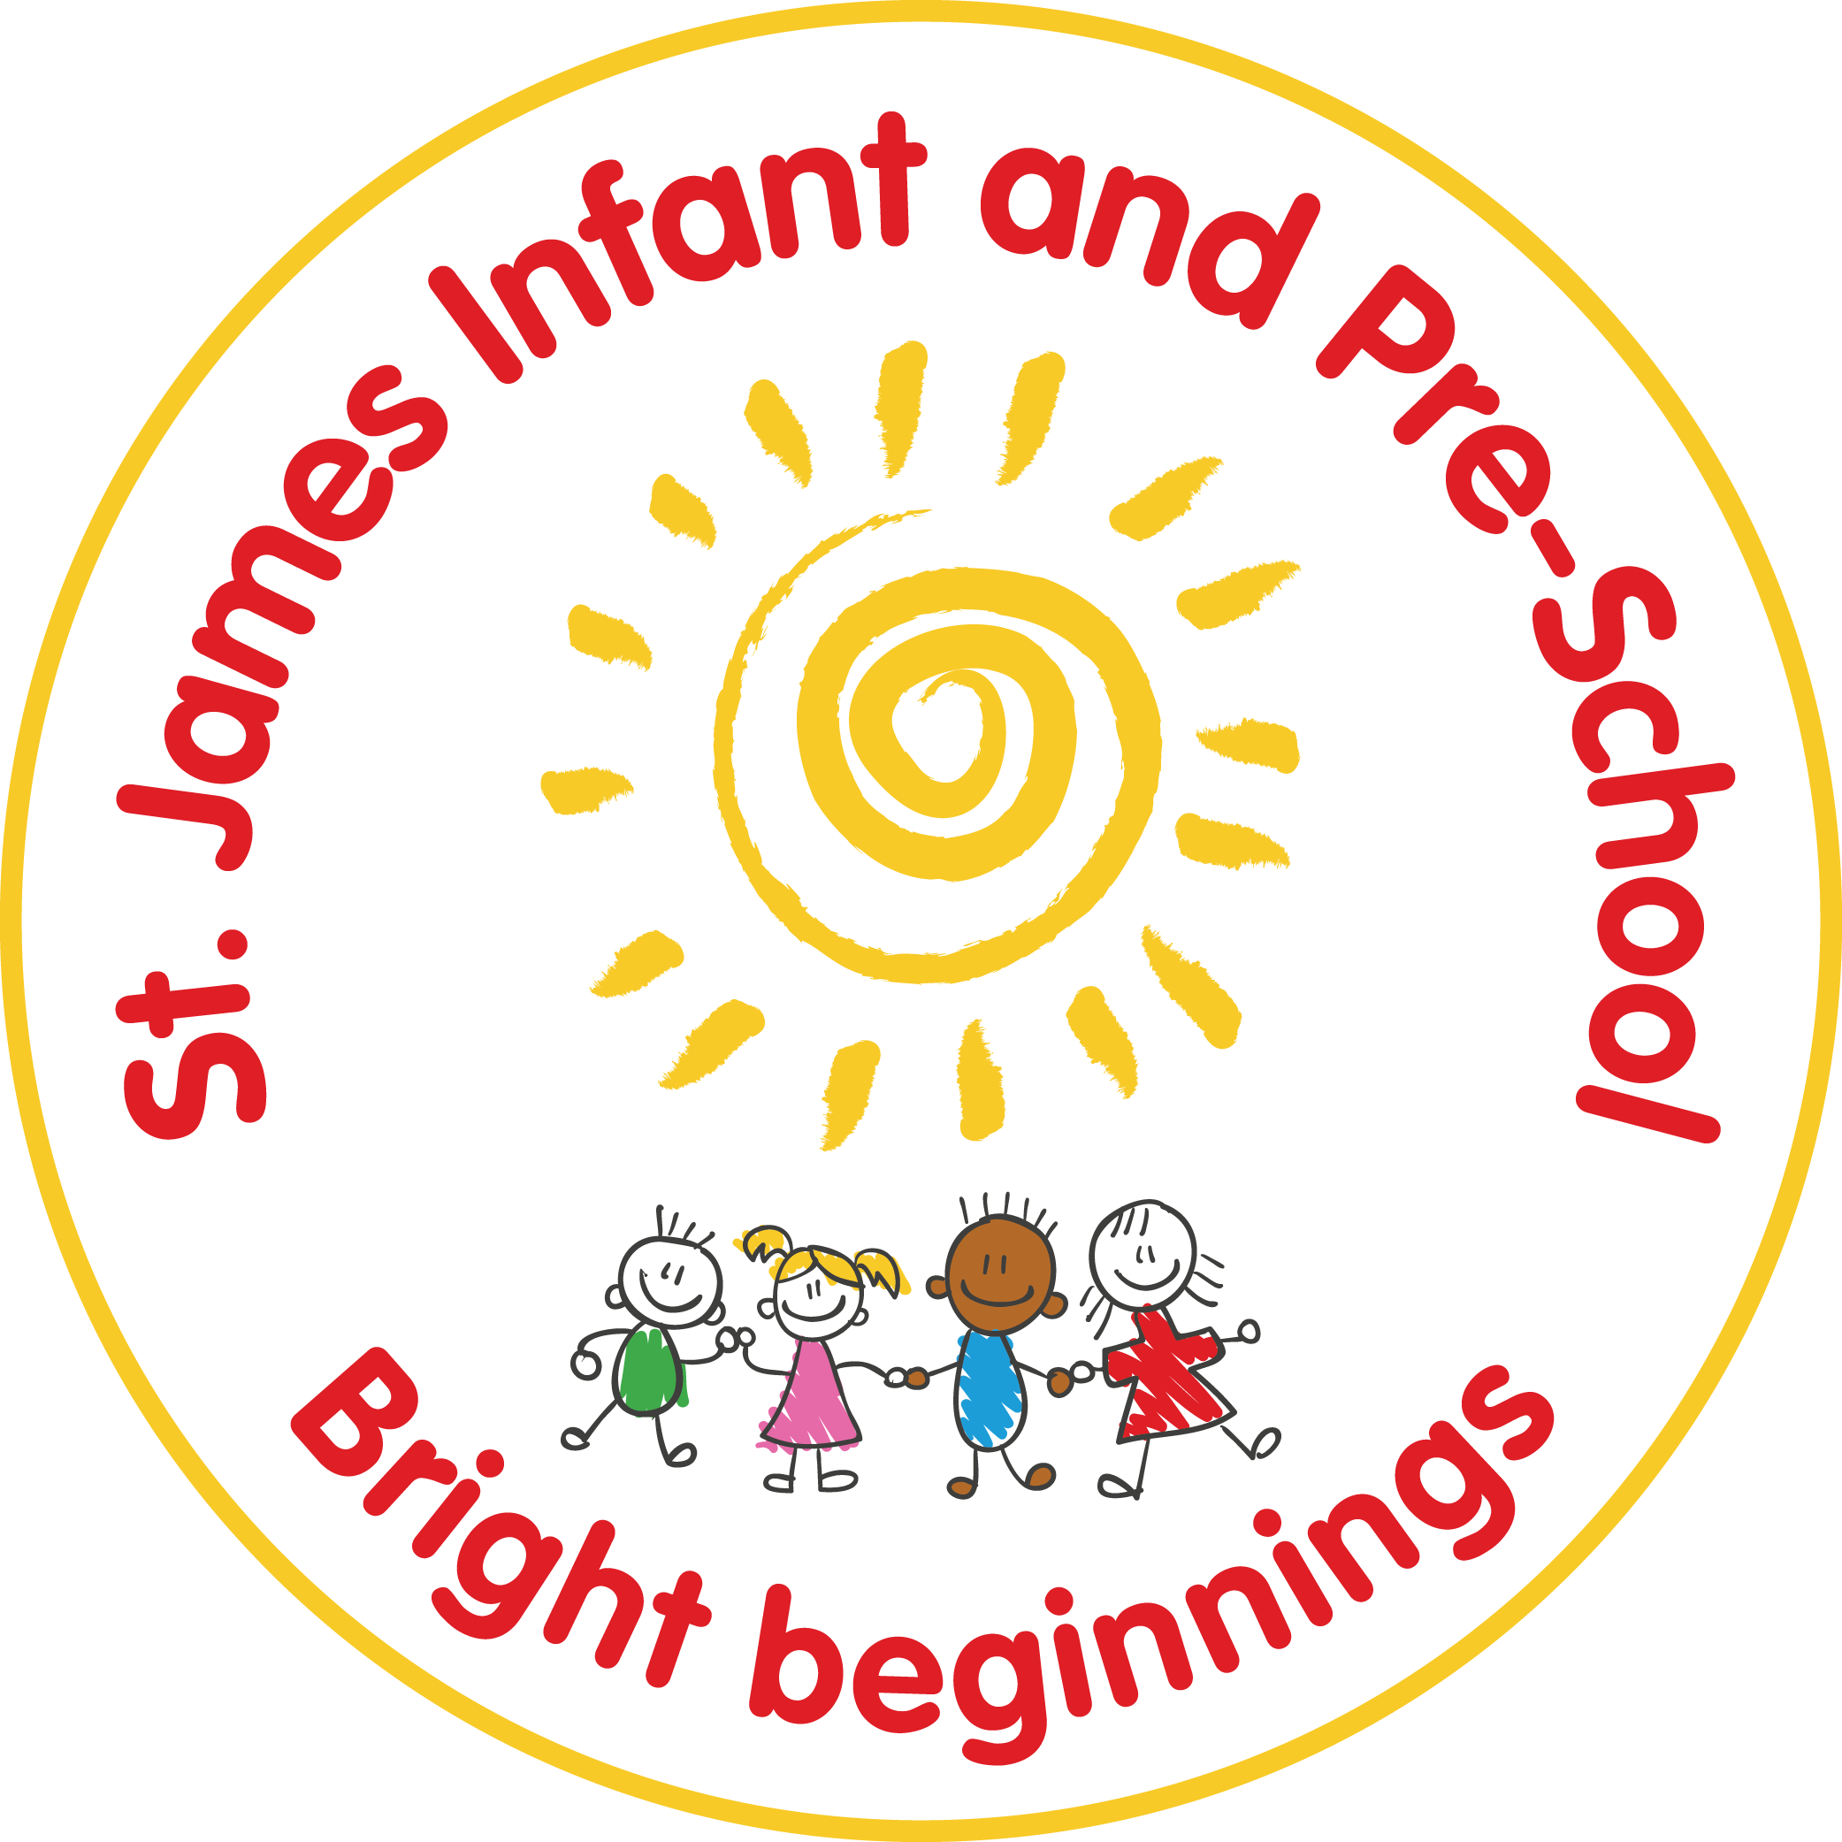

St James Infant & Pre-School
Early Years Foundation
Stage Policy
Statutory / Non-statutory
Date policy adopted | March 2017
Review date | Summer 2 ‘19 | Summer 2 ‘10 | Autumn 1 ‘21
Reviewer’s name | GG | SC | SC
Date minuted by committee meeting | 9.7.19
Next review due by | Summer 2 ‘20 | Summer 2 ‘21 | Autumn 1 ‘22
Annual review / 2 yearly review

THIS POLICY IS INTENDED TO ENSURE that whilst children are in Pre-School and Reception they have the opportunity to develop knowledge about themselves and their environment, through a broad and balanced curriculum and a range of experiences and activities.

LEARNING SHOULD BE ENHANCED THROUGH:
- Providing a bright, welcoming, safe, secure and stimulating environment where learning is fun.
- an environment and ethos that encourage independence, autonomy and self-control
- building upon the child’s existing knowledge and experiences in partnership with parents
- developing children’s interests and abilities fully as well as encouraging lively and enquiring minds
- developing the opportunities and skills to communicate effectively
- ensuring good progress and high levels of achievement for all children including vulnerable groups

AGREED PRINCIPLES AND PROCEDURES
Teaching and Learning, Planning & Assessment
There are three characteristics of effective learning that underpin the Early Years Foundation Stage (EYFS) curriculum. They describe factors, which play a central role in a child’s learning and in becoming an effective learner. They are vital elements of support for transition from Reception into year one. They run through and underpin all seven areas of learning and development. They represent the process of learning.
There are seven areas of learning as outlined in the EYFS framework. The first three areas are referred to as the Prime Areas and the following four areas are referred to as the Specific Areas. The following is a brief outline of the opportunities provided in each area.
The curriculum in the foundation stage underpins all future learning by supporting, fostering, promoting and developing children’s:
- Personal, Social and Emotional Development – planned activities build motivation, concentration and other social skills. In order to facilitate this development we aim to provide a welcoming, stimulating and appropriate environment where a child is able to develop a positive self-image and confidence. Activities are planned to help children develop awareness of their own needs, views and feelings and be sensitive to the needs, views and feelings of others. Children are encouraged to work together as a class and in a group, taking turns and sharing fairly, understanding that the need to follow our agreed values and codes of behaviour. Children are timetabled to attend kaleidoscope sessions on a weekly basis, when in Reception. This aims to increase their self-confidence and well-being.
- Communication and language - children participate in activities that develop interaction with others, negotiating plans and activities while taking turns in conversation and using language to imagine and recreate roles and experiences.
- Physical Development - In the early years, physical activity is important because not only does it encourage physical control and co-ordination but also because of the need to develop both, fine and gross motor skills. Physical development opportunities are planned for on a daily and weekly basis, and indoor and outdoor play, this enables the children to develop an awareness of space, of themselves and others around them. When in Reception, children will also develop skills through PE sessions with a specialist PE Coach and class teachers each week,
- Literacy - Phonics is taught as a discrete session, during the final term in Pre-School and throughout Reception (see English Policy.) Phonics is also integrated into daily provisions, giving children the opportunities to consolidate new skills. Reading is taught on an individual, group and class basis, in Reception. We follow a variety of reading resources. We use a variety of schemes to support and extend children with their reading. Throughout the year, planned opportunities allow for purposeful mark making through child-initiated play on a large and small scale and through adult directed activities, throughout the whole of the Foundation stage.
- Maths – learning in a broad range of contexts is planned so that children can explore, enjoy, learn, practice and talk about their developing understanding. They are provided with opportunities to practice and extend their skills in these areas and to gain confidence and competence in their use.
Children are encouraged to develop mathematical ideas and methods to solve practical problems, deepening their understanding so that mathematical concepts are embedded in their long term memory. At St James we follow a ‘Mastery Maths’ approach.
- Understanding the World- this includes aspects of Science, Geography and History. Children find out about past and present events in their own lives, and their families and people they know as well as beginning to understand the past through settings, characters and events that they encounter in books. They also observe, find out about and identify features in the place they live, the natural world and make comparisons with other countries in the world, drawing upon knowledge they can find in books, videos and (when appropriate) with maps. Children begin to find about their own cultures, beliefs, and those of other people and will talk lots about the people in society around them and their roles.
- Expressive Arts and Design - Creativity and imagination are valued and the children are encouraged to express ideas and feelings through a wide range of activities. They are also provided with the opportunities to explore and share their thoughts, ideas and feelings. Expressive arts and design encompasses a variety of areas such as; art, music, movement, dance, imaginative and role-play activities and design technology. Children have the opportunity to build and construct with a wide range of objects, selecting appropriate resources and adapting their work when necessary.

All areas of the EYFS are planned for on a daily basis (In response to the children’s outcomes) and weekly basis, and there is a balance of child-initiated play and adult led activities. The children are heavily involved in guiding their own learning experiences and children’s voice is highly valued in the planning process.

By the time children, start school a great amount of learning has already taken place within the family and the community. This needs to be recognised and valued and provides a starting point for lifelong learning. We analyse the Northamptonshire transition documents prior to the children starting school, for those joining us from other settings. In-school tracking grids are passed on from our own Pre-School. Home visits and parents consultations are also a useful tool in helping us to recognise the skills and abilities of each child. On entry into school, a base-lining observation schedule is planned. This has been devised to measure children's performance in language and literacy, mathematics and personal and social development. It is intended as a starting point for planning in relation to each child's individual strengths and areas for development. The information gathered enables the Reception teachers to input data into our chosen Baseline Assessment system.
All children are assessed throughout their time in the Foundation Stage, using a variety of methods and tracking. The planning format enables staff to make daily notes. Class Dojo, Post-it notes, photographs, observations and examples of work are other pieces of evidence we keep. Tracking is done using a variety of methods including Learning Journeys and the school tracking documents. An assessment against the Early Learning Goals (ELG’s) is made at the end of the Foundation Stage. All children are judged to be; working below, beginning, working within or secure against Early Learning Goals. This information is reported to parents in the end of year report. Parents are also given copies of their child/children’s next steps throughout the year.

Special Educational Needs, Gifted and Talented and Equal Opportunities
We recognise the need to ensure that the whole of the Early Years curriculum is accessible to each child by modifying and adapting opportunities, equipment and the environment as appropriate, thus encouraging independence. The school's Special Educational Needs policy is consulted where appropriate.
We seek to identify and make provision for any child who displays exceptionally high standards of achievement or talent in any area(s) of the curriculum. The opportunities provided will be structured and focused, ensuring progress but allowing for more divergent thinking and problem - solving activities. We aim to develop each child's capacity to learn and understand and to achieve his/her full potential. Subject leaders provide advice where necessary.
Equal opportunities and access to the curriculum are provided for all children regardless of ethnic or national origin, colour, language, gender, race, religion, social background or disability by providing an anti-bias curriculum and a positive environment. We also provide opportunities to develop an awareness of a variety of races, cultures and beliefs and to value this diversity. The school's Equal Opportunities policy is also consulted where appropriate.

MONITORING AND EVALUATION
The Phase Leader responsible for EYFS monitors the Early Years Foundation Stage curriculum and learning environment on a regular basis through lesson observations, work scrutiny, data analysis, and reviewing planning documents. Subject Leaders track the provision of the Early Years Foundation Stage through the theme planning to ensure coverage of all objectives. Its effectiveness is evaluated formally on an annual basis and an action plan with priorities for the following year is drawn up from this. The Phase Leader responsible for EYFS is responsible for the annual review of this policy and writing an action plan with the Foundation Stage team, they are also available for support and advice on resources, teaching, learning and intervention.

Reviewed and updated: October 2021 S Cooney

