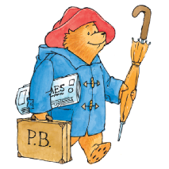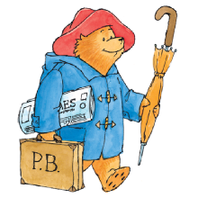

**Key learning opportunities**

* Learning about the beat of music
* Learning to add rhythm and pitch to a beat
* Learning how music relates to the past- stories
* Learning to create a song, including pulse, rhythm and pitch

**Music Year 1: Autumn - What if Paddington was lost in Daventry?**

**Key vocabulary**

Pulse, rhythm, pitch, tempo, dynamics, timbre, texture, structure



Finding and keeping a steady beat

Find simple rhythmic patters using long and short

Find simple melodic patterns using high and low

Improvise using notes with a backing track

Listen together

Talk about music- explore feelings, thoughts and emotions

Sing together

Share and evaluate performances

**Handwriting– Pencil grip song**

**Geography– South America – Peru**

**Science– Harvest**

**R.E.- Christianity - Christmas Story**

**P.E. – Dance – perform dances in time with music**

**Curriculum links:**

**Significant people / pieces**

Music of S. America - Peru

Autumn and Harvest

Christmas Carols

**Key Objectives**

Learning from the EYFS

**Previous learning:**