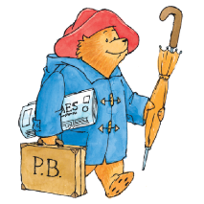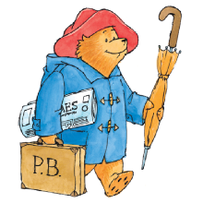

**Key learning opportunities**

* Naming colours
* Exploring colour mixing
* Describe the colour of the seasons
* Drawing -Using different line makers to draw with
* Painting – mixing colours and adding white and black to creates shades
* Sculpture – creating tiles
* Collage – sorting and arranging materials into colour groups
* Printing – using objects
* Look at and explore the work of others

**Art (Autumn) – Year R - What if Paddington was lost in Daventry?**

**Key vocabulary**

**General =** Colour names, Colour, Colour mixing, Colourful, Primary, Nature, Seasons,

**Drawing =** Pastels, Pencil, Line – thick, thin, wavy, straight,

**Painting =** Primary colours, secondary colours, mark making tools, brushes

**Sculpture** = rolling, cutting, pinching

**Collage =** cut, place, arrange, sticking

**Printing** = printing, experiment

**Textiles** = fabric, weave, up and down, pattern, join



**Reception – Expressive Arts and Design**

* To name colours
* To know some colours are created by mixing other colours together
* To name black and white
* Explore and use a variety of artistic effects; drawing, painting, sculpting, collage.
* Express their own ideas.
* Develop their ability to represent their ideas so others can recognise subjects.

Incas

Michael Bond

* Physical Development
* Understanding of the World
* Communication and Language

**Significant people**

**Curriculum links:**

**Key Objectives**

**Previous learning:**

Experiences in Poppy class