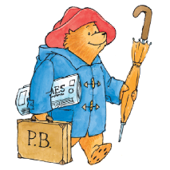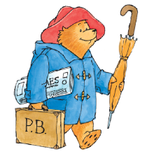

**Key learning opportunities**

* Naming all colours
* Mixing primary colours together to make secondary colours
* Describe the colour of the seasons
* Drawing - Using different materials to draw Inca patterns
* Painting – making secondary colours and adding white/grey (shades) and black to create different values of colour (tones). Developing brush control by using different size brushes
* Sculpture – creating patterns on tiles and investigating symmetry in Inca masks
* Collage – sorting and arranging materials into colour groups and use textiles
* Printing – using objects, creating repeating patterns
* Look at and explore the work of others

**Art (Autumn) – Year 2 - What if Paddington was lost in Daventry?**

**Key vocabulary**

**General =** Colour names, Colour, Colour mixing, Colourful, Primary, Nature, Seasons

**Drawing =** Pastels, Pencil, Line – thick, thin, wavy, straight,

**Painting =** Primary colours, secondary colours, mark making tools, brushes

**Sculpture** = rolling, cutting, pinching

**Collage =** cut, place, arrange, sticking

**Printing** = printing, experiment

**Textiles** = fabric, weave, up and down, pattern, join



**Significant people**

**Year 2 -**

* To name the 3 primary colours and select the correct ones to make the secondary colours
* To use a colour wheel
* To describe tones/shades and how they are created
* To show control over all line makers, applying different pressure
* To create symmetrical images
* To talk about the work of another artist / illustrator
* To create repeating patterns, using Inca patterns as inspiration

Incas

Peggy Fortnam

* Literacy
* Geography

**Curriculum links:**

**Key Objectives**

**Previous learning:**

Experiences in year 1