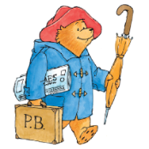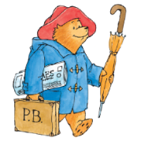

**Key learning opportunities – Year 2**

* Listening to and learning the stories:

Fantastic Mr Fox, Frog and Toad Together, Who’s Afraid of the Big Bad Book, Not Now Bernard

* Adjectives to describe characters and settings
* Comparing characters
* Extending sentences using ‘and’, ‘because’ & ‘but’
* Newspaper reports
* Use of commas, exclamation sentences
* Expanded noun phrases
* Reading & discussing poetry
* Daily Read, Write Inc lessons
* Word of the day
* Daily handwriting
* Daily group reading – Vipers

**Writing: Autumn - What if Paddington was lost in Daventry?**

**Key vocabulary**

* Expanded Noun Phrases
* Exclamation
* Question
* Adjective
* Nonfiction
* Infer
* Fluent

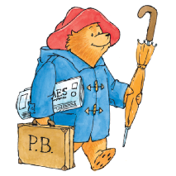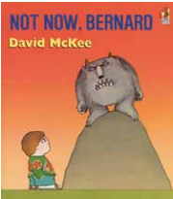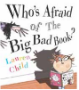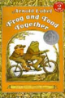

**Key Objectives**

**Year 2**

* To write for different purposes.
* Make simple additions, revisions and corrections.
* Write different types of sentences: question, exclamation,
* Use expanded noun phrases to describe and specify [for example, the blue butterfly]
* Use co-ordination (or, and, but) and Subordination (because)
* To apply phonic skills to read longer words and with increasing fluency.
* To read high frequency words and words which cannot be decoded.
* To re-read to build fluency.
* To listen to, understand, discuss and making inferences about a range of stories, poetry and nonfiction texts.
* To understand and use new vocabulary,

**Previous learning:**

Experiences in Year 1