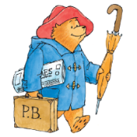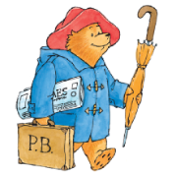

**Key learning opportunities – Year 1**

* Listening to and learning the stories:

The Tiger who came to tea, Elmer, Lost and Found & Knuffle Bunny.

* Retelling our focus stories and innovating these with our own ideas.
* Exploring characters thoughts and feelings,
* Adjectives
* Capital letters
* Use of ‘and’
* Reading & discussing poetry
* Daily Read, Write Inc lessons
* Word of the day
* Daily handwriting
* Daily group reading – Vipers

**English: Autumn - What if Paddington was lost in Daventry?**

**Key vocabulary**

* Adjectives
* Capital letters
* Innovate
* Nonfiction
* Phonics
* Special friends
* Fred talk

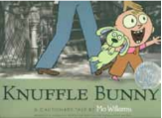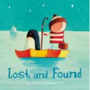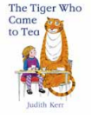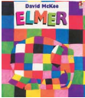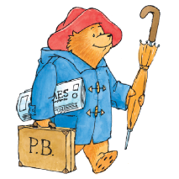

**Key Objectives**

Experiences in Reception

**Year 1**

•Using finger spaces, capital letters and full stops.

* Joining words and joining clauses using ‘and’
* Composing sentences orally before writing them
* Sequencing sentences to form short narratives
* Re-reading writing to check that it makes sense,
* To use phonics to decode words & know high frequency words off by heart.
* To re-read books to build fluency.
* To listen to, understand and discuss a range of stories, poetry and nonfiction texts.

**Previous learning:**