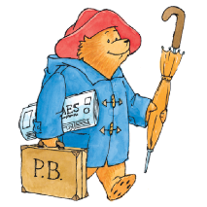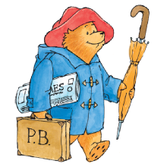

**Key learning opportunities**

* Moving safely,
* Sharing equipment
* Taking turns
* Increasing confidence in PE
* Finding and using space
* Making fruit smoothies.
* Changing into/out of P.E. kit.
* Continuous Provision – bikes / threading / climbing frame / balls / balancing equipment / peg boards / loose parts / scarves / scissors.
* Finger Gym.
* Kinetic Letters activities – letter formation / animal positions / sand trays.
* Christmas wrapping / cutting / sticking.
* Group games to investigate and practise ball skills.

**P.E. EYFS: Autumn - What if Paddington was lost in Daventry?**

**Key vocabulary**

Slow

Fast

Partner

Share

Take turns

Team

Space



**Curriculum links:**

**Physical development (P.E.)**

**Moving and handling:**

Show good control and co-ordination in large and small movements.

Move confidently in a range of ways, safely negotiating space.

Handle equipment and tools effectively, including pencils for writing.

**Health and self-care:**

Know the importance for good health of physical exercise, and a healthy diet, and talk about ways to keep healthy and safe.

Manage their own basic hygiene and personal needs successfully, **including dressing** and going to the toilet independently.

**Key Objectives**

Music – Dance to music

Handwriting – Kinetic Letters

Science – Rainforest animals / smoothies

R.E. – Christmas concert