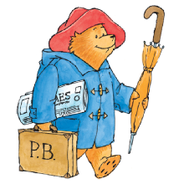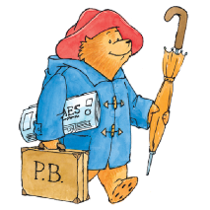

**Key vocabulary**

Information technology

Devises

Photographs

Portrait

Landscape

Light

Focus

Flash

Artificial light source

Edit

**Key learning opportunities**

* Identify devices around school
* Explore IT in environments beyond school
* Focus on the use of IT in a shop and how devices can work together
* Talk about the different rules that might be associated with using technology
* Devises can be sued to create photographs
* Photos taken in landscape and portrait
* Explore the use of a flash and artificial light source
* Edit images
* Explore images which appear to be real, after editing

**Computing (Autumn) – Year 2 - What if Paddington was lost in Daventry?**



Charlie Waite

To recognise different types of computers used in school and describe their uses

To identify information technology used in school and beyond school and how it benefits us

To recognise that choices are made when using information technology

To recognise some digital devices can capture an image using a camera

To capture a digital image

To recognise that photographs can be captured and viewed later

To take landscape and portrait photos

To identify how photographs can be improved

To explain the effect of light when taking a photo

**Previous learning:**

Experiences in year R

**Key Objectives**

* Art
* Online safety

**Curriculum links:**

**Significant people**